**TABLE OF CONTENT**

**Chapter 1**

Introduction …………………………………………………………………………………7-8

1.1 Overview

1.2 Objective

**Chapter 2**

Requirements and Analysis ……………………………………………………………….…...8

2.1 Hardware Requirements

2.2 Technology Uses

2.3 Modules

Admin Module

Patient Module

Doctor Module

2.4 Data Flow Diagram(DFD)……………….………………………………………………...10

DFD 0 Level

DFD 1 level

DFD 2 level (Admin)

DFD 2 level (Doctor)

DFD 2 level (Patient)

2.5 Entity Relationship Diagram (ER –Diagram)…………………………………….………12

**Chapter 3**

Database Design ……………………………………………………………………………...13

3.1 Data Dictionary

**Chapter 4**

Program code ………………………………………………………..…………………….18

4.1 Coding And Output

4.2 Testing Approach

**Chapter 5**

Results and Discussion..………………………………………………………..…………158

5.1 Future Scope

**Chapter 6**

Conclusion….………………………..……………………………………………………159

**CHAPTER 1**

**INTRODUCTION**

* 1. **Overview**

The **Project Hospital Management System (HMS)** is a comprehensive software solution designed to streamline hospital operations, improve patient care, and optimize administrative processes. It facilitates **patient registration, record-keeping, appointment scheduling** etc.

**Features of the Hospital Management System**

1. **Patient Registration & Record Management:**
   * Assigns a **unique patient ID** for easy tracking.
   * Stores patient details, including medical history, treatment records, and prescriptions.
   * Provides **quick access** to patient records, reducing paperwork and improving efficiency.
2. **Doctor & Appointment Management:**
   * Allows users to check **doctor availability** and schedule appointments.
   * Helps in managing **doctor-patient assignments** effectively.
   * Ensures smooth coordination between doctors, patients, and hospital staff.
3. **Search & Data Retrieval:**
   * Users can search for **patients, doctors** using their unique IDs.
   * Helps in quickly retrieving **patient history, doctor schedules.**
4. **User-Friendly Interface:**
   * Designed with an **intuitive and easy-to-use interface** for hospital staff.
   * Enhances hospital workflow and reduces manual workload.
   1. **Objective**

**Define Hospital** – A hospital is a place where patients receive medical treatment, care, and diagnosis from healthcare professionals.

**Patient Record Management** – The system stores and manages details of patients, including their personal information, medical history, and treatment records.

**Diagnosis Information** – Keeps a record of the diagnosis provided to each patient, ensuring accurate medical history tracking.

**Immunization Records** – Maintains records of vaccinations and immunizations given to children and patients for future reference.

**CHAPTER 2**

**REQUIREMENTS AND ANALYSIS**

* 1. **Hardware Requirement**

**Processor:** Intel **i5**

**RAM:** Up to **8GB** RAM

**Storage:** Up to **512GB**

* 1. **Technology Uses**

**Frontend:** HTML, CSS, JavaScript

**Backend:** PHP, Java

**Database:** MySQL

* 1. **Modules**

**Admin Module**

Manages hospital operations, users, and system settings.

Adds, updates, and deletes doctor and patient records.

Controls user access and security.

Generate reports.

**Doctor Module:**

Views assigned patients and updates treatment details.

Search patients by email or name.

Records diagnosis and prescriptions.

Manages appointment schedules.

**Patient Module**

Registers new patients and maintains medical history.

Schedules appointments with doctors.

Stores immunization and diagnosis records.

* 1. **Data Flow Diagram(DFD)**

**DFD 0 Level**

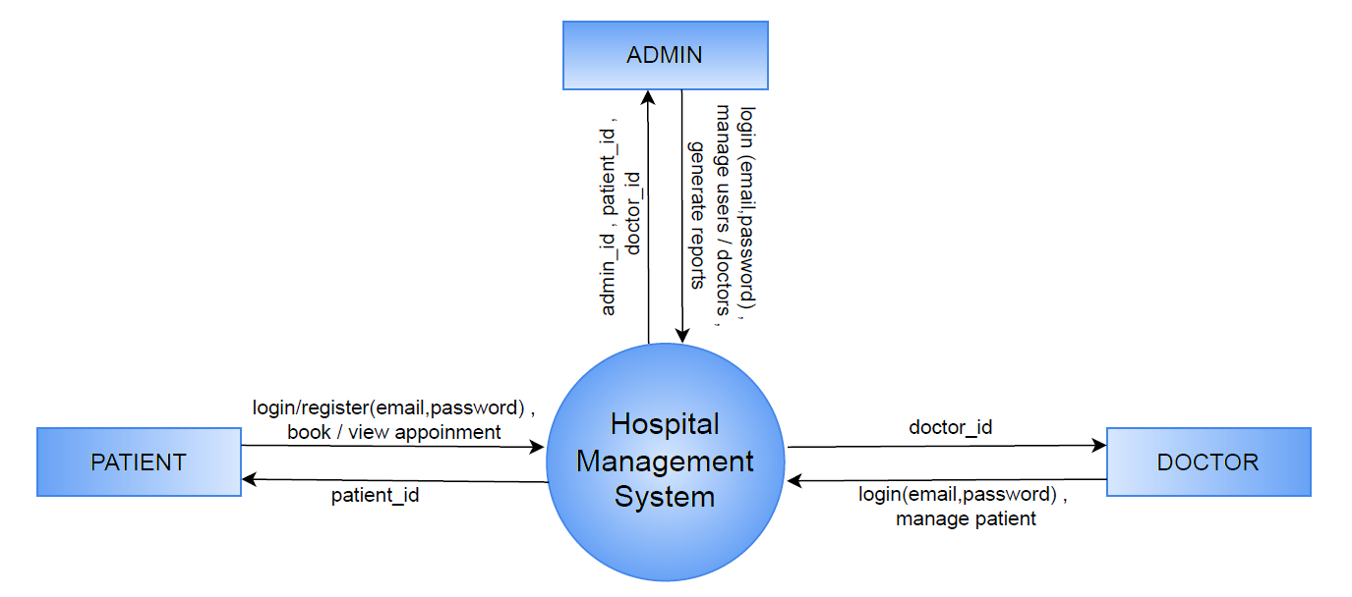

**DFD 1 level**

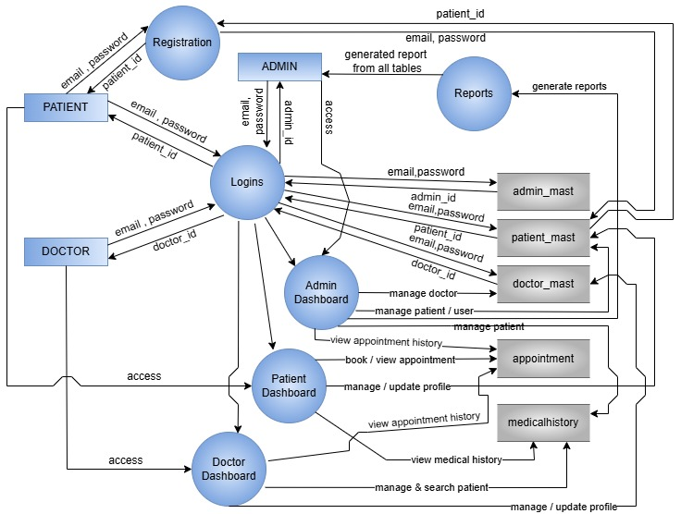

**DFD 2 level(Admin)**

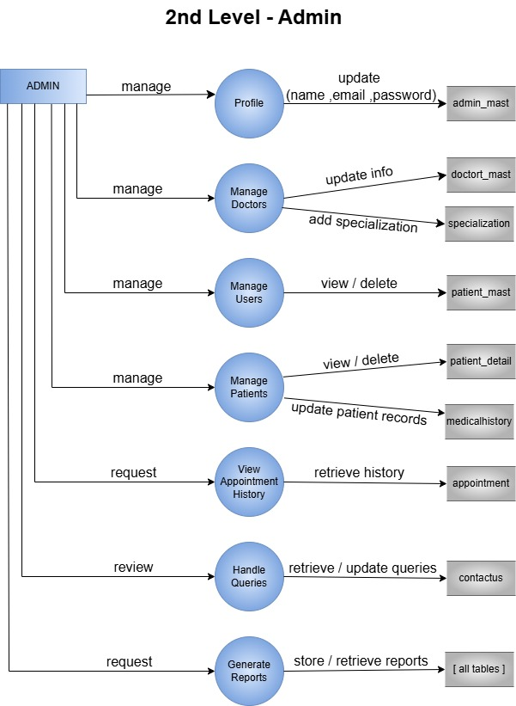

**DFD 2 level(Doctor)**

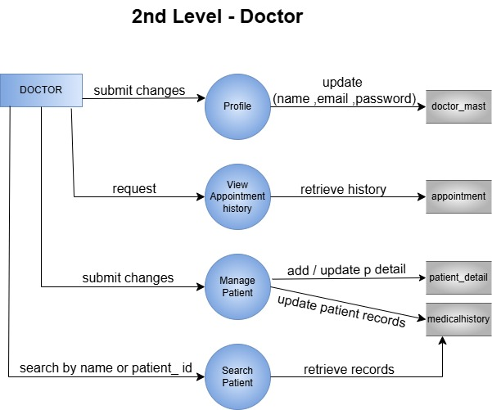

**DFD 2 level(Patient)**

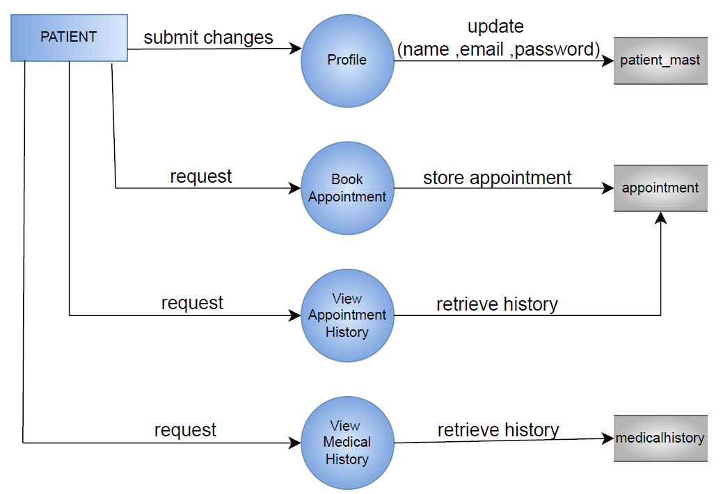

* 1. **Entity Relationship Diagram (ER –Diagram)**

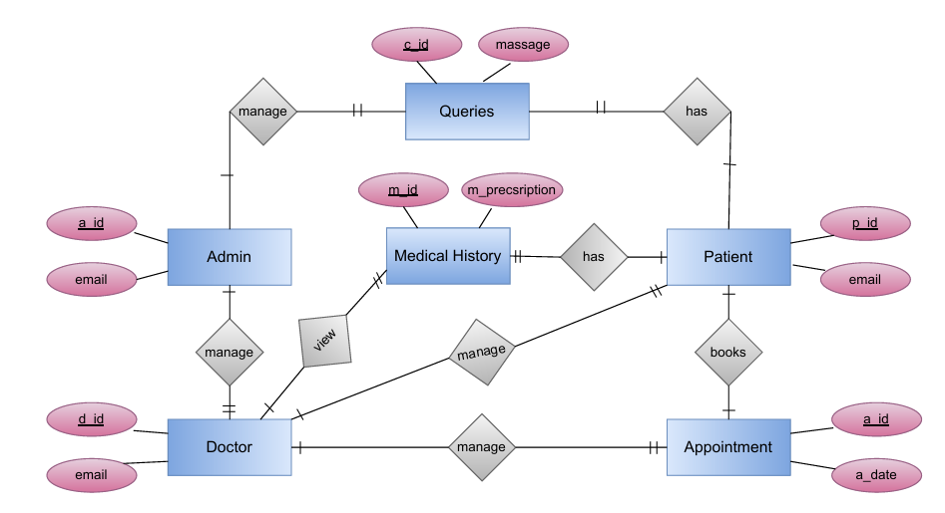

**CHAPTER 3**

**DATABASE DESIGN**

**3.1 Data Dictionary**

**Admin_mast**

|  |  |  |  |  |
| --- | --- | --- | --- | --- |
| Field | Type | Key | Default | Extra |
| a_id | int(11) | PRIMARYKEY | NULL | auto_increment |
| name | varchar(20) |  | NULL |  |
| email | varchar(100) |  | NULL |  |
| Password | varchar(255) |  | NULL |  |

**Doctor_mast**

|  |  |  |  |  |
| --- | --- | --- | --- | --- |
| Field | Type | Key | Default | Extra |
| d_id | int(11) | PRIMARYKEY | NULL | auto_increment |
| name | varchar(20) |  | NULL |  |
| specialization | text |  | NULL |  |
| docfees | int(11) |  | NULL |  |
| contact | varchar(10) |  | NULL |  |
| email | varchar(100) |  | NULL |  |
| password | varchar(255) |  | NULL |  |

**Patient_mast**

|  |  |  |  |  |
| --- | --- | --- | --- | --- |
| Field | Type | Key | Default | Extra |
| p_id | int(11) | PRIMARYKEY | NULL | auto_increment |
| fullname | varchar(100) |  | NULL |  |
| address | varchar(255) |  | NULL |  |
| city | varchar(100) |  | NULL |  |
| gender | varchar(50) |  | NULL |  |
| email | varchar(100) |  | NULL |  |
| password | varchar(255) |  | NULL |  |
| created_at | timestamp |  | current_timestamp() |  |

**Patient_detail**

|  |  |  |  |  |
| --- | --- | --- | --- | --- |
| Field | Type | Key | Default | Extra |
| p_detail_id | int(11) | PRIMARYKEY | *NULL* | auto_increment |
| d_id | int(11) |  | *NULL* |  |
| p_name | varchar(100) |  | *NULL* |  |
| p_email | varchar(100) |  | *NULL* |  |
| contact_no | varchar(10) |  | *NULL* |  |
| p_gender | varchar(50) |  | *NULL* |  |
| p_add | varchar(100) |  | *NULL* |  |
| p_age | int(11) |  | *NULL* |  |
| p_medhis | varchar(100) |  | *NULL* |  |
| created_at | timestamp |  | current_timestamp() |  |

**Appointment**

|  |  |  |  |  |
| --- | --- | --- | --- | --- |
| Field | Type | Key | Default | Extra |
| a_id | int(11) | PRIMARYKEY | NULL | auto_increment |
| specilization | varchar(100) |  | NULL |  |
| d_id | int(11) |  | NULL |  |
| p_id | int(11) |  | NULL |  |
| fees | int(11) |  | NULL |  |
| a_date | varchar(255) |  | NULL |  |
| a_time | varchar(255) |  | NULL |  |
| postingdate | timestamp |  | current_timestamp() |  |
| userstatus | int(11) |  | NULL |  |
| d_status | int(11) |  | NULL |  |

**Specilization**

|  |  |  |  |  |
| --- | --- | --- | --- | --- |
| Field | Type | Key | Default | Extra |
| s_id | int(11) | PRIMARY KEY | NULL | auto_increment |
| specilization | varchar(50) |  | NULL |  |
| created_at | timestamp |  | current_timestamp() |  |

**Pages**

|  |  |  |  |  |
| --- | --- | --- | --- | --- |
| Field | Type | Key | Default | Extra |
| id | int(11) | PRIMARYKEY | *NULL* | auto_increment |
| img | varchar(100) |  | *NULL* |  |
| type | varchar(100) |  | *NULL* |  |
| category | varchar(20) |  | *NULL* |  |
| description | text |  | *NULL* |  |

**Medical_history**

|  |  |  |  |  |
| --- | --- | --- | --- | --- |
| Field | Type | Key | Default | Extra |
| m_id | int(10) | PRIMARY KEY | NULL | auto_increment |
| p_detail_id | int(10) |  | NULL |  |
| Bp | varchar(200) |  | NULL |  |
| Bs | varchar(200) |  | NULL |  |
| weight | varchar(100) |  | NULL |  |
| temperature | varchar(200) |  | NULL |  |
| m_prescription | mediumtext |  | NULL |  |
| created_at | timestamp |  | current_timestamp() | ondatecurrent_timestamp() |

**Contactus**

|  |  |  |  |  |
| --- | --- | --- | --- | --- |
| Field | Type | Key | Default | Extra |
| c_id | int(11) | PRIMARYKEY | *NULL* | auto_increment |
| name | varchar(100) |  | *NULL* |  |
| email | varchar(100) |  | *NULL* |  |
| mobile | text |  | *NULL* |  |
| message | varchar(255) |  | *NULL* |  |
| created_at | timestamp |  | current_timestamp() |  |

**CHAPTER 4**

**PROGRAM CODE**

**4.1 Coding And Output**

**Database Connectivity**

<?php

    $conn = new mysqli("localhost","root","","project_hms");

    if(mysqli_error($conn))

        die ("Connection Error..!");

?>

**Header**



<!DOCTYPE html>

<html lang="en">

<head>

    <meta charset="UTF-8">

    <meta name="viewport" content="width=device-width, initial-scale=1.0">

    <title>Hospital Management System</title>

    <link rel="website icon" href="img/logo1.jpg" type="jpg">

    <link rel="stylesheet" href="css/style.css">

    <link href="https://cdnjs.cloudflare.com/ajax/libs/font-awesome/5.15.4/css/all.min.css" rel="stylesheet">

</head>

<body>

    <header class="header">

        <div class="logo">HMS</div>

        <nav>

            <ul>

                <li><a href="index.php">Home</a></li>

                <li><a href="services.php">Services</a></li>

                <li><a href="gallery.php">Gallery</a></li>

                <li><a href="logins.php">Logins</a></li>

            </ul>

        </nav>

    </header>

**Footer**



<section class="footer" id="footer">

        <div class="footer-box">

            <h2 style="text-align:left;">HMS<span> Health Care</span></h2>

            <p class="p" style="text-align: left;">Streamlining hospital operations with efficient management solutions, ensuring better patient care and seamless administration.</p>

            <div class="social">

                <a href="#"><i class='fa fa-facebook'></i></a>

                <a href="#"><i class='fa fa-twitter'></i></a>

                <a href="#"><i class='fa fa-instagram'></i></a>

            </div>

        </div>

        <div class="footer-box">

            <h3>Info</h3>

            <li><a href="aboutus.php">About Us</a></li>

            <li><a href="logins.php">Logins</a></li>

            <li><a href="gallery.php">Gallery</a></li>

            <li><a href="contactus.php">Contact Us</a></li>

        </div>

        <div class="footer-box contact-info">

            <h3>Contact Us</h3>

            <span>Email : hmsonline3111@gmail.com </span><br>

            <span>Mobile No.: 7682431160</span><br>

            <span>Valsad - 396001, Gujarat , India</span>

        </div>

    <div class="copyright">

        <p style="margin-top: 1%; text-align:center; margin-bottom:-0.25%">© 2025 Hospital Management System ❤</p>

    </div>

</section>

**Main Index**



<?php

    include("header.php");

    include("database.php");

?>

<style>

.hero-section {

    position: relative;

    overflow: hidden;

    width: 100%;

}

.hero-overlay {

    position: absolute;

    top: 500px;

    left: 360px;

    color: white;

    font-size: 2em;

    z-index: 2;

}

.hero-image {

    width: 100%;

    height: 540px;

    object-fit: cover;

    display: none;

}

.slider img:first-child {

    display: block;

}

.left-arrow, .right-arrow {

    position: absolute;

    top: 50%;

    transform: translateY(-50%);

    font-size: 3em;

    color: white;

    background-color: rgba(0, 0, 0, 0.5);

    padding: 10px;

    cursor: pointer;

    z-index: 3;

}

.left-arrow {

    left: 10px;

}

.right-arrow {

    right: 10px;

}

.left-arrow:hover, .right-arrow:hover {

    background-color: rgba(0, 0, 0, 0.7);

}

</style>

<section class="hero-section">

    <div class="hero-overlay">

        <h1>Hospital Management System</h1>

    </div>

    <div class="slider">

        <?php

        // Fetch images from pages table where type is 'ad'

        $query = "SELECT img FROM pages WHERE type='ad'";

        $query_run = mysqli_query($conn, $query);

        if (mysqli_num_rows($query_run) > 0) {

            while ($row = mysqli_fetch_assoc($query_run)) {

                echo "<img src='img/{$row['img']}' alt='Hospital Management System' class='hero-image'>";

            }

        } else {

            echo "<p>No advertisements available.</p>";

        }

        ?>

    </div>

    <span class="left-arrow" onclick="moveSlide(-1)">&#10094;</span>

    <span class="right-arrow" onclick="moveSlide(1)">&#10095;</span>

</section>

<script>

let slideIndex = 0;

function moveSlide(step) {

    const slides = document.querySelectorAll('.hero-image');

    slides[slideIndex].style.display = 'none';

    slideIndex += step;

    if (slideIndex < 0) {

        slideIndex = slides.length - 1;

    } else if (slideIndex >= slides.length) {

        slideIndex = 0;

    }

    slides[slideIndex].style.display = 'block';

}

document.addEventListener("DOMContentLoaded", function() {

    const slides = document.querySelectorAll('.hero-image');

    if (slides.length > 0) {

        slides[0].style.display = 'block';

    }

});

</script>

    <section class="logins-section">

        <h2>Logins</h2>

        <div class="login-cards">

            <div class="login-card">

                <img src="img/patient.jpg" alt="Patient Login"><br>

                <p class="log">Patient Login</p>

                <a href="patient_login.php"><Button class="logBtn">Click Here</Button></a>

            </div>

            <div class="login-card">

                <img src="img/doctor.jpg" alt="Doctor Login"><br>

                <p class="log">Doctor Login</p>

                <a href="doctor_login.php"><Button class="logBtn">Click Here</Button></a>

            </div>

            <div class="login-card">

                <img src="img/admin.jpg" alt="Admin Login"><br>

                <p class="log">Admin Login</p>

                <a href="admin_login.php"><Button class="logBtn">Click Here</Button></a>

            </div>

        </div>

    </section>

    <section class="features-section">

        <h2>Our Key Features</h2>

        <div class="feature-list">

            <div class="feature-item">

                <i class="fas fa-heartbeat"></i>

                <p>Cardiology</p>

            </div>

            <div class="feature-item">

                <i class="fas fa-ribbon"></i>

                <p>Orthopaedic</p>

            </div>

            <div class="feature-item">

                <i class="fab fa-monero"></i>

                <p>Neurology</p>

            </div>

            <div class="feature-item">

                <i class="fas fa-capsules"></i>

                <p>Pharma Pipeline</p>

            </div>

            <div class="feature-item">

                <i class="fas fa-prescription-bottle-alt"></i>

                <p>Pharma Team</p>

            </div>

            <div class="feature-item">

                <i class="far fa-thumbs-up"></i>

                <p>High-Quality Treatments</p>

            </div>

        </div>

    </section>

    <section class="about-section">

    <div class="about-container">

    <?php

    $query = "SELECT * FROM pages WHERE type='about' LIMIT 1";

    $query_run = mysqli_query($conn, $query);

    if (mysqli_num_rows($query_run) > 0) {

        $row = mysqli_fetch_assoc($query_run);

        ?>

        <img src="img/<?php echo $row['img']; ?>" alt="About Hospital" class="about-image">

        <div class="about-content">

            <h2 class="about-title">About Our Hospital</h2>

            <p class="about-description"><?php echo $row['description']; ?></p>

        </div>

        <?php

    } else {

        echo "<p>No about information available.</p>";

    }

    ?>

</div>

    <section class="gallery-section">

        <h2 style="color: rgb(82, 136, 191);">Our Gallery</h2>

        <div class="gallery-grid">

            <?php

                $query = "SELECT * FROM pages WHERE type='gallery' ORDER BY RAND() LIMIT 4";

                $query_run = mysqli_query($conn, $query);

                $check_product = mysqli_num_rows($query_run) > 0;

                if ($check_product) {

                    while ($row = mysqli_fetch_array($query_run)) {

                        ?>

                        <img src="img/<?php echo $row['img']; ?>" alt="">

                        <?php

                    }

                }

            ?>

        </div>

    </section>

<?php

    include("footer.php");

?>

**Gallery**



<?php

    include("header.php");

    include("database.php");

?>

<!DOCTYPE html>

<html lang="en">

<head>

    <meta charset="UTF-8">

    <meta name="viewport" content="width=device-width, initial-scale=1.0">

    <link rel="stylesheet" href="style.css">

    <title>Gallery</title>

    <style>

        .hospital-gallery-container {

            max-width: 1200px;

            margin: 0 auto;

            padding: 20px;

            text-align: center;

        }

        .gallery-title {

            color:rgb(52, 95, 139);

            margin-bottom: 20px;

        }

        .filter-buttons {

            margin-bottom: 20px;

        }

        .filter-buttons button {

            background-color:rgb(118, 166, 213);

            color: #fff;

            border: none;

            padding: 10px 15px;

            border-radius: 5px;

            cursor: pointer;

            margin: 0 5px;

            transition: background-color 0.3s ease;

        }

        .filter-buttons button:hover {

            background-color:rgb(80, 116, 151);

        }

        .hospital-gallery {

            display: grid;

            grid-template-columns: repeat(auto-fill, minmax(250px, 1fr));

            gap: 20px;

        }

        .gallery-item {

            display: none;

            background-color: #fff;

            border-radius: 8px;

            box-shadow: 0 4px 8px rgba(0, 0, 0, 0.1);

            overflow: hidden;

            transition: transform 0.3s ease-in-out;

        }

        .gallery-item img {

            width: 100%;

            height: auto;

            display: block;

            object-fit: cover;

        }

        .gallery-item p {

            padding: 10px;

            background-color: #ecf0f1;

            font-size: 16px;

            color: #2c3e50;

        }

        .gallery-item:hover {

            transform: scale(1.025);

        }

    </style>

    <script>

        function filterGallery(type) {

            const items = document.querySelectorAll('.gallery-item');

            items.forEach(item => {

                if (type === 'all' || item.classList.contains(type)) {

                    item.style.display = 'block';

                } else {

                    item.style.display = 'none';

                }

            });

        }

        document.addEventListener('DOMContentLoaded', () => {

            filterGallery('all');

        });

    </script>

</head>

<body>

    <div class="hospital-gallery-container">

        <h1 class="gallery-title">Hospital Gallery</h1>

        <div class="filter-buttons">

        <?php

            $category_query = "SELECT DISTINCT category FROM pages WHERE type='gallery' AND category != ''";

            $category_result = mysqli_query($conn, $category_query);

            if (mysqli_num_rows($category_result) > 0) {

                echo '<button onclick="filterGallery(\'all\')">All</button>';

                $unique_categories = [];

                while ($category_row = mysqli_fetch_assoc($category_result)) {

                    $category = strtolower(trim($category_row['category']));

                    if (!in_array($category, $unique_categories)) {

                        $unique_categories[] = $category;

                        $category_name = ucfirst($category);

                        echo "<button onclick=\"filterGallery('$category')\">$category_name</button>";

                    }

                }

            }

        ?>

        </div>

        <div class="hospital-gallery">

            <?php

                $query = "SELECT * FROM pages WHERE type='gallery'";

                $query_run = mysqli_query($conn, $query);

                if (mysqli_num_rows($query_run) > 0) {

                    while ($row = mysqli_fetch_array($query_run)) {

                        $category = strtolower($row['category']);

                        ?>

                        <div class="gallery-item <?php echo $category; ?>">

                            <img src="img/<?php echo $row['img']; ?>" alt="">

                        </div>

                        <?php

                    }

                }

            ?>

        </div>

    </div>

</body>

</html>

<?php

    include("footer.php");

?>

**Logins**

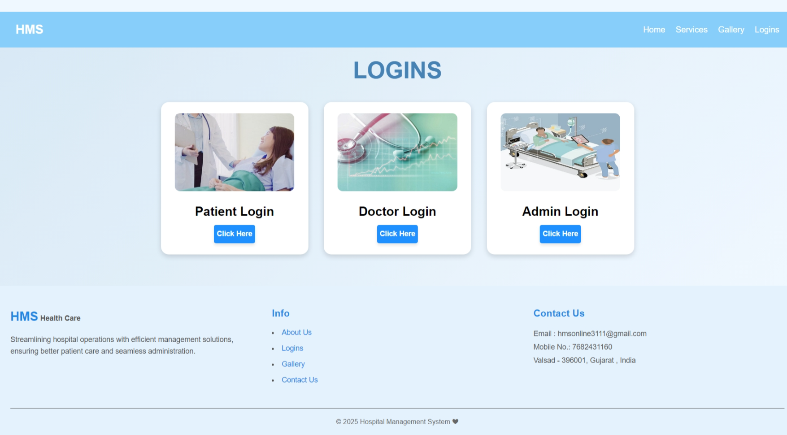

<?php

    include("header.php");

?>

    <section class="logins-section">

        <h2 style="margin-top: -2%;">Logins</h2>

        <div class="login-cards">

            <div class="login-card">

                <img src="img/patient.jpg" alt="Patient Login"><br>

                <p class="log">Patient Login</p>

                <a href="patient_login.php"><Button class="logBtn">Click Here</Button></a>

            </div>

            <div class="login-card">

                <img src="img/doctor.jpg" alt="Doctor Login"><br>

                <p class="log">Doctor Login</p>

                <a href="doctor_login.php"><Button class="logBtn">Click Here</Button></a>

            </div>

            <div class="login-card">

                <img src="img/admin.jpg" alt="Admin Login"><br>

                <p class="log">Admin Login</p>

                <a href="admin_login.php"><Button class="logBtn">Click Here</Button></a>

            </div>

        </div>

    </section>

<?php

    include("footer.php");

?>

**Contact Us**

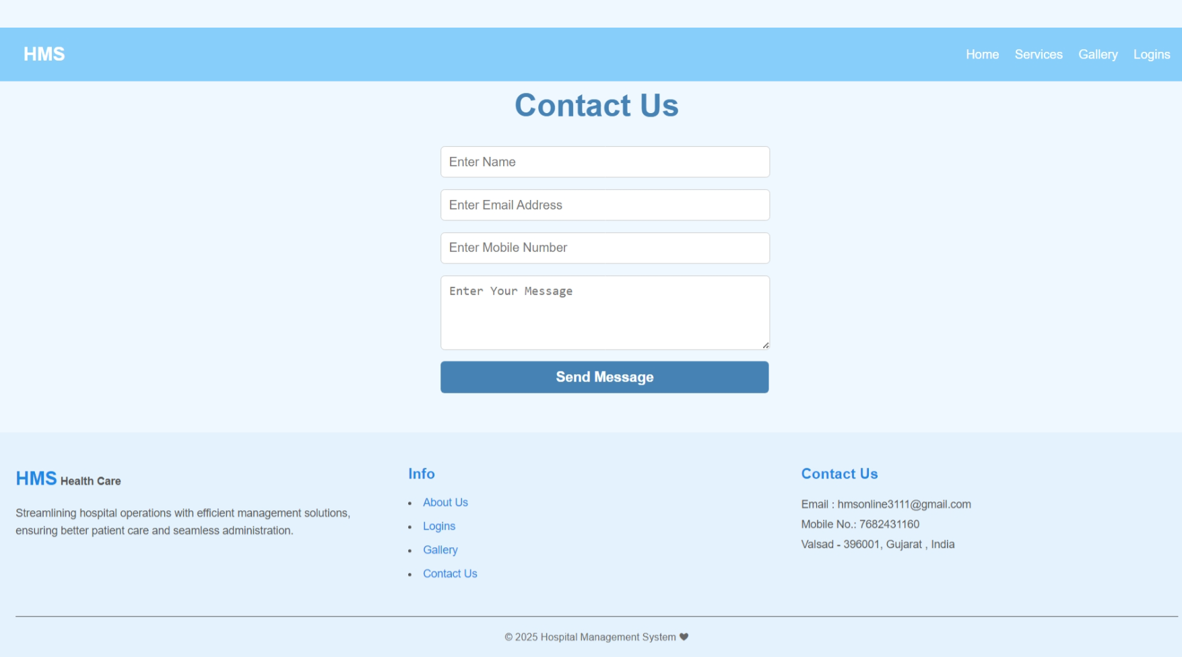<?php

include("header.php");

include("database.php");

if ($_SERVER["REQUEST_METHOD"] == "POST") {

    $name = $_POST['name'];

    $email = $_POST['email'];

    $mobile = $_POST['mobile'];

    $message = $_POST['message'];

    $sql = "INSERT INTO contactus (name, email, mobile, message) VALUES ('$name', '$email', '$mobile', '$message')";

    if ($conn->query($sql) === TRUE) {

        echo "<script>alert('Message sent successfully!');</script>";

    } else {

        echo "<script>alert('Error: " . $conn->error . "');</script>";

    }

}

?>

<!DOCTYPE html>

<html lang="en">

<head>

    <meta charset="UTF-8">

    <meta name="viewport" content="width=device-width, initial-scale=1.0">

    <title>Document</title>

    <link rel="stylesheet" href="css/style.css">

</head>

<body>

    <section class="contact-section">

        <h2 style="margin-top: -1%;">Contact Us</h2>

        <form class="contact-form" action="" method="post">

            <input type="text" name="name" placeholder="Enter Name" required>

            <input type="email" name="email" placeholder="Enter Email Address" required>

            <input type="tel" name="mobile" placeholder="Enter Mobile Number" required>

            <textarea name="message" rows="4" placeholder="Enter Your Message" required></textarea>

            <button type="submit" style="width: 105%;">Send Message</button>

        </form>

    </section>

    <?php

        include("footer.php");

    ?>

</body>

</html>

**Admin Login**

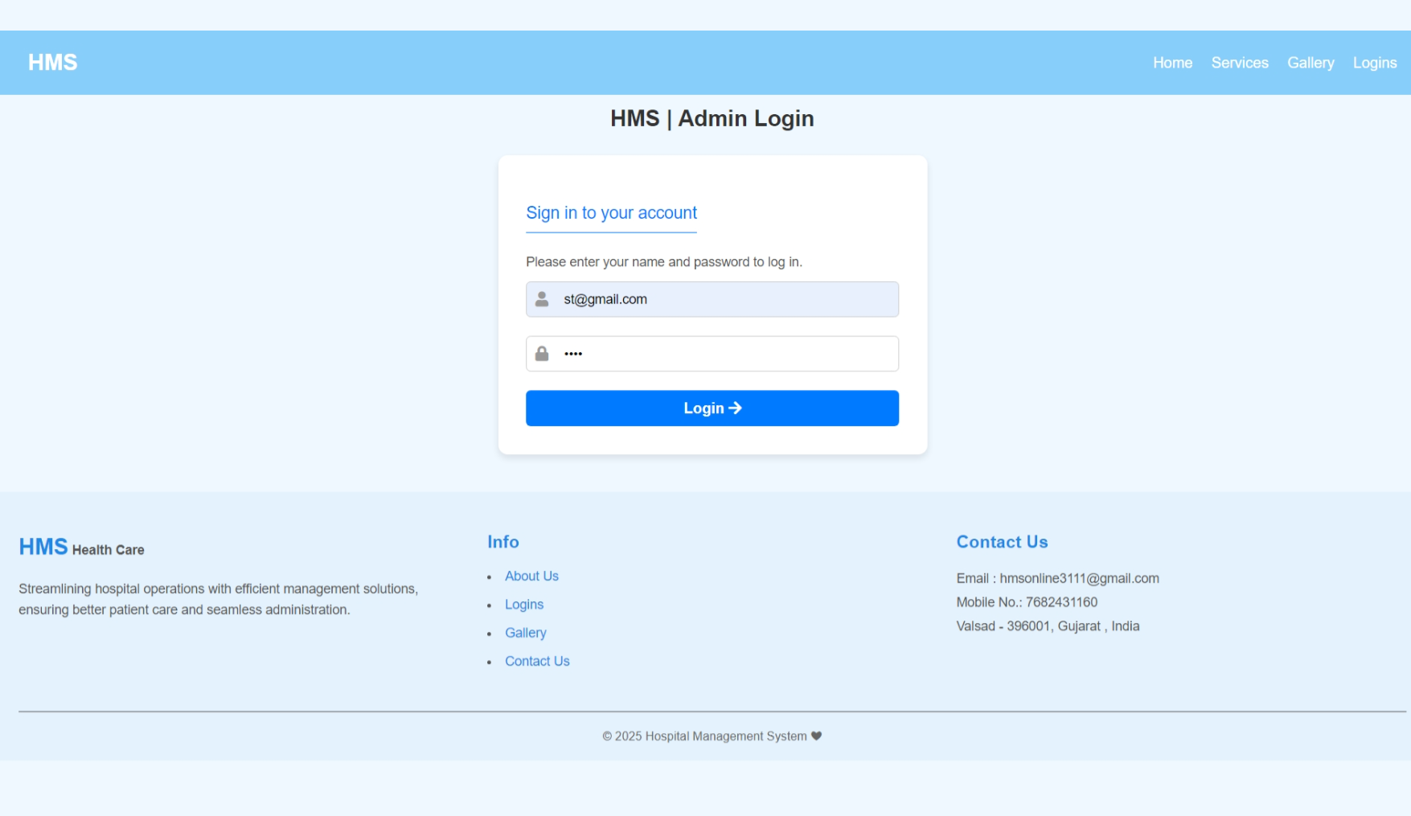

<?php

    session_start();

    include("header.php");

?>

<!DOCTYPE html>

<html lang="en">

<head>

    <meta charset="UTF-8">

    <meta name="viewport" content="width=device-width, initial-scale=1.0">

    <title>HMS | Admin Login</title>

    <link href="https://cdnjs.cloudflare.com/ajax/libs/font-awesome/5.15.4/css/all.min.css" rel="stylesheet">

    <link rel="stylesheet" href="css/rl_style.css">

</head>

<body>

    <section class="login-container" style="margin-bottom: -23%;">

    <h1>HMS | Admin Login</h1>

        <div class="login-box" style="margin-bottom: 25%;">

            <form method="POST" action="<?php echo htmlspecialchars($_SERVER["PHP_SELF"])?>">

                <p class="p2">Sign in to your account</p>

                <p class="p1">Please enter your name and password to log in.</p>

                <div class="input-group">

                    <label for="email">

                        <i class="fa fa-user"></i>

                    </label>

                    <input type="email" id="email" name="email" placeholder="Email" required>

                </div>

                <div class="input-group">

                    <label for="password">

                        <i class="fa fa-lock"></i>

                    </label>

                    <input type="password" id="password" name="password" placeholder="Password" required>

                </div>

                <button type="submit" class="login-btn">Login <i class="fa fa-arrow-right"></i></button>

                <?php

                    include("database.php");

                    if($_SERVER["REQUEST_METHOD"]=="POST")

                    {

                        $email = filter_input(INPUT_POST,"email",FILTER_SANITIZE_SPECIAL_CHARS);

                        $password = filter_input(INPUT_POST,"password",FILTER_SANITIZE_SPECIAL_CHARS);

                        if(!empty($email) && !empty($password))

                        {

                            $sql = "SELECT * FROM admin_mast WHERE email = '$email'";

                            $result = mysqli_query($conn, $sql);

                            if (mysqli_num_rows($result) > 0) {

                                $user = mysqli_fetch_assoc($result);

                                if ($password === $user["password"]){

                                    $_SESSION['admin_id']=$user['a_id'];

                                    $_SESSION['admin_name']=$user['name'];

                                    header("location:admin_index.php");

                                    exit;

                                }

                            }

                        }

                    }

                    mysqli_close($conn);

                ?>

            </form>

        </div>

    </section>

    <?php

        include("footer.php");

    ?>

</body>

</html>

**Admin Account**

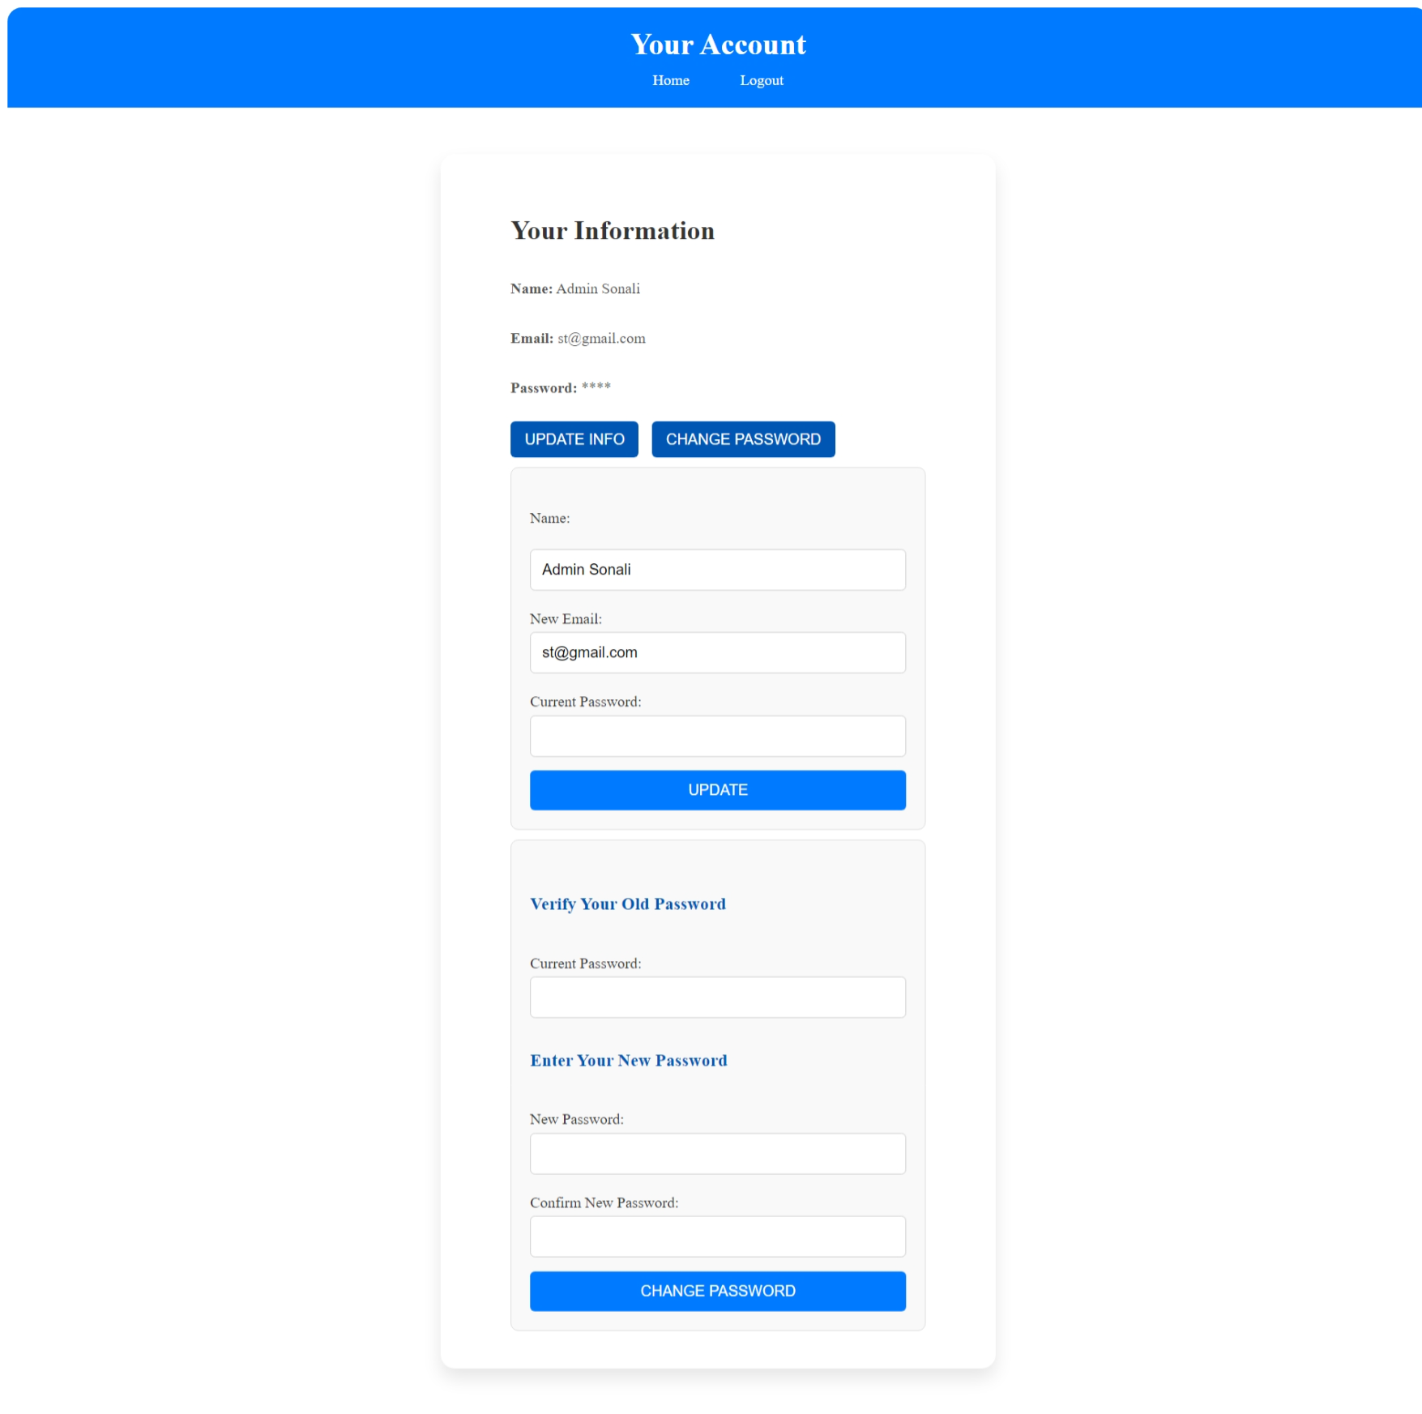

<?php

session_start();

include("database.php");

if (!isset($_SESSION['admin_id'])) {

    header("Location: admin_login.php");

    exit();

}

$admin_id = $_SESSION['admin_id'];

$query = "SELECT * FROM admin_mast WHERE a_id = '$admin_id'";

$result = mysqli_query($conn, $query);

if ($result && mysqli_num_rows($result) > 0) {

    $admin = mysqli_fetch_assoc($result);

} else {

    echo "Admin not found.";

    exit();

}

$message = "";

if ($_SERVER["REQUEST_METHOD"] == "POST" && isset($_POST['update'])) {

    $name = trim($_POST['name']);

    $new_email = trim($_POST['email']);

    $password = trim($_POST['password']);

    $name = mysqli_real_escape_string($conn, $name);

    $new_email = mysqli_real_escape_string($conn, $new_email);

    $password = mysqli_real_escape_string($conn, $password);

    if ($password === $admin['password']) {

        $update_query = "UPDATE admin_mast SET name='$name', email='$new_email' WHERE a_id='$admin_id'";

        if (mysqli_query($conn, $update_query)) {

            $message = "Account details updated successfully!";

            $result = mysqli_query($conn, $query);

            if ($result && mysqli_num_rows($result) > 0) {

                $doctor = mysqli_fetch_assoc($result);

            }

        } else {

            $message = "Error updating account details.";

        }

    } else {

        $message = "Incorrect password. Please try again.";

    }

}

if ($_SERVER["REQUEST_METHOD"] == "POST" && isset($_POST['change_password'])) {

    $password = trim($_POST['password']);

    $new_password = trim($_POST['new_password']);

    $confirm_password = trim($_POST['confirm_password']);

    $password = mysqli_real_escape_string($conn, $password);

    $new_password = mysqli_real_escape_string($conn, $new_password);

    $confirm_password = mysqli_real_escape_string($conn, $confirm_password);

    if ($password === $admin['password']) {

        if ($new_password === $confirm_password) {

            $update_query = "UPDATE admin_mast SET password='$new_password' WHERE a_id='$admin_id'";

            if (mysqli_query($conn, $update_query)) {

                $message = "Password updated successfully!";

            } else {

                $message = "Error updating password.";

            }

        } else {

            $message = "New passwords do not match!";

        }

    } else {

        $message = "Incorrect current password!";

    }

}

?>

<!DOCTYPE html>

<html lang="en">

<head>

    <meta charset="UTF-8">

    <meta name="viewport" content="width=device-width, initial-scale=1.0">

    <title>Account</title>

    <link rel="website icon" href="img/logo1.jpg" type="jpg">

    <link rel="stylesheet" href="css/account_style.css">

</head>

<body>

    <header>

        <h2>Your Account</h2>

        <nav>

            <a href="admin_index.php">Home</a>&nbsp;&nbsp;&nbsp;&nbsp;&nbsp;

            <a href="logout.php">Logout</a>

        </nav>

    </header>

    <div class="container">

        <section class="sec">

            <h2>Your Information</h2><br>

            <p><strong>Name:</strong> <?php echo htmlspecialchars($admin['name']); ?></p><br>

            <p><strong>Email:</strong> <?php echo htmlspecialchars($admin['email']); ?></p><br>

            <p><strong>Password:</strong> <?php echo str_repeat('*', strlen($admin['password'])); ?></p><br>

            <button class="btn1" onclick="toggleForm('update-info-form')">Update Info</button>

            <button class="btn1" onclick="toggleForm('change-password-form')">Change Password</button>

            <form method="POST" id="update-info-form" class="form-section">

                <br><label for="name">Name:</label><br>

                <input type="text" id="name" name="name" class="ipt1" value="<?php echo htmlspecialchars($admin['name']); ?>" required><br>

                <label for="email">New Email:</label>

                <input type="email" id="email" name="email" class="email-pass" value="<?php echo htmlspecialchars($admin['email']); ?>" required><br>

                <label for="password">Current Password:</label>

                <input type="password" id="password" class="email-pass" name="password" required><br>

                <button type="submit" class="btn" name="update">Update</button><br>

            </form>

            <form method="POST" id="change-password-form" class="form-section">

                <br><h3>Verify Your Old Password</h3><br>

                <label for="password">Current Password:</label>

                <input type="password" id="password" class="email-pass" name="password" required><br>

                <h3>Enter Your New Password</h3><br>

                <label for="new_password">New Password:</label>

                <input type="password" id="new_password" class="ipt" name="new_password" required><br>

                <label for="confirm_password">Confirm New Password:</label>

                <input type="password" id="confirm_password" class="ipt" name="confirm_password" required><br>

                <button type="submit" class="btn" name="change_password">Change Password</button>

            </form>

        </section>

    </div>

    <?php

    if($message){

        echo "<script type='text/javascript'>alert('$message');</script>";

    }

    ?>

    <script>

        function toggleForm(formId) {

            var form = document.getElementById(formId);

            if (form.style.display === "none" || form.style.display === "") {

                form.style.display = "block";

            } else {

                form.style.display = "none";

            }

        }

    </script>

</body>

</html>

**Admin Header**

<?php

    session_start();

    if(isset($_SESSION['admin_name'])){

        $admin_name = $_SESSION['admin_name'];

    }else{

        header("Location: admin_login.php");

    }

?>

<!DOCTYPE html>

<html lang="en">

<head>

    <meta charset="UTF-8">

    <meta name="viewport" content="width=device-width, initial-scale=1.0">

    <title>Hospital Management System</title>

    <link rel="website icon" href="img/logo1.jpg" type="jpg">

    <link href="https://cdnjs.cloudflare.com/ajax/libs/font-awesome/5.15.4/css/all.min.css" rel="stylesheet">

    <link rel="stylesheet" href="css/style.css">

    <style>

        * {

        margin: 0;

        padding: 0;

        box-sizing: border-box;

        font-family: Arial, sans-serif;

        }

        body {

            display: flex;

            background-color: #f0f8ff;

        }

        .sidebar {

            width: 250px;

            height: 100vh;

            background:rgb(66, 134, 206);

            color: white;

            padding: 20px;

        }

        .sidebar h2 {

            text-align: center;

            margin-bottom: 20px;

        }

        .sidebar ul {

            list-style: none;

            padding: 0;

        }

        .sidebar ul li {

            padding: 15px;

        }

        .sidebar ul li a {

            color: white;

            text-decoration: none;

            display: block;

        }

        .sidebar ul li a:hover {

            background:rgb(94, 142, 193);

            border-radius: 5px;

        }

        .main-content {

            flex: 1;

            padding:5px;

        }

        header {

            display: flex;

            justify-content: space-between;

            align-items: center;

            background: white;

            box-shadow: 0px 2px 10px rgba(0, 0, 0, 0.1);

        }

        .dashboard {

            margin-top: 20px;

        }

        .cards {

            display: flex;

            /*justify-content: space-between;*/

            gap: 20px;

            margin-left: 2%;

        }

        .card {

            background: white;

            padding: 20px;

            text-align: center;

            width: 30%;

            border-radius: 10px;

            box-shadow: 0px 4px 10px rgba(0, 0, 0, 0.1);

        }

        .card img {

            width: 50px;

            margin-bottom: 10px;

        }

        .card a {

            display: block;

            margin-top: 10px;

            color:rgb(50, 128, 210);

            text-decoration: none;

        }

        .card a:hover {

            text-decoration: underline;

        }

        .dropdown {

            position: relative;

            display: inline-block;

        }

        .dropbtn {

            margin-left: -19%;

            margin-top: -10%;

            margin-bottom: -10%;

            padding: 10px 20px;

            font-size: 16px;

            border: none;

            cursor: pointer;

        }

        .dropdown-content {

            display: none;

            position: absolute;

            background-color:rgb(255, 255, 255);

            min-width: 160px;

            box-shadow: 0px 8px 16px rgba(0, 0, 0, 0.2);

            z-index: 1;

        }

        .dropdown-content a {

            color:black;

            padding: 6px 16px;

            text-decoration: none;

            display: block;

        }

        .dropdown:hover .dropdown-content {

            display: block;

        }

    </style>

</head>

<body>

<div class="sidebar">

<ul>

    <li><a href="admin_index.php">Dashboard</a></li>

    <li class="dropdown">

        <a href="#" class="dropbtn">

            Doctors <i class="fas fa-caret-down"></i>

        </a>

        <div class="dropdown-content">

            <a href="dr_specialization.php" style="color: black; border-radius:0;width:183px;">Add Specialization</a>

            <a href="a_add_doctor.php" style="color: black; border-radius:0;">Add Doctor</a>

            <a href="a_manage_doctor.php" style="color: black; border-radius:0;">Manage Doctor</a>

        </div>

    </li>

    <li class="dropdown">

        <a href="#" class="dropbtn">

            Users <i class="fas fa-caret-down"></i>

        </a>

        <div class="dropdown-content">

            <a href="a_manage_user.php" style="color: black; border-radius:0;">Manage User</a>

        </div>

    </li>

    <li class="dropdown">

        <a href="#" class="dropbtn">

            Patients <i class="fas fa-caret-down"></i>

        </a>

        <div class="dropdown-content">

            <a href="a_manage_patient.php" style="color: black; border-radius:0;">Manage Patient</a>

        </div>

    </li>

    <li><a href="a_appointment_history.php">Appointment History</a></li>

    <li class="dropdown">

        <a href="#" class="dropbtn">

            Queries <i class="fas fa-caret-down"></i>

        </a>

        <div class="dropdown-content">

            <a href="a_read_query.php" style="color: black; border-radius:0;">Read Query</a>

        </div>

    </li>

    <li class="dropdown">

        <a href="#" class="dropbtn">

            Reports <i class="fas fa-caret-down"></i>

        </a>

        <div class="dropdown-content">

            <a href="a_report.php" style="color: black; border-radius:0;width:183px">B/w Dates Reports</a>

        </div>

    </li>

    <li class="dropdown">

        <a href="#" class="dropbtn">

            Pages <i class="fas fa-caret-down"></i>

        </a>

        <div class="dropdown-content">

            <a href="a_ad.php" style="color: black; border-radius:0;">Advertisement</a>

            <a href="a_aboutus.php" style="color: black; border-radius:0;">About Us</a>

            <a href="a_gallery.php" style="color: black; border-radius:0;">Gallery</a>

        </div>

    </li>

    <li><a href="logout.php" onclick="return confirmLogout()">Logout</a></li>

</ul>

</div>

    <div class="main-content">

        <header>

            <h2>&nbsp;&nbsp;Hospital Management System</h2>

            <div class="user-info" style="font-weight: bold; margin-right:1%;">

            <i class="fas fa-user"></i>&nbsp;&nbsp;<?php echo $admin_name; ?>

            </div>

        </header>

**Admin Dashboard**

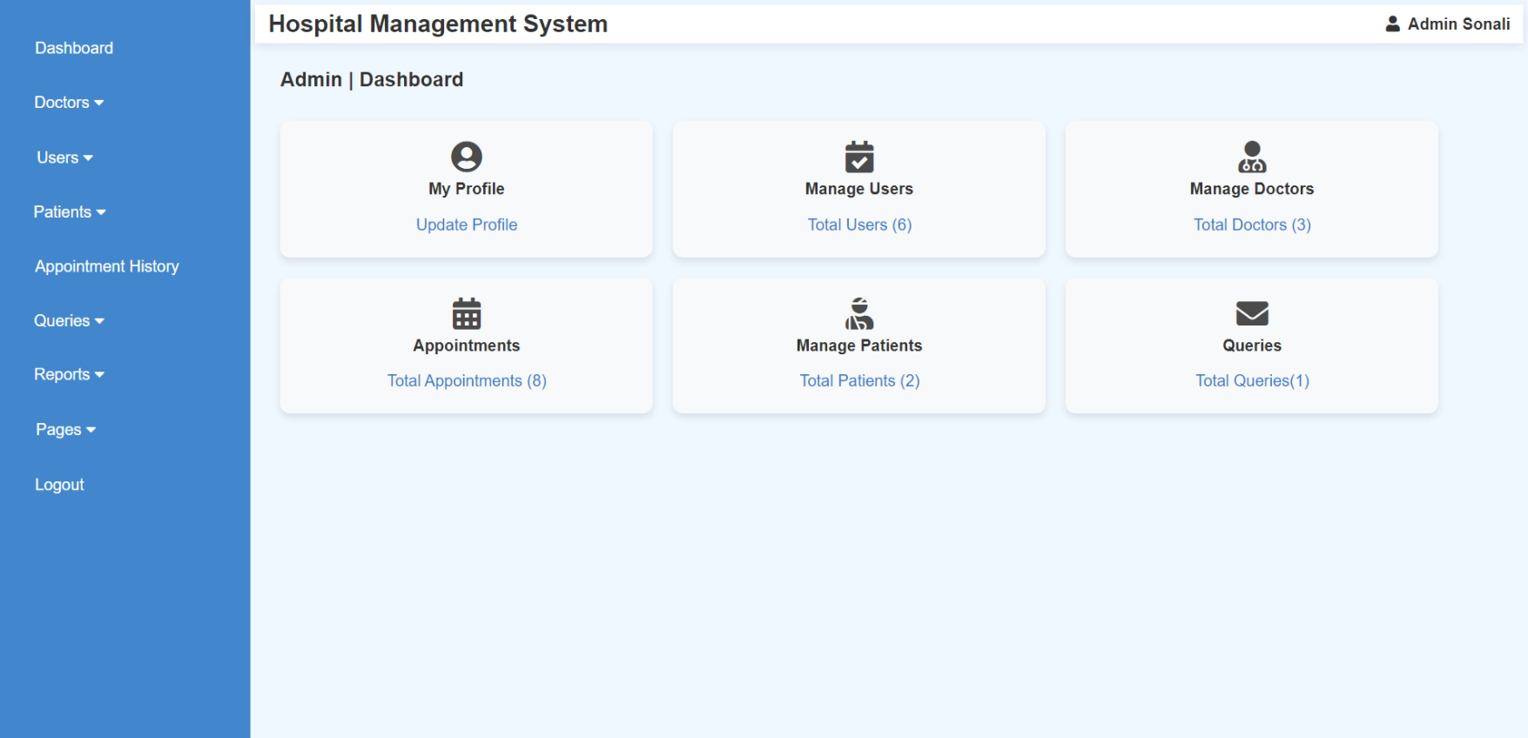

<?php

include("admin_header.php");

include('database.php');

if (!isset($_SESSION['admin_name'])) {

    header('Location: admin_login.php');

    exit();

}

$admin_name = $_SESSION['admin_name'];

$patientCount = 0;

$doctorCount = 0;

$appointmentCount = 0;

$queryCount = 0;

try {

    $result = $conn->query("SELECT COUNT(*) AS total FROM patient_mast");

    $userCount = $result->fetch_assoc()['total'];

    $result = $conn->query("SELECT COUNT(*) AS total FROM doctor_mast");

    $doctorCount = $result->fetch_assoc()['total'];

    $result = $conn->query("SELECT COUNT(*) AS total FROM appointment");

    $appointmentCount = $result->fetch_assoc()['total'];

    $result = $conn->query("SELECT COUNT(*) AS total FROM patient_detail");

    $patientCount = $result->fetch_assoc()['total'];

    $result = $conn->query("SELECT COUNT(*) AS total FROM contactus");

    $queryCount = $result->fetch_assoc()['total'];

} catch (Exception $e) {

    echo "Error: " . $e->getMessage();

}

?>

<section class="dashboard">

    <h3 style="margin-left: 2%; font-size:20px;">Admin | Dashboard</h3>

    <br>

    <div class="cards" style="display: flex; flex-wrap: wrap; gap: 20px; margin-left: 2%;">

        <div class="card" style="text-align: center; padding: 20px; background: #f8f9fa; border-radius: 10px; box-shadow: 0 4px 8px rgba(0, 0, 0, 0.1);">

            <i class="fas fa-user-circle fa-2x" style="opacity: 0.9;"></i><br>

            <h4>My Profile</h4>

            <a href="admin_account.php">Update Profile</a>

        </div>

        <div class="card" style="text-align: center; padding: 20px; background: #f8f9fa; border-radius: 10px; box-shadow: 0 4px 8px rgba(0, 0, 0, 0.1);">

            <i class="fas fa-calendar-check fa-2x" style="opacity: 0.9;"></i>

            <h4>Manage Users</h4>

            <a href="a_manage_user.php">Total Users (<?= $userCount ?>)</a>

        </div>

        <div class="card" style="text-align: center; padding: 20px; background: #f8f9fa; border-radius: 10px; box-shadow: 0 4px 8px rgba(0, 0, 0, 0.1);">

            <i class="fas fa-user-md fa-2x" style="opacity: 0.9;"></i>

            <h4>Manage Doctors</h4>

            <a href="a_manage_doctor.php">Total Doctors (<?= $doctorCount ?>)</a>

        </div>

        <div class="card" style="text-align: center; padding: 20px; background: #f8f9fa; border-radius: 10px; box-shadow: 0 4px 8px rgba(0, 0, 0, 0.1);">

            <i class="fas fa-calendar-alt fa-2x" style="opacity: 0.9;"></i>

            <h4>Appointments</h4>

            <a href="a_appointment_history.php">Total Appointments (<?= $appointmentCount ?>)</a>

        </div>

        <div class="card" style="text-align: center; padding: 20px; background: #f8f9fa; border-radius: 10px; box-shadow: 0 4px 8px rgba(0, 0, 0, 0.1);">

            <i class="fas fa-user-injured fa-2x" style="opacity: 0.9;"></i>

            <h4>Manage Patients</h4>

            <a href="a_manage_patient.php">Total Patients (<?= $patientCount ?>)</a>

        </div>

        <div class="card" style="text-align: center; padding: 20px; background: #f8f9fa; border-radius: 10px; box-shadow: 0 4px 8px rgba(0, 0, 0, 0.1);">

            <i class="fas fa-envelope fa-2x" style="opacity: 0.9;"></i>

            <h4>Queries</h4>

            <a href="a_read_query.php">Total Queries(<?= $queryCount ?>)</a>

        </div>

    </div>

</section>

</body>

</html>

**Admin (Manage Doctor)**

* **Add Specialization**

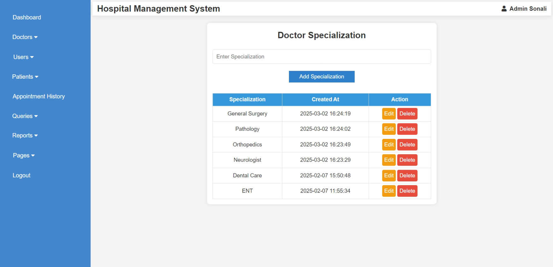

<?php

ob_start();

include("admin_header.php");

include("database.php");

if ($_SERVER["REQUEST_METHOD"] == "POST" && isset($_POST['add_specialization'])) {

$specialization = mysqli_real_escape_string($conn, $_POST['specialization']);

if (!empty($specialization)) {

$query = "INSERT INTO specilization (specilization) VALUES ('$specialization')";

mysqli_query($conn, $query);

}

}

if ($_SERVER["REQUEST_METHOD"] == "POST" && isset($_POST['update_specialization'])) {

$s_id = intval($_POST['s_id']);

$updated_specialization = mysqli_real_escape_string($conn, $_POST['updated_specialization']);

if (!empty($updated_specialization)) {

$update_query = "UPDATE specilization SET specilization='$updated_specialization' WHERE s_id=$s_id";

mysqli_query($conn, $update_query);

header("Location: dr_specialization.php");

exit();

}

}

if (isset($_GET['delete_id'])) {

$s_id = intval($_GET['delete_id']);

$delete_query = "DELETE FROM specilization WHERE s_id = $s_id";

mysqli_query($conn, $delete_query);

header("Location: dr_specialization.php");

exit();

}

$query = "SELECT * FROM specilization ORDER BY created_at DESC";

$result = mysqli_query($conn, $query);

ob_end_flush();

?>

<!DOCTYPE html>

<html lang="en">

<head>

<meta charset="UTF-8">

<meta name="viewport" content="width=device-width, initial-scale=1.0">

<title>Doctor Specialization</title>

<link rel="stylesheet" href="css/doctor_appointments.css">

<script>

function showEditForm(id, specialization) {

document.getElementById("edit-form").style.display = "block";

document.getElementById("s_id").value = id;

document.getElementById("updated_specialization").value = specialization;

}

</script>

</head>

<body>

<div class="container">

<h2>Doctor Specialization</h2>

<form method="POST">

<input type="text" name="specialization" placeholder="Enter Specialization" required>

<div class="btn-container">

<button type="submit" name="add_specialization" class="btn btn-add">Add Specialization</button>

</div>

</form>

<table>

<tr>

<th>Specialization</th>

<th>Created At</th>

<th>Action</th>

</tr>

<?php while ($row = mysqli_fetch_assoc($result)) { ?>

<tr>

<td><?php echo $row['specilization']; ?></td>

<td><?php echo $row['created_at']; ?></td>

<td>

<a href="javascript:void(0);" class="btn btn-edit" onclick="showEditForm('<?php echo $row['s_id']; ?>', '<?php echo htmlspecialchars($row['specilization']); ?>')">Edit</a>

<a href="dr_specialization.php?delete_id=<?php echo $row['s_id']; ?>" class="btn btn-delete" onclick="return confirm('Are you sure?');">Delete</a>

</td>

</tr>

<?php } ?>

</table>

<div id="edit-form" class="edit-form">

<h3>Edit Specialization</h3>

<form method="POST">

<input type="hidden" name="s_id" id="s_id">

<input type="text" name="updated_specialization" id="updated_specialization" required>

<button type="submit" name="update_specialization" class="btn btn-edit">Update</button>

</form>

</div>

</div>

</body>

</html>

* **Add Doctor**

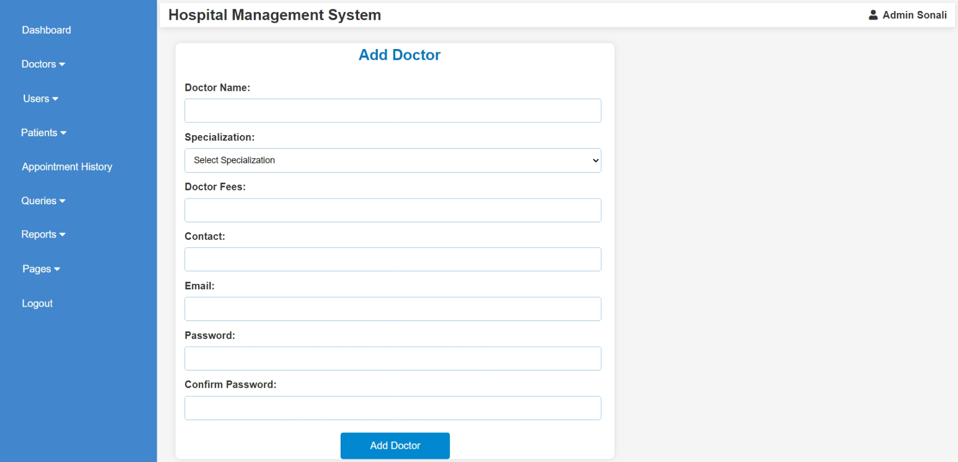

<?php

include("database.php");

include("admin_header.php");

if ($_SERVER["REQUEST_METHOD"] == "POST") {

    $name = $_POST['name'];

    $specilization = $_POST['specilization'];

    $docfees = $_POST['docfees'];

    $contact = $_POST['contact'];

    $email = $_POST['email'];

    $password = $_POST['password'];

    $confirm_password = $_POST['confirm_password'];

    if ($password !== $confirm_password) {

        echo "<script>alert('Passwords do not match!');</script>";

    } else {

        $sql = "INSERT INTO doctor_mast (name, specilization, docfees, contact, email, password)

                VALUES ('$name', '$specilization', '$docfees', '$contact', '$email', '$password')";

        if (mysqli_query($conn, $sql)) {

            echo "<script>alert('Doctor added successfully!');</script>";

        } else {

            echo "<script>alert('Error: " . mysqli_error($conn) . "');</script>";

        }

    }

}

?>

<!DOCTYPE html>

<html lang="en">

<head>

    <meta charset="UTF-8">

    <meta name="viewport" content="width=device-width, initial-scale=1.0">

    <title>Add Doctor</title>

    <style>

        body {

            font-family: Arial, sans-serif;

            background: #f5f5f5;

            display: flex;

            justify-content: center;

            align-items: center;

            height: 100vh;

            margin: 0;

        }

        .form-container {

            background: white;

            border-radius: 8px;

            box-shadow: 0px 0px 10px rgba(0, 0, 0, 0.1);

            width: 700px;

            text-align: center;

            margin-top: 2%;

            margin-left: 2%;

        }

        .form-title {

            color: #0277bd;

            margin-bottom: 20px;

            margin-left: 2%;

        }

        .form-label {

            display: block;

            margin-top: 10px;

            font-weight: bold;

            text-align: left;

            margin-left: 2%;

        }

        .form-input, .form-select {

            width: 95%;

            padding: 10px;

            margin-top: 5px;

            border: 1px solid #90caf9;

            border-radius: 4px;

            font-size: 14px;

            margin-left: -1%;

        }

        .form-button {

            width: 25%;

            padding: 12px;

            background: #0288d1;

            color: white;

            border: none;

            border-radius: 4px;

            margin-top: 20px;

            cursor: pointer;

            font-size: 16px;

        }

        .form-button:hover {

            background: #01579b;

        }

        .form-message {

            text-align: center;

            font-size: 16px;

            margin-top: 10px;

            color: red;

        }

    </style>

</head>

<body>

<div class="form-container">

    <h2 class="form-title">Add Doctor</h2>

    <form method="POST">

        <label class="form-label">Doctor Name:</label>

        <input type="text" name="name" class="form-input" required>

        <label class="form-label">Specialization:</label>

        <select name="specilization" class="form-select" required>

            <option value="">Select Specialization</option>

            <?php

            $result = mysqli_query($conn, "SELECT DISTINCT specilization FROM specilization");

            while ($row = mysqli_fetch_assoc($result)) {

                echo "<option value='" . $row['specilization'] . "'>" . $row['specilization'] . "</option>";

            }

            ?>

        </select>

        <label class="form-label">Doctor Fees:</label>

        <input type="number" name="docfees" class="form-input" required>

        <label class="form-label">Contact:</label>

        <input type="text" name="contact" class="form-input" required>

        <label class="form-label">Email:</label>

        <input type="email" name="email" class="form-input" required>

        <label class="form-label">Password:</label>

        <input type="password" name="password" class="form-input" required>

        <label class="form-label">Confirm Password:</label>

        <input type="password" name="confirm_password" class="form-input" required>

        <button type="submit" class="form-button">Add Doctor</button>

    </form>

</div>

</body>

</html>

* **Manage Doctor (Edit Doctor Details)**

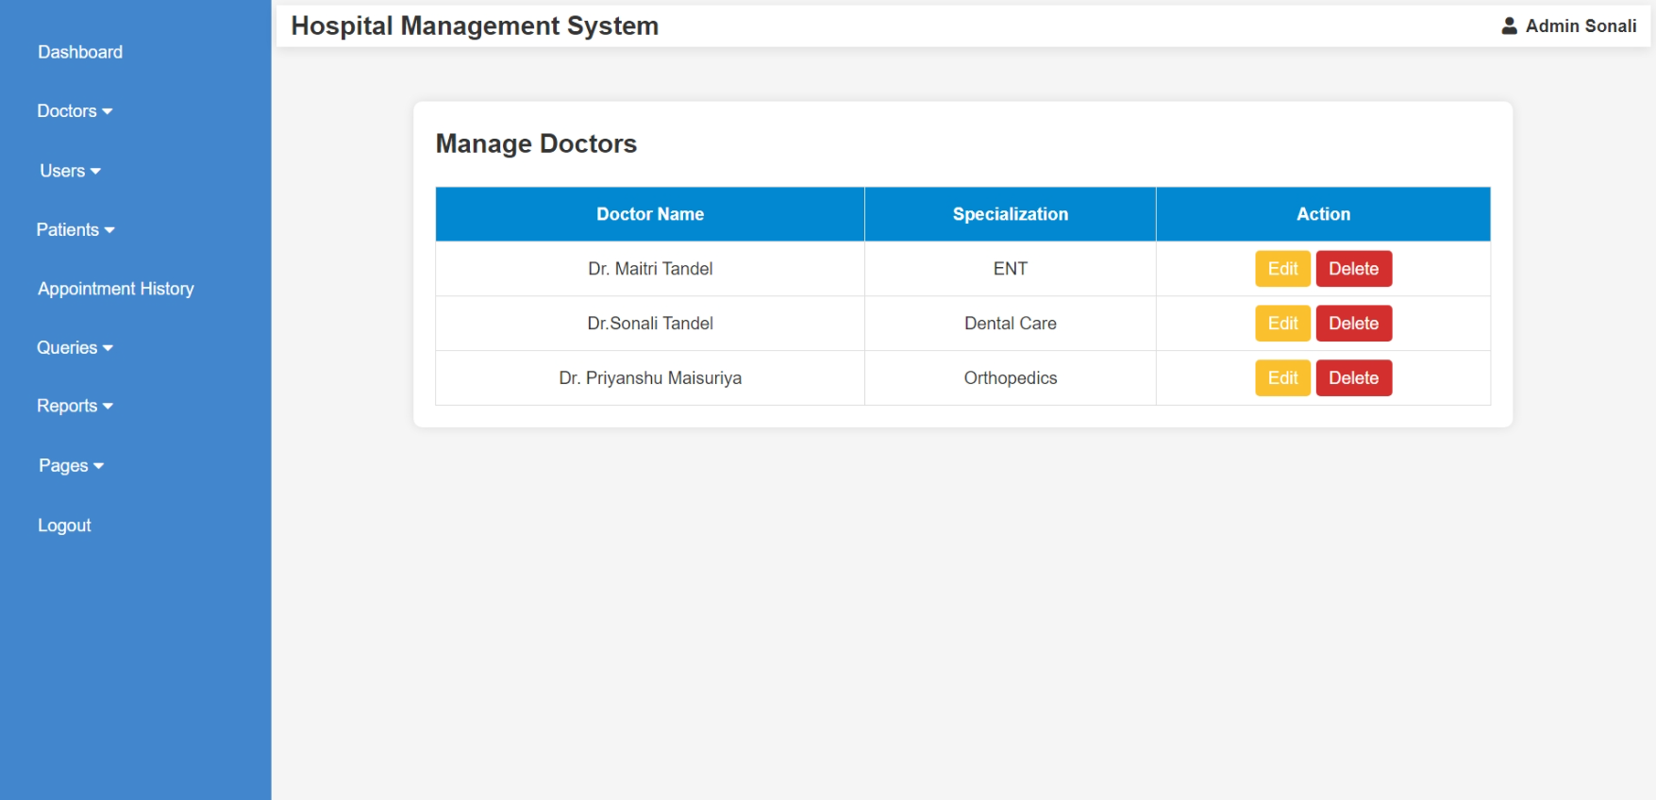

<?php

include("database.php");

include("admin_header.php");

$sql = "SELECT d_id, name, specilization FROM doctor_mast";

$result = mysqli_query($conn, $sql);

?>

<!DOCTYPE html>

<html lang="en">

<head>

    <meta charset="UTF-8">

    <meta name="viewport" content="width=device-width, initial-scale=1.0">

    <title>Manage Doctors</title>

    <style>

        body {

            font-family: Arial, sans-serif;

            background: #f5f5f5;

        }

        .table-container {

            width: 80%;

            margin: auto;

            background: white;

            padding: 20px;

            border-radius: 8px;

            box-shadow: 0px 0px 10px rgba(0, 0, 0, 0.1);

            margin-top: 50px;

        }

        table {

            width: 100%;

            border-collapse: collapse;

            margin-top: 20px;

        }

        th, td {

            padding: 12px;

            border: 1px solid #ddd;

            text-align: center;

        }

        th {

            background: #0288d1;

            color: white;

        }

        .action-btn {

            padding: 8px 12px;

            color: white;

            border: none;

            border-radius: 4px;

            cursor: pointer;

            text-decoration: none;

        }

        .edit-btn {

            background: #fbc02d;

        }

        .delete-btn {

            background: #d32f2f;

        }

        .edit-btn:hover {

            background: #f57f17;

        }

        .delete-btn:hover {

            background: #b71c1c;

        }

    </style>

</head>

<body>

    <div class="table-container">

        <h2>Manage Doctors</h2>

        <table>

            <tr>

                <th>Doctor Name</th>

                <th>Specialization</th>

                <th>Action</th>

            </tr>

            <?php while ($row = mysqli_fetch_assoc($result)) { ?>

                <tr>

                    <td><?= $row['name'] ?></td>

                    <td><?= $row['specilization'] ?></td>

                    <td>

                        <a href="a_edit_doctor.php?d_id=<?= $row['d_id'] ?>" class="action-btn edit-btn">Edit</a>

                        <a href="a_delete_doctor.php?d_id=<?= $row['d_id'] ?>" class="action-btn delete-btn" onclick="return confirm('Are you sure you want to delete this doctor?');">Delete</a>

                    </td>

                </tr>

            <?php } ?>

        </table>

    </div>

</body>

</html>

* + **Edit Doctor Details**

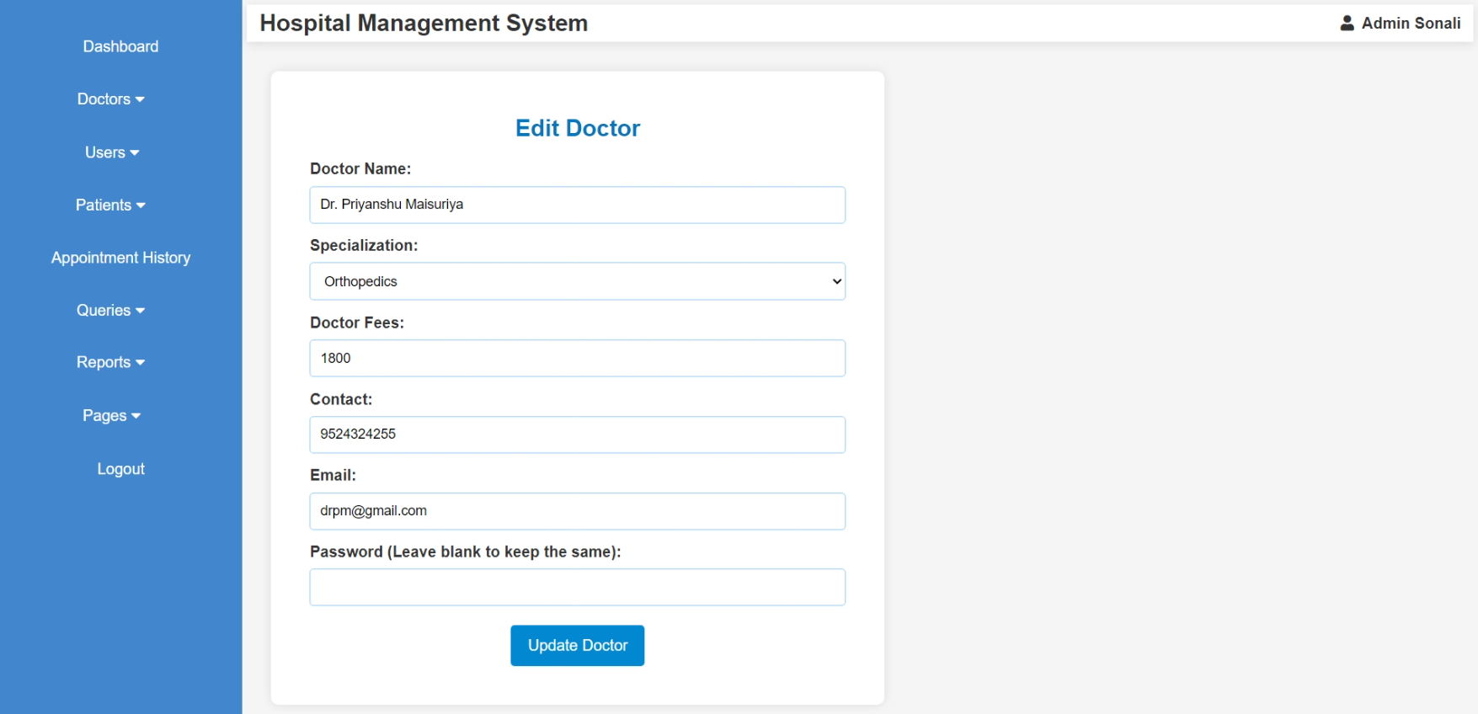

<?php

include("database.php");

include("admin_header.php");

if (isset($_GET['d_id'])) {

    $d_id = $_GET['d_id'];

    $query = "SELECT * FROM doctor_mast WHERE d_id = $d_id";

    $result = mysqli_query($conn, $query);

    $doctor = mysqli_fetch_assoc($result);

}

if ($_SERVER["REQUEST_METHOD"] == "POST") {

    $name = $_POST['name'];

    $specilization = $_POST['specilization'];

    $docfees = $_POST['docfees'];

    $contact = $_POST['contact'];

    $email = $_POST['email'];

    $password = $_POST['password'];

    $password_query = $password ? ", password='" . password_hash($password, PASSWORD_DEFAULT) . "'" : "";

    $update_sql = "UPDATE doctor_mast SET

                    name='$name',

                    specilization='$specilization',

                    docfees='$docfees',

                    contact='$contact',

                    email='$email'

                    $password_query

                    WHERE d_id=$d_id";

    if (mysqli_query($conn, $update_sql)) {

        echo "<script>alert('Doctor updated successfully!'); window.location.href='a_manage_doctor.php';</script>";

    } else {

        echo "<script>alert('Error updating doctor: " . mysqli_error($conn) . "');</script>";

    }

}

?>

<!DOCTYPE html>

<html lang="en">

<head>

    <meta charset="UTF-8">

    <meta name="viewport" content="width=device-width, initial-scale=1.0">

    <title>Edit Doctor</title>

    <style>

        body {

            font-family: Arial, sans-serif;

            background: #f5f5f5;

            text-align: center;

        }

        .form-container {

            background: white;

            padding: 40px;

            border-radius: 8px;

            box-shadow: 0px 0px 10px rgba(0, 0, 0, 0.1);

            width: 400px;

            margin: auto;

            margin-top: 30px;

            width: 50%;

            margin-left: 2%;

        }

        .form-title {

            color: #0277bd;

        }

        .form-label {

            display: block;

            text-align: left;

            font-weight: bold;

            margin-top: 10px;

        }

        .form-input, .form-select {

            width: 100%;

            padding: 10px;

            margin-top: 5px;

            border: 1px solid #90caf9;

            border-radius: 4px;

            font-size: 14px;

        }

        .form-button {

            width: 25%;

            padding: 12px;

            background: #0288d1;

            color: white;

            border: none;

            border-radius: 4px;

            margin-top: 20px;

            cursor: pointer;

            font-size: 16px;

        }

        .form-button:hover {

            background: #01579b;

        }

    </style>

</head>

<body>

    <div class="form-container">

        <h2 class="form-title">Edit Doctor</h2>

        <form method="POST">

            <label class="form-label">Doctor Name:</label>

            <input type="text" name="name" class="form-input" value="<?= $doctor['name'] ?>" required>

            <label class="form-label">Specialization:</label>

            <select name="specilization" class="form-select" required>

                <option value="">Select Specialization</option>

                <?php

                $result = mysqli_query($conn, "SELECT DISTINCT specilization FROM specilization");

                while ($row = mysqli_fetch_assoc($result)) {

                    $selected = ($row['specilization'] == $doctor['specilization']) ? "selected" : "";

                    echo "<option value='" . $row['specilization'] . "' $selected>" . $row['specilization'] . "</option>";

                }

                ?>

            </select>

            <label class="form-label">Doctor Fees:</label>

            <input type="number" name="docfees" class="form-input" value="<?= $doctor['docfees'] ?>" required>

            <label class="form-label">Contact:</label>

            <input type="text" name="contact" class="form-input" value="<?= $doctor['contact'] ?>" required>

            <label class="form-label">Email:</label>

            <input type="email" name="email" class="form-input" value="<?= $doctor['email'] ?>" required>

            <label class="form-label">Password (Leave blank to keep the same):</label>

            <input type="password" name="password" class="form-input">

            <button type="submit" class="form-button">Update Doctor</button>

        </form>

    </div>

</body>

</html>

**Admin (Manage User)**

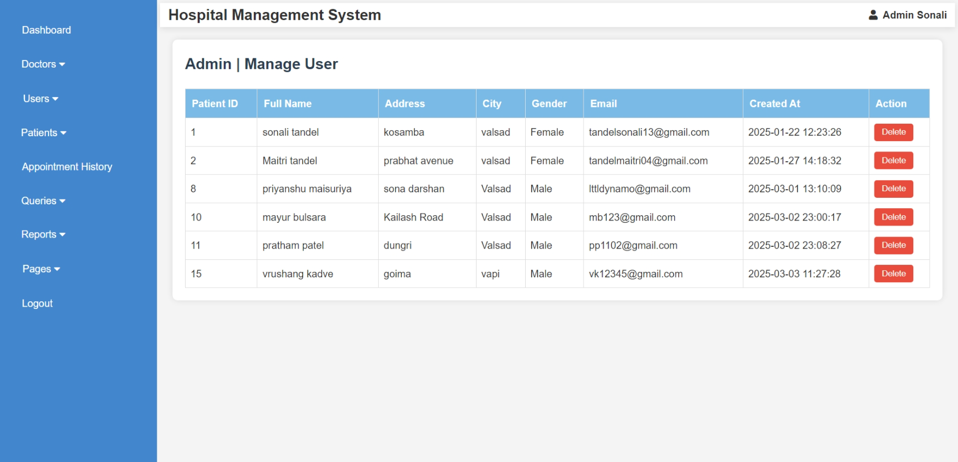

<?php

    include("admin_header.php");

    include('database.php');

    if (isset($_POST['delete']) && isset($_POST['p_id'])) {

        $p_id = $_POST['p_id'];

        $p_id = mysqli_real_escape_string($conn, $p_id);

        $query = "DELETE FROM patient_mast WHERE p_id = '$p_id'";

        $result = mysqli_query($conn, $query);

        if ($result) {

            echo "";

        } else {

            echo "<p>Error deleting patient: " . mysqli_error($conn) . "</p>";

        }

    }

    $query = "SELECT * FROM patient_mast";

    $result = mysqli_query($conn, $query);

?>

<style>

    body {

        font-family: Arial, sans-serif;

        background-color: #f4f4f4;

        margin: 0;

        padding: 0;

    }

    section.dashboard {

        margin: 20px;

        padding: 20px;

        background-color: #fff;

        border-radius: 8px;

        box-shadow: 0 0 10px rgba(0, 0, 0, 0.1);

    }

    h3 {

        color: #2c3e50;

        font-size: 24px;

        margin-bottom: 20px;

    }

    table {

        width: 100%;

        border-collapse: collapse;

        margin-top: 20px;

    }

    table, th, td {

        border: 1px solid #ddd;

    }

    th {

        background-color:rgb(121, 187, 230);

        color: white;

        padding: 10px;

        text-align: left;

    }

    td {

        padding: 8px;

        text-align: left;

    }

    td input[type="submit"] {

        background-color: #e74c3c;

        color: white;

        border: none;

        padding: 6px 12px;

        cursor: pointer;

        border-radius: 4px;

        transition: background-color 0.3s ease;

    }

    td input[type="submit"]:hover {

        background-color: #c0392b;

    }

    @media screen and (max-width: 768px) {

        table, th, td {

            font-size: 14px;

        }

        td input[type="submit"] {

            padding: 4px 8px;

        }

    }

</style>

<section class="dashboard">

<h3>Admin | Manage User</h3>

<table border="1">

<thead>

    <tr>

        <th>Patient ID</th>

        <th>Full Name</th>

        <th>Address</th>

        <th>City</th>

        <th>Gender</th>

        <th>Email</th>

        <th>Created At</th>

        <th>Action</th>

    </tr>

</thead>

<tbody>

    <?php

    if (mysqli_num_rows($result) > 0) {

        while ($row = mysqli_fetch_assoc($result)) {

            echo "<tr>

                    <td>{$row['p_id']}</td>

                    <td>{$row['fullname']}</td>

                    <td>{$row['address']}</td>

                    <td>{$row['city']}</td>

                    <td>{$row['gender']}</td>

                    <td>{$row['email']}</td>

                    <td>{$row['created_at']}</td>

                    <td>

                        <form method='POST' action='' onsubmit='return confirmDelete()' style='display:inline;'>

                            <input type='hidden' name='p_id' value='{$row['p_id']}'>

                            <input type='submit' name='delete' value='Delete'>

                        </form>

                    </td>

                </tr>";

        }

    } else {

        echo "<tr><td colspan='8'>No patients found.</td></tr>";

    }

    ?>

</tbody>

</table>

</section>

<script>

    function confirmDelete() {

        return confirm('Are you sure you want to delete this patient?');

    }

</script>

</body>

</html>

**Admin (Manage Patient & View Patient Detail)**

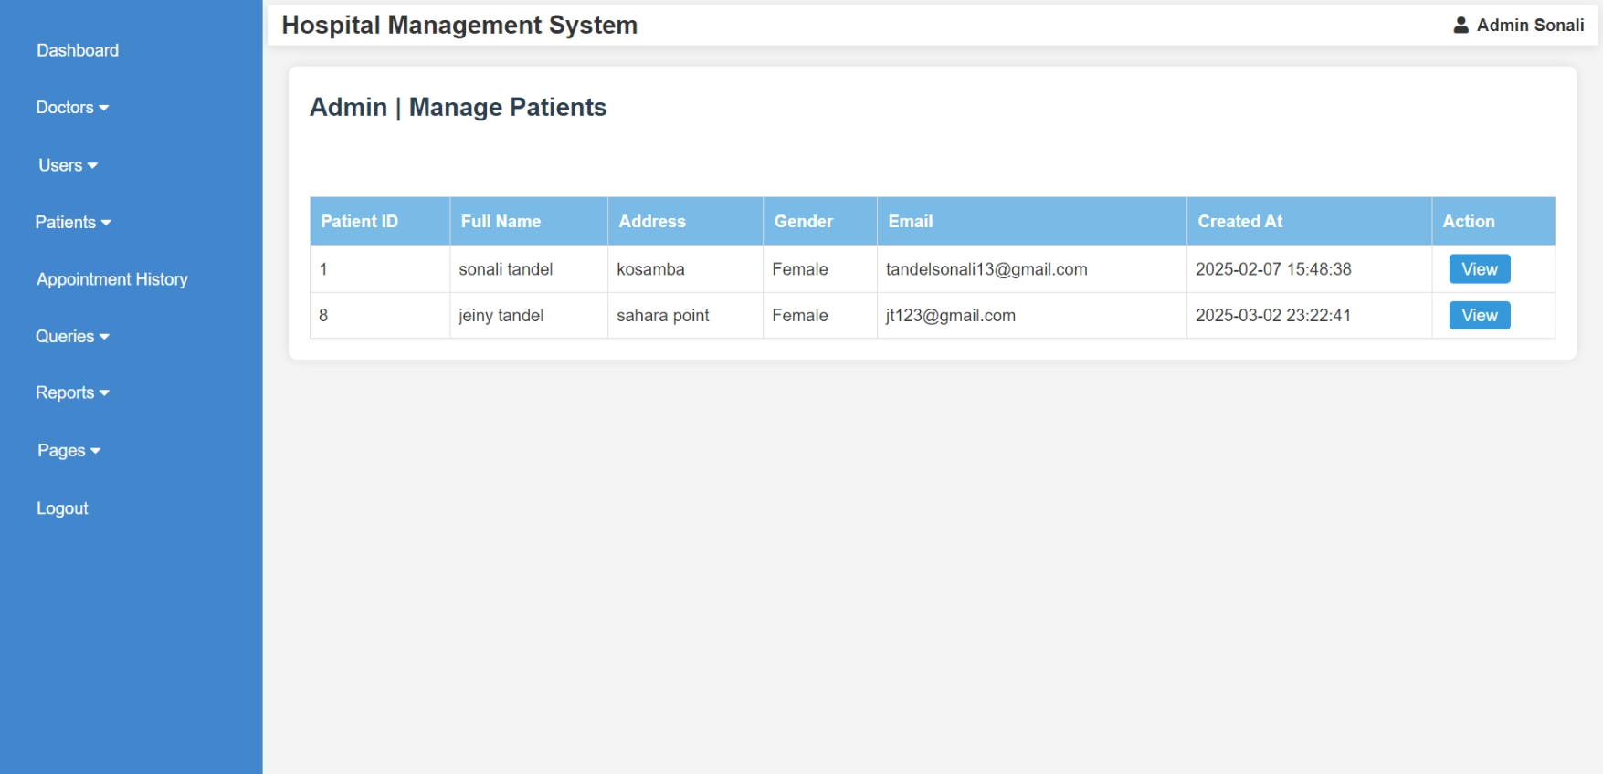

<?php

include("admin_header.php");

include('database.php');

if (!isset($_SESSION['admin_id'])) {

    header('Location: admin_login.php');

    exit;

}

$admin_id = intval($_SESSION['admin_id']);

$query = "SELECT DISTINCT p_detail_id, p_name, p_add, p_email, p_gender, created_at

          FROM patient_detail ";

$result = mysqli_query($conn, $query);

?>

<!DOCTYPE html>

<html lang="en">

<head>

    <meta charset="UTF-8">

    <meta name="viewport" content="width=device-width, initial-scale=1.0">

    <title>Manage Patients</title>

    <style>

        body {

            font-family: Arial, sans-serif;

            background-color: #f4f4f4;

            margin: 0;

            padding: 0;

        }

        section.dashboard {

            margin: 20px;

            padding: 20px;

            background-color: #fff;

            border-radius: 8px;

            box-shadow: 0 0 10px rgba(0, 0, 0, 0.1);

        }

        h3 {

            color: #2c3e50;

            font-size: 24px;

            margin-bottom: 20px;

        }

        table {

            width: 100%;

            border-collapse: collapse;

            margin-top: 20px;

        }

        table, th, td {

            border: 1px solid #ddd;

        }

        th {

            background-color: rgb(121, 187, 230);

            color: white;

            padding: 10px;

            text-align: left;

        }

        td {

            padding: 8px;

            text-align: left;

        }

        td input[type="submit"] {

            background-color: #e74c3c;

            color: white;

            border: none;

            padding: 6px 12px;

            cursor: pointer;

            border-radius: 4px;

            transition: background-color 0.3s ease;

        }

        td input[type="submit"]:hover {

            background-color: #c0392b;

        }

        .view-btn, .edit-btn {

            background-color: #3498db;

            color: white;

            padding: 1px 12px;

            text-decoration: none;

            border-radius: 4px;

            margin-left: 8px;

            display: inline-block;

        }

        .edit-btn {

            background-color: #f39c12;

        }

        @media screen and (max-width: 768px) {

            table, th, td {

                font-size: 14px;

            }

            td input[type="submit"] {

                padding: 4px 8px;

            }

        }

    </style>

</head>

<body>

<section class="dashboard">

<h3>Admin | Manage Patients</h3><br>

<table border="1">

<thead>

    <tr>

        <th>Patient ID</th>

        <th>Full Name</th>

        <th>Address</th>

        <th>Gender</th>

        <th>Email</th>

        <th>Created At</th>

        <th>Action</th>

    </tr>

</thead>

<tbody>

    <?php

    if ($result && mysqli_num_rows($result) > 0) {

        while ($row = mysqli_fetch_assoc($result)) {

            echo "<tr>

                    <td>{$row['p_detail_id']}</td>

                    <td>{$row['p_name']}</td>

                    <td>{$row['p_add']}</td>

                    <td>{$row['p_gender']}</td>

                    <td>{$row['p_email']}</td>

                    <td>{$row['created_at']}</td>

                    <td>

                        <a href='a_view_patient.php?p_detail_id={$row['p_detail_id']}' class='view-btn'>View</a>

                    </td>

                </tr>";

        }

    } else {

        echo "<tr><td colspan='7'>No patients found.</td></tr>";

    }

    ?>

</tbody>

</table>

</section>

<script>

    function confirmDelete() {

        return confirm('Are you sure you want to delete this patient?');

    }

</script>

</body>

</html>

* + **View Patient Details**

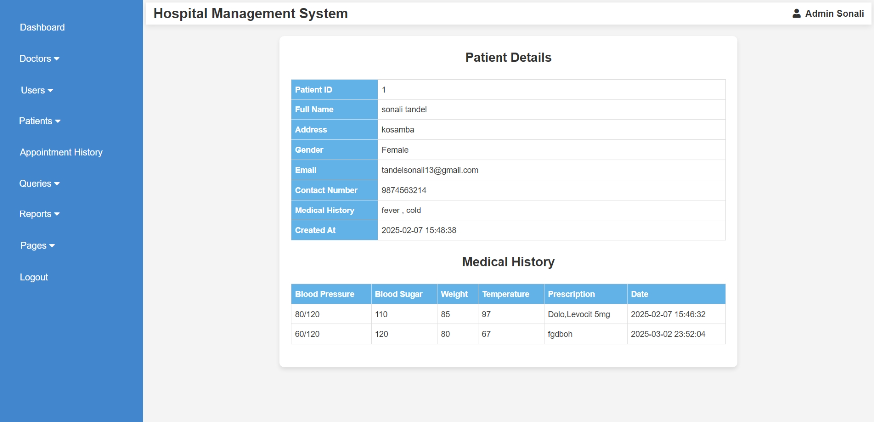

<?php

ob_start();

include("admin_header.php");

include('database.php');

if (!isset($_SESSION['admin_id'])) {

    header('Location:admin_login.php');

    exit;

}

$admin_id = intval($_SESSION['admin_id']);

if (isset($_GET['p_detail_id'])) {

    $p_detail_id = intval($_GET['p_detail_id']);

    $query = "SELECT * FROM patient_detail WHERE p_detail_id = '$p_detail_id'";

    $result = mysqli_query($conn, $query);

    if ($result && mysqli_num_rows($result) > 0) {

        $row = mysqli_fetch_assoc($result);

    } else {

        echo "<p>Patient not found or access denied.</p>";

        exit;

    }

} else {

    echo "<p>Invalid request.</p>";

    exit;

}

ob_end_flush();

?>

<!DOCTYPE html>

<html lang="en">

<head>

    <meta charset="UTF-8">

    <meta name="viewport" content="width=device-width, initial-scale=1.0">

    <title>Patient Details</title>

    <style>

    body {

        font-family: Arial, sans-serif;

        background-color: #f4f4f4;

        margin: 0;

        padding: 0;

    }

    .container {

        background: #fff;

        padding: 20px;

        border-radius: 8px;

        box-shadow: 0 4px 8px rgba(0, 0, 0, 0.1);

        max-width: 800px;

        width: 100%;

        margin: 20px auto;

    }

    h3 {

        text-align: center;

        color: #333;

        font-size: 22px;

        margin-bottom: 20px;

    }

    table {

        width: 100%;

        border-collapse: collapse;

        margin-bottom: 20px;

    }

    th, td {

        border: 1px solid #ddd;

        padding: 6px;

        font-size: 14px;

        text-align: left;

    }

    th {

        background-color: rgb(99, 178, 231);

        color: white;

        font-weight: bold;

    }

    .toggle-btn {

        display: block;

        margin: 20px auto;

        padding: 10px 16px;

        background-color: #3498db;

        color: white;

        border: none;

        border-radius: 4px;

        cursor: pointer;

        font-size: 16px;

        transition: 0.3s;

    }

    .toggle-btn:hover {

        background-color: #2980b9;

    }

    @media (max-width: 600px) {

        .container {

            padding: 15px;

        }

        th, td {

            padding: 8px;

        }

        .toggle-btn {

            width: 100%;

        }

    }

    </style>

</head>

<body>

<div class="container">

    <h3>Patient Details</h3>

    <table>

        <tr><th style="width: 20%;">Patient ID</th><td><?php echo $row['p_detail_id']; ?></td></tr>

        <tr><th>Full Name</th><td><?php echo $row['p_name']; ?></td></tr>

        <tr><th>Address</th><td><?php echo $row['p_add']; ?></td></tr>

        <tr><th>Gender</th><td><?php echo $row['p_gender']; ?></td></tr>

        <tr><th>Email</th><td><?php echo $row['p_email']; ?></td></tr>

        <tr><th>Contact Number</th><td><?php echo $row['contact_no']; ?></td></tr>

        <tr><th>Medical History</th><td><?php echo $row['p_medhis']; ?></td></tr>

        <tr><th>Created At</th><td><?php echo $row['created_at']; ?></td></tr>

    </table>

    <h3>Medical History</h3>

    <?php

    $medical_query = "SELECT * FROM medical_history WHERE p_detail_id = '$p_detail_id'";

    $medical_result = mysqli_query($conn, $medical_query);

    if (mysqli_num_rows($medical_result) > 0) { ?>

        <table>

            <tr>

                <th>Blood Pressure</th>

                <th>Blood Sugar</th>

                <th>Weight</th>

                <th>Temperature</th>

                <th>Prescription</th>

                <th>Date</th>

            </tr>

            <?php while ($med_row = mysqli_fetch_assoc($medical_result)) { ?>

                <tr>

                    <td><?php echo $med_row['bp']; ?></td>

                    <td><?php echo $med_row['bs']; ?></td>

                    <td><?php echo $med_row['weight']; ?></td>

                    <td><?php echo $med_row['temperature']; ?></td>

                    <td><?php echo $med_row['m_prescription']; ?></td>

                    <td><?php echo $med_row['created_at']; ?></td>

                </tr>

            <?php } ?>

        </table>

    <?php } else { ?>

        <p>No medical history available.</p>

    <?php } ?>

</div>

</body>

</html>

**Admin View Appointment History**

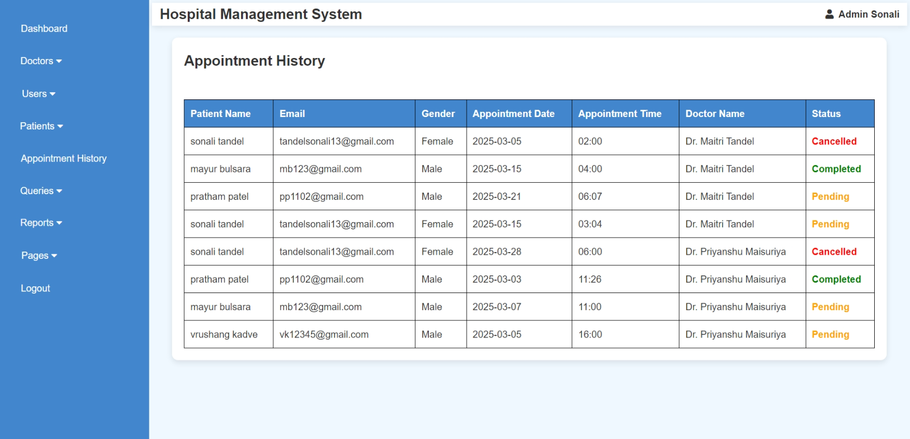 <?php

    include("admin_header.php");

    include('database.php');

    if (!isset($_SESSION['admin_id'])) {

        header('Location: admin_login.php');

        exit;

    }

    $query = "SELECT a.a_id, p.fullname AS patient_name, p.email, p.gender, a.a_date, a.a_time, a.d_status,

                     d.name AS doctor_name

              FROM appointment a

              JOIN patient_mast p ON a.p_id = p.p_id

              JOIN doctor_mast d ON a.d_id = d.d_id";

    $result = mysqli_query($conn, $query);

?>

<!DOCTYPE html>

<html lang="en">

<head>

    <meta charset="UTF-8">

    <meta name="viewport" content="width=device-width, initial-scale=1.0">

    <title>Appointment History</title>

    <link rel="stylesheet" href="css/style.css">

    <style>

        body {

            font-family: Arial, sans-serif;

            background-color: #f0f8ff;

        }

        .container {

            width: 98%;

            margin: 20px auto;

            background: white;

            padding: 20px;

            border-radius: 10px;

            box-shadow: 0px 4px 10px rgba(0, 0, 0, 0.1);

        }

        table {

            width: 100%;

            border-collapse: collapse;

            margin-top: 20px;

        }

        table, th, td {

            border: 1px solid black;

        }

        th, td {

            padding: 10px;

            text-align: left;

        }

        th {

            background-color: rgb(66, 134, 206);

            color: white;

        }

        .status-form select {

            padding: 5px;

        }

        .status-form button {

            padding: 5px 10px;

            background-color: #4CAF50;

            color: white;

            border: none;

            cursor: pointer;

        }

        .status-form button:hover {

            background-color: #45a049;

        }

    </style>

</head>

<body>

    <div class="container">

        <h2>Appointment History</h2><br>

        <table>

            <tr>

                <th>Patient Name</th>

                <th>Email</th>

                <th>Gender</th>

                <th>Appointment Date</th>

                <th>Appointment Time</th>

                <th>Doctor Name</th>

                <th>Status</th>

            </tr>

            <?php while ($row = mysqli_fetch_assoc($result)) { ?>

                <tr>

                    <td><?php echo htmlspecialchars($row['patient_name']); ?></td>

                    <td><?php echo htmlspecialchars($row['email']); ?></td>

                    <td><?php echo htmlspecialchars($row['gender']); ?></td>

                    <td><?php echo htmlspecialchars($row['a_date']); ?></td>

                    <td><?php echo htmlspecialchars($row['a_time']); ?></td>

                    <td><?php echo htmlspecialchars($row['doctor_name']); ?></td>

                    <td class="status-text" style="font-weight: bold;

                        <?php

                            if ($row['d_status'] == 1) {

                                echo 'color: green;';

                            } elseif ($row['d_status'] == 0) {

                                echo 'color: orange;';

                            } else {

                                echo 'color: red;';

                            }

                        ?>">

                        <?php

                            echo ($row['d_status'] == 1) ? 'Completed' :

                                (($row['d_status'] == 0) ? 'Pending' : 'Cancelled');

                        ?>

                    </td>

                </tr>

                            <?php } ?>

        </table>

    </div>

</body>

</html>

**Admin Handle Queries (Read Query)**

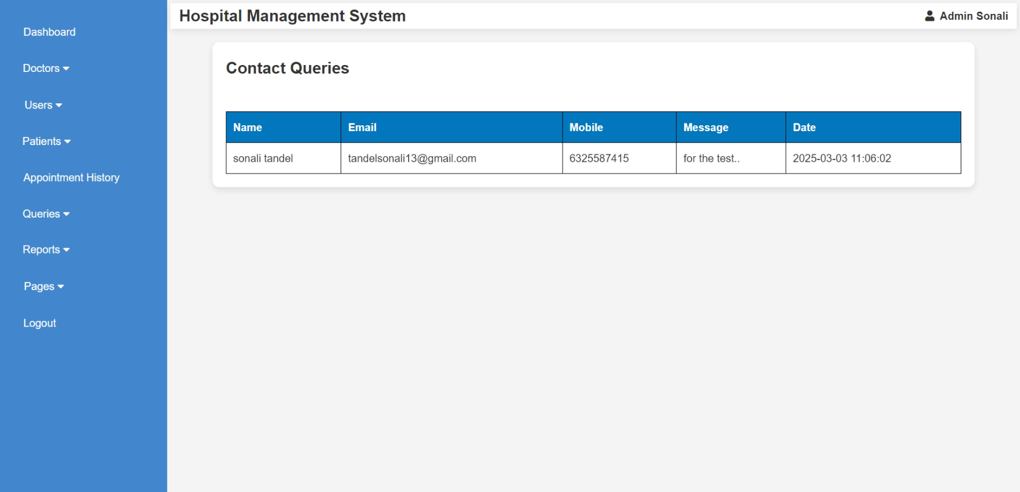 <?php

include("admin_header.php");

include("database.php");

$query = "SELECT * FROM contactus ORDER BY created_at DESC";

$result = mysqli_query($conn, $query);

?>

<!DOCTYPE html>

<html lang="en">

<head>

    <meta charset="UTF-8">

    <meta name="viewport" content="width=device-width, initial-scale=1.0">

    <title>Contact Queries</title>

    <link rel="stylesheet" href="css/style.css">

    <style>

        body {

            font-family: Arial, sans-serif;

            background-color: #f4f4f4;

        }

        .container {

            width: 90%;

            margin: 20px auto;

            background: white;

            padding: 20px;

            border-radius: 10px;

            box-shadow: 0px 4px 10px rgba(0, 0, 0, 0.1);

        }

        table {

            width: 100%;

            border-collapse: collapse;

            margin-top: 20px;

        }

        th, td {

            border: 1px solid black;

            padding: 10px;

            text-align: left;

        }

        th {

            background-color: #0277bd;

            color: white;

        }

    </style>

</head>

<body>

    <div class="container">

        <h2>Contact Queries</h2><br>

        <table>

            <tr>

                <th>Name</th>

                <th>Email</th>

                <th>Mobile</th>

                <th>Message</th>

                <th>Date</th>

            </tr>

            <?php while ($row = mysqli_fetch_assoc($result)) { ?>

                <tr>

                    <td><?php echo htmlspecialchars($row['name']); ?></td>

                    <td><?php echo htmlspecialchars($row['email']); ?></td>

                    <td><?php echo htmlspecialchars($row['mobile']); ?></td>

                    <td><?php echo htmlspecialchars($row['message']); ?></td>

                    <td class="timestamp"><?php echo htmlspecialchars($row['created_at']); ?></td>

                </tr>

            <?php } ?>

        </table>

    </div>

</body>

</html>

**Admin View Reports (B/w Dates Reports)**

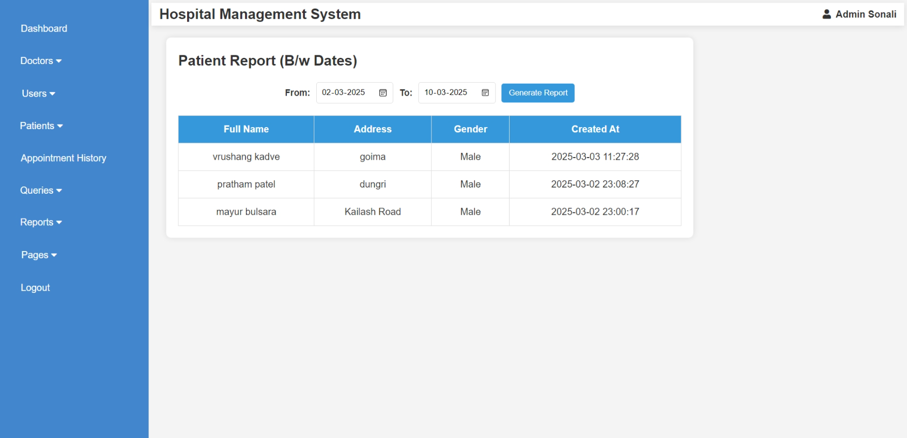<?php

include("admin_header.php");

include("database.php");

$from_date = "";

$to_date = "";

$result = null;

if ($_SERVER["REQUEST_METHOD"] == "POST" && isset($_POST['filter'])) {

    $from_date = $_POST['from_date'];

    $to_date = $_POST['to_date'];

    if (!empty($from_date) && !empty($to_date)) {

        $query = "SELECT * FROM patient_mast WHERE created_at BETWEEN ? AND ? ORDER BY created_at DESC";

        $stmt = mysqli_prepare($conn, $query);

        mysqli_stmt_bind_param($stmt, "ss", $from_date, $to_date);

        mysqli_stmt_execute($stmt);

        $result = mysqli_stmt_get_result($stmt);

    } else {

        echo "<script>alert('Please select both dates!');</script>";

    }

}

?>

<!DOCTYPE html>

<html lang="en">

<head>

    <meta charset="UTF-8">

    <meta name="viewport" content="width=device-width, initial-scale=1.0">

    <title>Patient Report (B/w Dates)</title>

    <style>

        body {

            font-family: Arial, sans-serif;

            background-color: #f4f4f4;

            margin: 0;

            padding: 0;

        }

        .container {

            width: 70%;

            margin: 20px auto;

            padding: 20px;

            background: white;

            box-shadow: 0px 0px 10px rgba(0, 0, 0, 0.1);

            border-radius: 8px;

            margin-left: 2%;

        }

        form {

            display: flex;

            justify-content: center;

            align-items: center;

            gap: 10px;

            margin-bottom: 20px;

        }

        label {

            font-size: 15px;

            font-weight: bold;

        }

        input[type="date"] {

            padding: 8px;

            border: 1px solid #ddd;

            border-radius: 4px;

        }

        button {

            padding: 8px 12px;

            background: #3498db;

            color: white;

            border: none;

            cursor: pointer;

            border-radius: 4px;

        }

        button:hover {

            opacity: 0.8;

        }

        table {

            width: 100%;

            border-collapse: collapse;

        }

        th, td {

            border: 1px solid #ddd;

            padding: 10px;

            text-align: center;

        }

        th {

            background: #3498db;

            color: white;

        }

        .no-data {

            text-align: center;

            font-size: 16px;

            color: red;

            margin-top: 10px;

        }

    </style>

</head>

<body>

<div class="container">

    <h2 style="margin-bottom: 2%;">Patient Report (B/w Dates)</h2>

    <form method="POST">

        <label>From: </label>

        <input type="date" name="from_date" value="<?php echo $from_date; ?>" required>

        <label>To: </label>

        <input type="date" name="to_date" value="<?php echo $to_date; ?>" required>

        <button type="submit" name="filter">Generate Report</button>

    </form>

    <?php if ($result && mysqli_num_rows($result) > 0) { ?>

        <table>

            <tr>

                <th>Full Name</th>

                <th>Address</th>

                <th>Gender</th>

                <th>Created At</th>

            </tr>

            <?php while ($row = mysqli_fetch_assoc($result)) { ?>

            <tr>

                <td><?php echo $row['fullname']; ?></td>

                <td><?php echo $row['address']; ?></td>

                <td><?php echo $row['gender']; ?></td>

                <td><?php echo $row['created_at']; ?></td>

            </tr>

            <?php } ?>

        </table>

    <?php } elseif ($_SERVER["REQUEST_METHOD"] == "POST") { ?>

        <p class="no-data">No records found for the selected dates.</p>

    <?php } ?>

</div>

</body>

</html>

**Admin Handle Pages**

* **Advertisement**

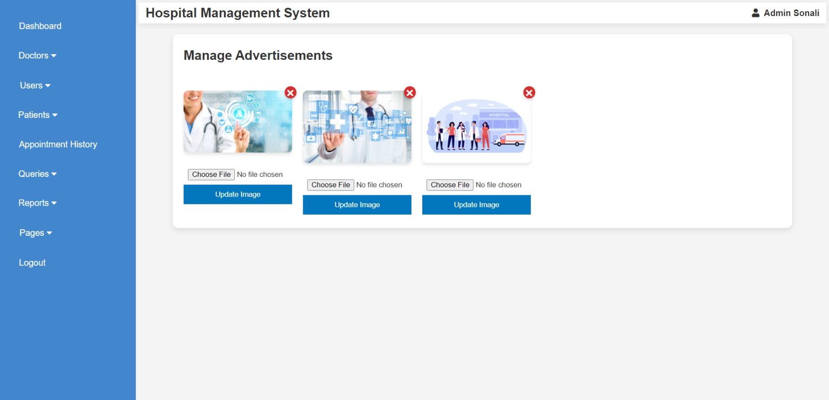<?php

ob_start();

include("admin_header.php");

include("database.php");

$ads = mysqli_query($conn, "SELECT * FROM pages WHERE type='ad'");

if ($_SERVER["REQUEST_METHOD"] == "POST" && isset($_POST['update_id']) && isset($_FILES['new_img'])) {

$id = intval($_POST['update_id']);

if (!empty($_FILES['new_img']['name'])) {

$new_img = basename($_FILES['new_img']['name']);

move_uploaded_file($_FILES['new_img']['tmp_name'], "img/" . $new_img);

$updateQuery = "UPDATE pages SET img='$new_img' WHERE id=$id AND type='ad'";

mysqli_query($conn, $updateQuery);

header("Location: a_ad.php");

exit;

}

}

if (isset($_GET['delete_id'])) {

$id = intval($_GET['delete_id']);

$deleteQuery = "DELETE FROM pages WHERE id = $id AND type='ad'";

mysqli_query($conn, $deleteQuery);

header("Location: a_ad.php");

exit;

}

ob_end_flush();

?>

<!DOCTYPE html>

<html lang="en">

<head>

<meta charset="UTF-8">

<meta name="viewport" content="width=device-width, initial-scale=1.0">

<title>Manage Advertisements</title>

<link rel="stylesheet" href="css/style.css">

<style>

body { font-family: Arial, sans-serif; background-color: #f4f4f4; }

.container { width: 90%; margin: 20px auto; background: white; padding: 20px; border-radius: 10px; box-shadow: 0px 4px 10px rgba(0, 0, 0, 0.1); }

.ads { display: flex; flex-wrap: wrap; gap: 20px; margin-top: 20px; }

.ad-item { position: relative; width: 200px; text-align: center; }

.ad-item img { width: 100%; border-radius: 8px; box-shadow: 0px 4px 6px rgba(0, 0, 0, 0.1); }

.update-form { margin-top: 10px; }

.update-form input { width: 100%; padding: 8px; margin-top: 5px; }

.update-form button { background-color: #0277bd; color: white; padding: 10px; border: none; cursor: pointer; width: 100%; margin-bottom: 5px; }

.update-form button:hover { background-color: #02569b; }

.delete-icon {

position: absolute;

top: -8px;

right: -8px;

background-color: #d32f2f;

color: white;

border: none;

font-size: 15px;

font-weight: bold;

width: 22px;

height: 22px;

border-radius: 50%;

cursor: pointer;

display: flex;

align-items: center;

justify-content: center;

box-shadow: 0px 2px 5px rgba(0, 0, 0, 0.2);

}

.delete-icon:hover { background-color: #b71c1c; }

</style>

</head>

<body>

<div class="container">

<h2>Manage Advertisements</h2><br>

<div class="ads">

<?php while ($row = mysqli_fetch_assoc($ads)) { ?>

<div class="ad-item">

<a href="a_ad.php?delete_id=<?php echo $row['id']; ?>" onclick="return confirm('Are you sure you want to delete this ad?');">

<button class="delete-icon">✖</button>

</a>

<img src="img/<?php echo htmlspecialchars($row['img']); ?>" alt="Advertisement">

<form method="POST" enctype="multipart/form-data" class="update-form">

<input type="hidden" name="update_id" value="<?php echo $row['id']; ?>">

<input type="file" name="new_img" required>

<button type="submit">Update Image</button>

</form>

</div>

<?php } ?>

</div>

</div>

</body>

</html>

* **About Us**

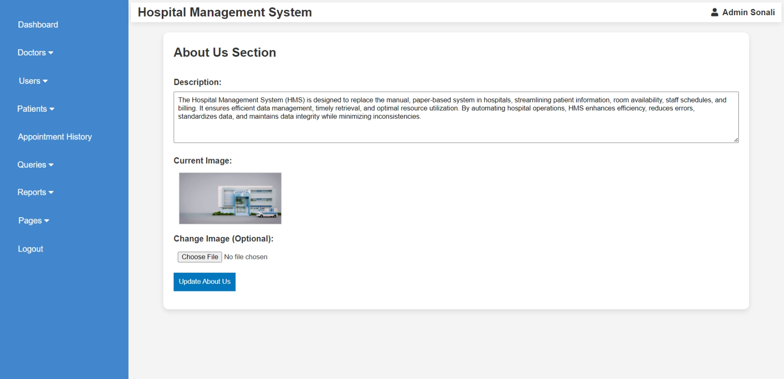<?php

ob_start();

include("admin_header.php");

include("database.php");

$query = "SELECT * FROM pages WHERE type='about' LIMIT 1";

$result = mysqli_query($conn, $query);

$row = mysqli_fetch_assoc($result);

if ($_SERVER["REQUEST_METHOD"] == "POST") {

$description = mysqli_real_escape_string($conn, $_POST['description']);

$img = $row['img'];

if (!empty($_FILES['img']['name'])) {

$img = basename($_FILES['img']['name']);

move_uploaded_file($_FILES['img']['tmp_name'], "img/" . $img);

}

$updateQuery = "UPDATE pages SET description='$description', img='$img' WHERE type='about'";

mysqli_query($conn, $updateQuery);

header("Location: a_aboutus.php");

exit;

}

ob_end_flush();

?>

<!DOCTYPE html>

<html lang="en">

<head>

<meta charset="UTF-8">

<meta name="viewport" content="width=device-width, initial-scale=1.0">

<title>Edit About Us</title>

<link rel="stylesheet" href="css/style.css">

<style>

body { font-family: Arial, sans-serif; background-color: #f4f4f4; }

.container { width: 90%; margin: 20px auto; background: white; padding: 20px; border-radius: 10px; box-shadow: 0px 4px 10px rgba(0, 0, 0, 0.1); }

.form-group { margin-bottom: 15px; }

.form-group label { display: block; font-weight: bold; }

.form-group input, .form-group textarea { width: 100%; padding: 8px; margin-top: 5px; height: 100px; }

.form-group button { background-color: #0277bd; color: white; padding: 10px; border: none; cursor: pointer; }

.form-group button:hover { background-color: #02569b; }

.image-preview { margin-top: 10px; display: flex; align-items: center; }

.image-preview img { width: 200px; height: auto; margin-left: 10px; border: 1px solid #ccc; }

</style>

</head>

<body>

<div class="container">

<h2>About Us Section</h2><br>

<form method="POST" enctype="multipart/form-data">

<div class="form-group">

<label>Description:</label>

<textarea name="description" required><?php echo htmlspecialchars($row['description']); ?></textarea>

</div>

<div class="form-group">

<label>Current Image:</label>

<div class="image-preview">

<?php if (!empty($row['img'])) { ?>

<img src="img/<?php echo htmlspecialchars($row['img']); ?>" alt="Image">

<?php } else { echo "No Image"; } ?>

</div>

</div>

<div class="form-group">

<label>Change Image (Optional):</label>

<input type="file" name="img" style="margin-bottom: -6%;">

</div>

<div class="form-group">

<button type="submit">Update About Us</button>

</div>

</form>

</div>

</body>

</html>

* **Gallery**

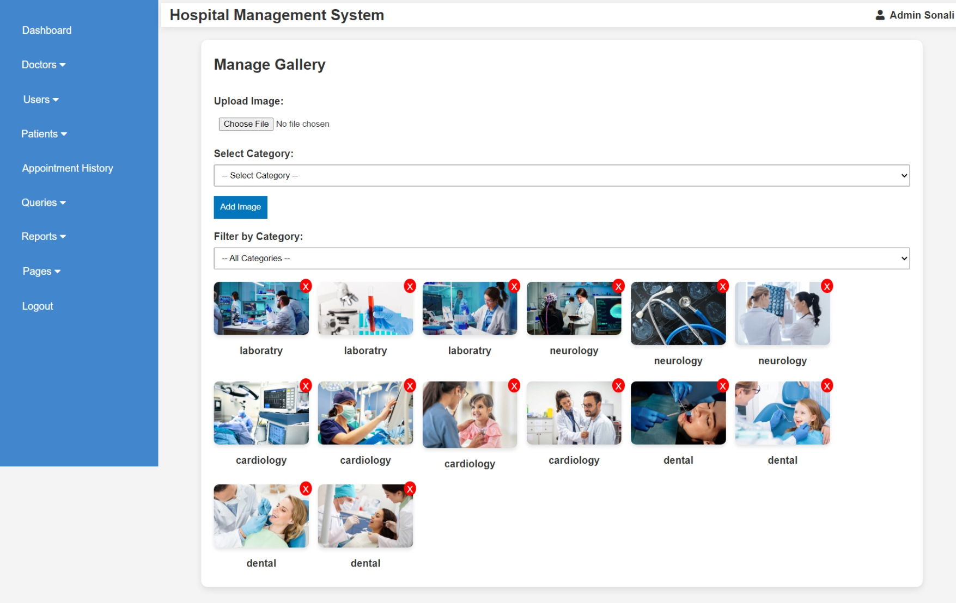

<?php

ob_start();

include("admin_header.php");

include("database.php");

$categories = mysqli_query($conn, "SELECT DISTINCT category FROM pages WHERE type='gallery'");

if ($_SERVER["REQUEST_METHOD"] == "POST" && isset($_FILES['img'])) {

if (!empty($_FILES['img']['name']) && !empty($_POST['category'])) {

$img = basename($_FILES['img']['name']);

$category = mysqli_real_escape_string($conn, $_POST['category']);

move_uploaded_file($_FILES['img']['tmp_name'], "img/" . $img);

$insertQuery = "INSERT INTO pages (img, category, type) VALUES ('$img', '$category', 'gallery')";

mysqli_query($conn, $insertQuery);

header("Location: a_gallery.php");

exit;

}

}

if (isset($_GET['delete'])) {

$id = intval($_GET['delete']);

$imgQuery = "SELECT img FROM pages WHERE id = $id AND type='gallery'";

$imgResult = mysqli_query($conn, $imgQuery);

$imgRow = mysqli_fetch_assoc($imgResult);

if (!empty($imgRow['img']) && file_exists("img/" . $imgRow['img'])) {

unlink("img/" . $imgRow['img']);

}

$deleteQuery = "DELETE FROM pages WHERE id = $id AND type='gallery'";

mysqli_query($conn, $deleteQuery);

header("Location: a_gallery.php");

exit;

}

$selected_category = isset($_GET['category']) ? mysqli_real_escape_string($conn, $_GET['category']) : "";

$query = "SELECT * FROM pages WHERE type='gallery'";

if (!empty($selected_category)) {

$query .= " AND category = '$selected_category'";

}

$query .= " ORDER BY id DESC";

$result = mysqli_query($conn, $query);

ob_end_flush();

?>

<!DOCTYPE html>

<html lang="en">

<head>

<meta charset="UTF-8">

<meta name="viewport" content="width=device-width, initial-scale=1.0">

<title>Manage Gallery</title>

<link rel="stylesheet" href="css/style.css">

<style>

body { font-family: Arial, sans-serif; background-color: #f4f4f4; }

.container { width: 90%; margin: 20px auto; background: white; padding: 20px; border-radius: 10px; box-shadow: 0px 4px 10px rgba(0, 0, 0, 0.1); }

.form-group { margin-bottom: 15px; }

.form-group label { display: block; font-weight: bold; }

.form-group input, .form-group select { width: 100%; padding: 8px; margin-top: 5px; }

.form-group button { background-color: #0277bd; color: white; padding: 10px; border: none; cursor: pointer; }

.form-group button:hover { background-color: #02569b; }

.gallery { display: flex; flex-wrap: wrap; gap: 15px; margin-top: 20px; }

.gallery-item { position: relative; width: 150px; }

.gallery-item img { width: 100%; border-radius: 8px; box-shadow: 0px 4px 6px rgba(0, 0, 0, 0.1); }

.delete-btn { position: absolute; top: -5px; right: -5px; background: red; color: white; padding: 5px; border: none; cursor: pointer; font-size: 14px; border-radius: 50%; height: 23px; }

</style>

</head>

<body>

<div class="container">

<h2>Manage Gallery</h2><br>

<form method="POST" enctype="multipart/form-data">

<div class="form-group">

<label>Upload Image:</label>

<input type="file" name="img" required>

</div>

<div class="form-group">

<label>Select Category:</label>

<select name="category" required>

<option value="">-- Select Category --</option>

<?php while ($cat = mysqli_fetch_assoc($categories)) { ?>

<option value="<?php echo htmlspecialchars($cat['category']); ?>">

<?php echo htmlspecialchars($cat['category']); ?>

</option>

<?php } ?>

</select>

</div>

<div class="form-group">

<button type="submit">Add Image</button>

</div>

</form>

<form method="GET">

<div class="form-group">

<label>Filter by Category:</label>

<select name="category" onchange="this.form.submit()">

<option value="">-- All Categories --</option>

<?php

mysqli_data_seek($categories, 0);

while ($cat = mysqli_fetch_assoc($categories)) {

$selected = ($cat['category'] == $selected_category) ? 'selected' : '';

echo "<option value='" . htmlspecialchars($cat['category']) . "' $selected>" . htmlspecialchars($cat['category']) . "</option>";

}

?>

</select>

</div>

</form>

<div class="gallery">

<?php while ($row = mysqli_fetch_assoc($result)) { ?>

<div class="gallery-item">

<img src="img/<?php echo htmlspecialchars($row['img']); ?>" alt="Gallery Image">

<p style="text-align: center; margin: 5px 0; font-weight: bold;">

<?php echo htmlspecialchars($row['category']); ?>

</p>

<a href="a_gallery.php?delete=<?php echo $row['id']; ?>" onclick="return confirm('Are you sure you want to delete this image?')">

<button class="delete-btn">X</button>

</a>

</div>

<?php } ?>

</div>

</div>

</body>

</html>

**Doctor Login**

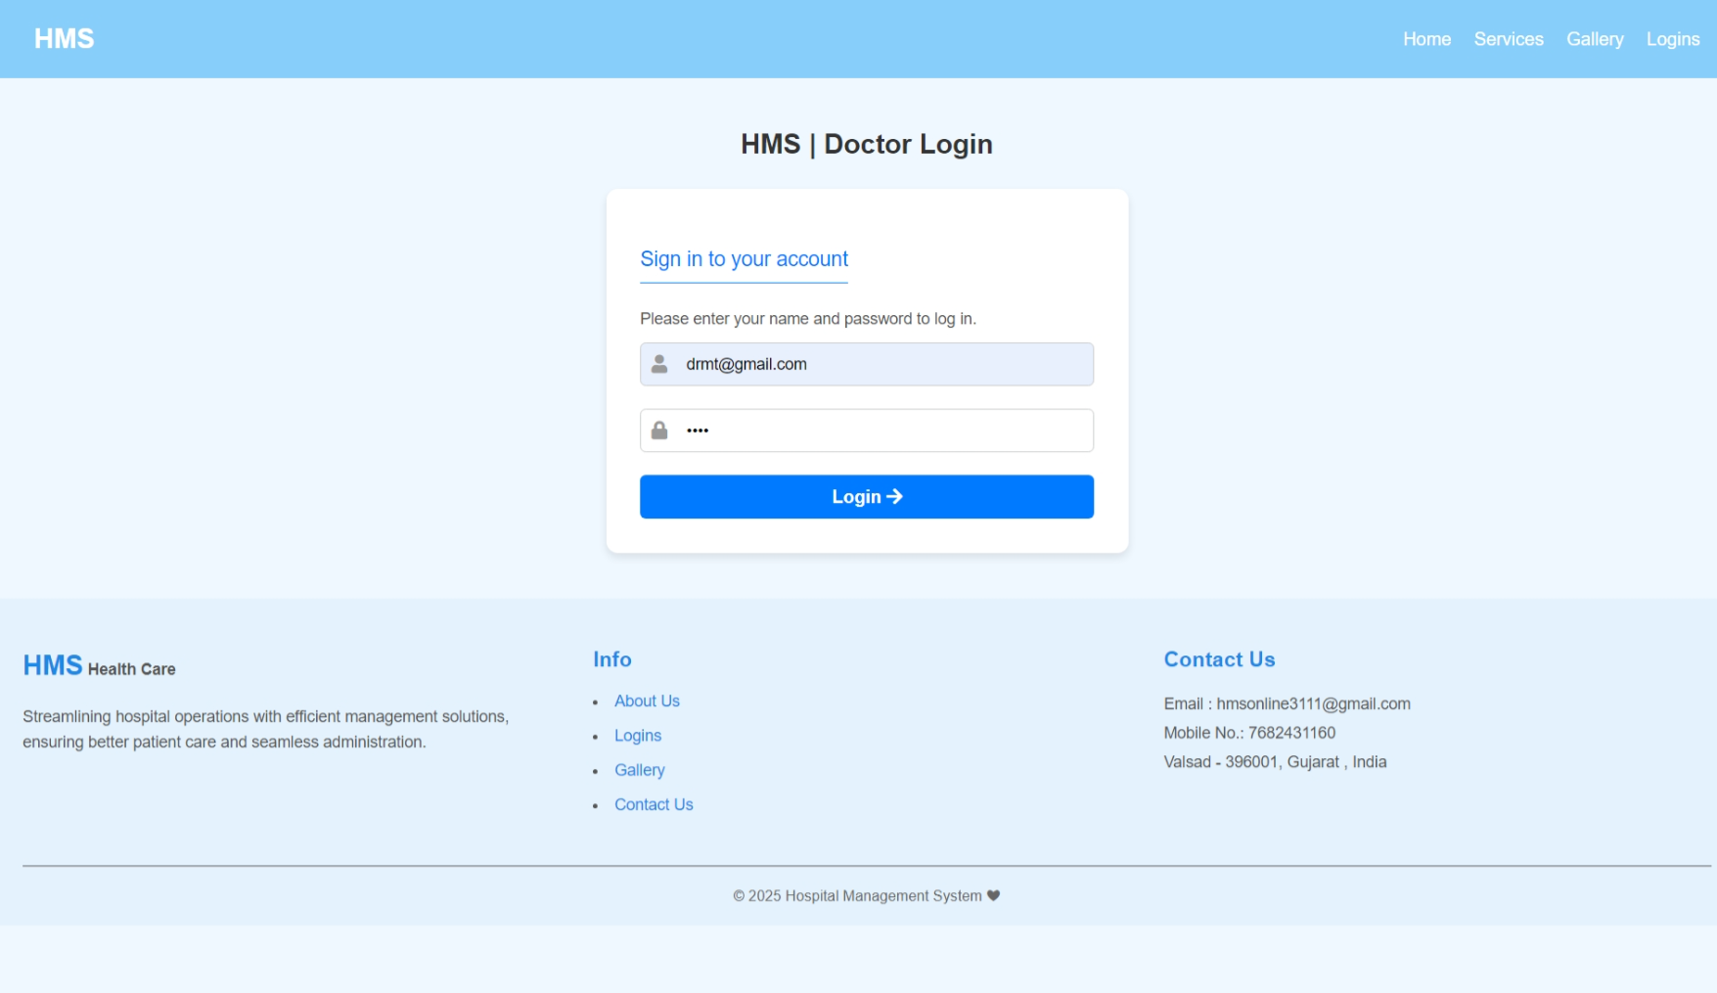<?php

    session_start();

    include("header.php");

?>

<!DOCTYPE html>

<html lang="en">

<head>

    <meta charset="UTF-8">

    <meta name="viewport" content="width=device-width, initial-scale=1.0">

    <title>HMS | Doctor Login</title>

    <link href="https://cdnjs.cloudflare.com/ajax/libs/font-awesome/5.15.4/css/all.min.css" rel="stylesheet">

    <link rel="stylesheet" href="css/rl_style.css">

</head>

<body>

    <section class="login-container" style="margin-bottom: -23%;">

    <h1>HMS | Doctor Login</h1>

        <div class="login-box" style="margin-bottom: 25%;">

            <form method="POST" action="<?php echo htmlspecialchars($_SERVER["PHP_SELF"])?>">

                <p class="p2">Sign in to your account</p>

                <p class="p1">Please enter your name and password to log in.</p>

                <div class="input-group">

                    <label for="email">

                        <i class="fa fa-user"></i>

                    </label>

                    <input type="email" id="email" name="email" placeholder="Email" required>

                </div>

                <div class="input-group">

                    <label for="password">

                        <i class="fa fa-lock"></i>

                    </label>

                    <input type="password" id="password" name="password" placeholder="Password" required>

                </div>

                <button type="submit" class="login-btn">Login <i class="fa fa-arrow-right"></i></button>

                <?php

                    include("database.php");

                    if($_SERVER["REQUEST_METHOD"]=="POST")

                    {

                        $email = filter_input(INPUT_POST,"email",FILTER_SANITIZE_SPECIAL_CHARS);

                        $password = filter_input(INPUT_POST,"password",FILTER_SANITIZE_SPECIAL_CHARS);

                        if(!empty($email) && !empty($password))

                        {

                            $sql = "SELECT * FROM doctor_mast WHERE email = '$email'";

                            $result = mysqli_query($conn, $sql);

                            if (mysqli_num_rows($result) > 0) {

                                $user = mysqli_fetch_assoc($result);

                                if ($password === $user["password"]){

                                    $_SESSION['doctor_id']=$user['d_id'];

                                    $_SESSION['doctor_name']=$user['name'];

                                    header('location:doctor_index.php');

                                    exit;

                                }

                            }

                        }

                    }

                    mysqli_close($conn);

                ?>

            </form>

        </div>

    </section>

    <?php

        include("footer.php");

    ?>

</body>

</html>

**Doctor Account**

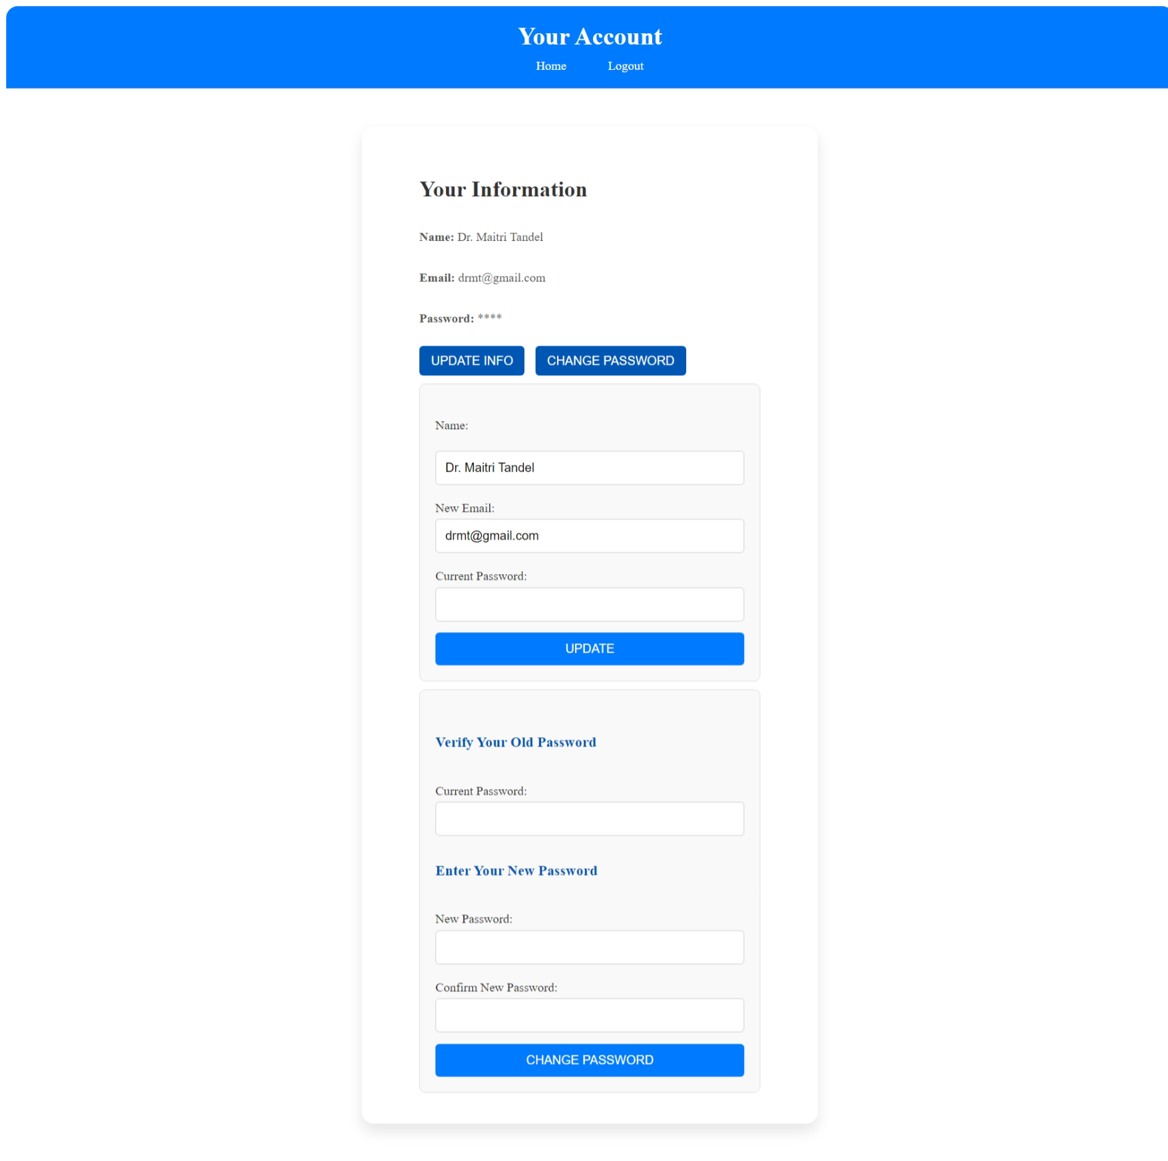<?php

session_start();

include("database.php");

if (!isset($_SESSION['doctor_id'])) {

    header("Location: doctor_login.php");

    exit();

}

$doctor_id = $_SESSION['doctor_id'];

$query = "SELECT * FROM doctor_mast WHERE d_id = '$doctor_id'";

$result = mysqli_query($conn, $query);

if ($result && mysqli_num_rows($result) > 0) {

    $doctor = mysqli_fetch_assoc($result);

} else {

    echo "Admin not found.";

    exit();

}

$message = "";

if ($_SERVER["REQUEST_METHOD"] == "POST" && isset($_POST['update'])) {

    $name = trim($_POST['name']);

    $new_email = trim($_POST['email']);

    $password = trim($_POST['password']);

    $name = mysqli_real_escape_string($conn, $name);

    $new_email = mysqli_real_escape_string($conn, $new_email);

    $password = mysqli_real_escape_string($conn, $password);

    if ($password === $doctor['password']) {

        $update_query = "UPDATE doctor_mast SET name='$name', email='$new_email' WHERE d_id='$doctor_id'";

        if (mysqli_query($conn, $update_query)) {

            $message = "Account details updated successfully!";

            $result = mysqli_query($conn, $query);

            if ($result && mysqli_num_rows($result) > 0) {

                $doctor = mysqli_fetch_assoc($result);

            }

        } else {

            $message = "Error updating account details.";

        }

    } else {

        $message = "Incorrect password. Please try again.";

    }

}

if ($_SERVER["REQUEST_METHOD"] == "POST" && isset($_POST['change_password'])) {

    $password = trim($_POST['password']);

    $new_password = trim($_POST['new_password']);

    $confirm_password = trim($_POST['confirm_password']);

    $password = mysqli_real_escape_string($conn, $password);

    $new_password = mysqli_real_escape_string($conn, $new_password);

    $confirm_password = mysqli_real_escape_string($conn, $confirm_password);

    if ($password === $doctor['password']) {

        if ($new_password === $confirm_password) {

            $update_query = "UPDATE doctor_mast SET password='$new_password' WHERE d_id='$doctor_id'";

            if (mysqli_query($conn, $update_query)) {

                $message = "Password updated successfully!";

            } else {

                $message = "Error updating password.";

            }

        } else {

            $message = "New passwords do not match!";

        }

    } else {

        $message = "Incorrect current password!";

    }

}

?>

<!DOCTYPE html>

<html lang="en">

<head>

    <meta charset="UTF-8">

    <meta name="viewport" content="width=device-width, initial-scale=1.0">

    <title>Account</title>

    <link rel="website icon" href="img/logo1.jpg" type="jpg">

    <link rel="stylesheet" href="css/account_style.css">

</head>

<body>

    <header>

        <h2>Your Account</h2>

        <nav>

            <a href="doctor_index.php">Home</a>&nbsp;&nbsp;&nbsp;&nbsp;&nbsp;

            <a href="logout.php">Logout</a>

        </nav>

    </header>

    <div class="container">

        <section class="sec">

            <h2>Your Information</h2><br>

            <p><strong>Name:</strong> <?php echo htmlspecialchars($doctor['name']); ?></p><br>

            <p><strong>Email:</strong> <?php echo htmlspecialchars($doctor['email']); ?></p><br>

            <p><strong>Password:</strong> <?php echo str_repeat('*', strlen($doctor['password'])); ?></p><br>

            <button class="btn1" onclick="toggleForm('update-info-form')">Update Info</button>

            <button class="btn1" onclick="toggleForm('change-password-form')">Change Password</button>

            <form method="POST" id="update-info-form" class="form-section">

                <br><label for="name">Name:</label><br>

                <input type="text" id="name" name="name" class="ipt1" value="<?php echo htmlspecialchars($doctor['name']); ?>" required><br>

                <label for="email">New Email:</label>

                <input type="email" id="email" name="email" class="email-pass" value="<?php echo htmlspecialchars($doctor['email']); ?>" required><br>

                <label for="password">Current Password:</label>

                <input type="password" id="password" class="email-pass" name="password" required><br>

                <button type="submit" class="btn" name="update">Update</button><br>

            </form>

            <form method="POST" id="change-password-form" class="form-section">

                <br><h3>Verify Your Old Password</h3><br>

                <label for="password">Current Password:</label>

                <input type="password" id="password" class="email-pass" name="password" required><br>

                <h3>Enter Your New Password</h3><br>

                <label for="new_password">New Password:</label>

                <input type="password" id="new_password" class="ipt" name="new_password" required><br>

                <label for="confirm_password">Confirm New Password:</label>

                <input type="password" id="confirm_password" class="ipt" name="confirm_password" required><br>

                <button type="submit" class="btn" name="change_password">Change Password</button>

            </form>

        </section>

    </div>

    <?php

    if($message){

        echo "<script type='text/javascript'>alert('$message');</script>";

    }

    ?>

    <script>

        function toggleForm(formId) {

            var form = document.getElementById(formId);

            if (form.style.display === "none" || form.style.display === "") {

                form.style.display = "block";

            } else {

                form.style.display = "none";

            }

        }

    </script>

</body>

</html>

**Doctor Header**

<?php

    session_start();

    include('database.php');

    if (!isset($_SESSION['doctor_id'])) {

        header('Location: doctor_login.php');

        exit;

    }

    $doctor_name = $_SESSION['doctor_name'];

?>

<!DOCTYPE html>

<html lang="en">

<head>

    <meta charset="UTF-8">

    <meta name="viewport" content="width=device-width, initial-scale=1.0">

    <title>Hospital Management System</title>

    <link rel="website icon" href="img/logo1.jpg" type="jpg">

    <link href="https://cdnjs.cloudflare.com/ajax/libs/font-awesome/5.15.4/css/all.min.css" rel="stylesheet">

    <link rel="stylesheet" href="css/style.css">

    <style>

        * {

        margin: 0;

        padding: 0;

        box-sizing: border-box;

        font-family: Arial, sans-serif;

        }

        body {

            display: flex;

            background-color: #f0f8ff;

        }

        .sidebar {

            width: 250px;

            height: 100vh;

            background:rgb(66, 134, 206);

            color: white;

            padding: 20px;

        }

        .sidebar h2 {

            text-align: center;

            margin-bottom: 20px;

        }

        .sidebar ul {

            list-style: none;

            padding: 0;

        }

        .sidebar ul li {

            padding: 15px;

        }

        .sidebar ul li a {

            color: white;

            text-decoration: none;

            display: block;

        }

        .sidebar ul li a:hover {

            background:rgb(94, 142, 193);

            border-radius: 5px;

        }

        .main-content {

            flex: 1;

            padding:5px;

        }

        header {

            display: flex;

            justify-content: space-between;

            align-items: center;

            background: white;

            box-shadow: 0px 2px 10px rgba(0, 0, 0, 0.1);

        }

        .dashboard {

            margin-top: 20px;

        }

        .cards {

            display: flex;

            /*justify-content: space-between;*/

            gap: 20px;

            margin-left: 2%;

        }

        .card {

            background: white;

            padding: 20px;

            text-align: center;

            width: 30%;

            border-radius: 10px;

            box-shadow: 0px 4px 10px rgba(0, 0, 0, 0.1);

        }

        .card img {

            width: 50px;

            margin-bottom: 10px;

        }

        .card a {

            display: block;

            margin-top: 10px;

            color:rgb(50, 128, 210);

            text-decoration: none;

        }

        .card a:hover {

            text-decoration: underline;

        }

        .dropdown {

            position: relative;

            display: inline-block;

        }

        .dropbtn {

            margin-left: -19%;

            margin-top: -10%;

            margin-bottom: -10%;

            padding: 10px 20px;

            font-size: 16px;

            border: none;

            cursor: pointer;

        }

        .dropdown-content {

            display: none;

            position: absolute;

            background-color:rgb(255, 255, 255);

            min-width: 160px;

            box-shadow: 0px 8px 16px rgba(0, 0, 0, 0.2);

            z-index: 1;

        }

        .dropdown-content a {

            color:black;

            padding: 6px 16px;

            text-decoration: none;

            display: block;

        }

        .dropdown:hover .dropdown-content {

            display: block;

        }

    </style>

</head>

<body>

<div class="sidebar">

    <ul>

        <li><a href="doctor_index.php">Dashboard</a></li>

        <li><a href="dr_appointment_history.php">Appointment History</a></li>

        <li class="dropdown">

            <a href="#" class="dropbtn">Patients <i class="fas fa-caret-down"></i></a>

            <div class="dropdown-content">

                <a href="add_patient.php" style="color: black; border-radius:0;">Add Patient</a>

                <a href="manage_patient.php" style="color: black; border-radius:0;">Manage Patient</a>

            </div>

        </li>

        <li><a href="search_patient.php">Search</a></li>

        <li><a href="logout.php" onclick="return confirmLogout()">Logout</a>

            <script>

                function confirmLogout() {

                    return confirm("Are you sure you want to log out?");

                }

            </script>

        </li>

    </ul>

</div>

    <div class="main-content">

        <header>

            <h2>&nbsp;&nbsp;Hospital Management System</h2>

            <div class="user-info" style="font-weight: bold; margin-right:1%;">

            <i class="fas fa-user"></i>&nbsp;&nbsp;<?php echo $doctor_name; ?>

            </div>

        </header>

**Doctor Dashboard**

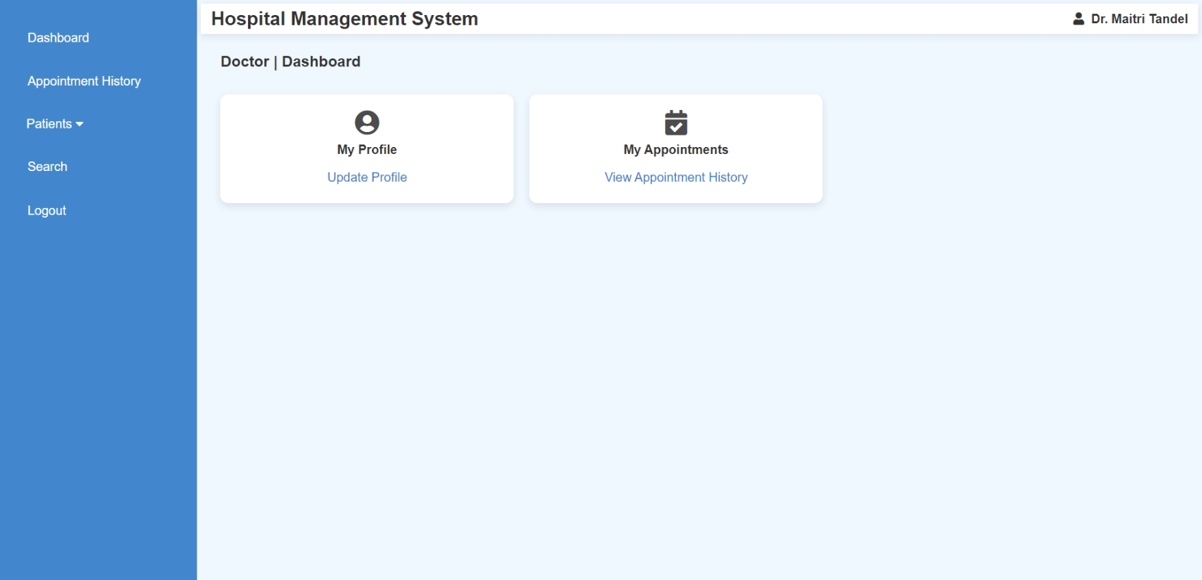<?php

    include("doctor_header.php");

    include("database.php");

    $doctor_id = $_SESSION['doctor_id'];

    $current_date = date('Y-m-d');

    $query = "SELECT COUNT(*) AS pending_count FROM appointment WHERE d_id = $doctor_id AND a_date = '$current_date' AND d_status = 0";

    $result = mysqli_query($conn, $query);

    $row = mysqli_fetch_assoc($result);

    $pending_count = $row['pending_count'];

?>

<section class="dashboard">

    <h3 style="font-size:larger; margin-left:2%;">Doctor | Dashboard</h3><br>

    <div class="cards">

        <div class="card">

            <i class="fas fa-user-circle fa-2x" style="opacity: 0.9;"></i><br>

            <h4 style="margin-top:0.8%;">My Profile</h4>

            <a href="doctor_account.php">Update Profile</a>

        </div>

        <div class="card">

            <i class="fas fa-calendar-check fa-2x" style="opacity: 0.9;"></i>

            <h4 style="margin-top:0.8%;">My Appointments</h4>

            <a href="dr_appointment_history.php">

                View Appointment History

                <?php if ($pending_count > 0) { ?>

                    <span style="color: red; font-weight: bold;">(<?= $pending_count ?> pending)</span>

                <?php } ?>

            </a>

        </div>

    </div>

</section>

**Doctor View Appointment History**

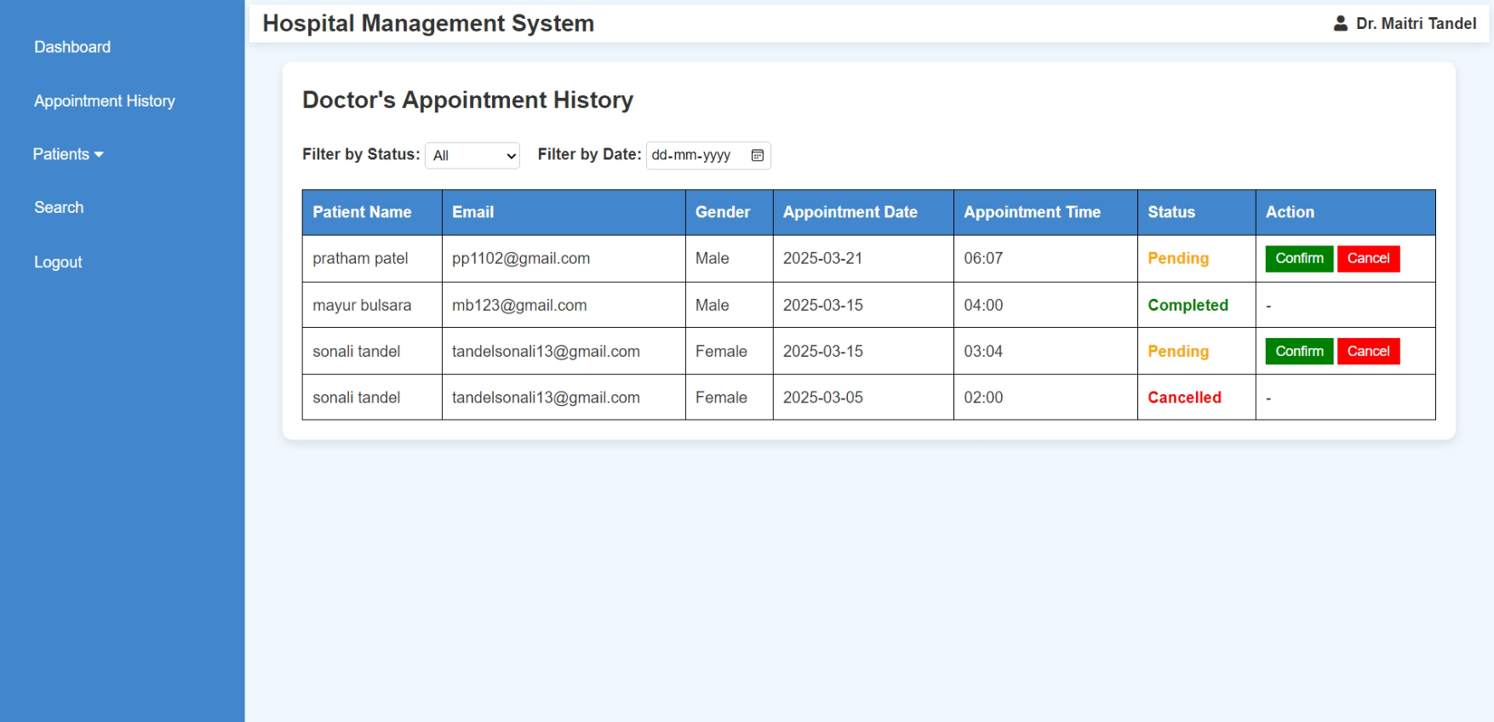<?php

ob_start();

include("doctor_header.php");

include('database.php');

if (!isset($_SESSION['doctor_id'])) {

    header('Location: doctor_login.php');

    exit;

}

$doctor_id = intval($_SESSION['doctor_id']);

if (isset($_POST['confirm_id'])) {

    $confirm_id = intval($_POST['confirm_id']);

    $update_confirm_query = "UPDATE appointment SET d_status = 1 WHERE a_id = $confirm_id AND d_id = $doctor_id";

    mysqli_query($conn, $update_confirm_query);

    header("Location: " . $_SERVER['PHP_SELF']);

    exit;

}

if (isset($_POST['cancel_id'])) {

    $cancel_id = intval($_POST['cancel_id']);

    $update_cancel_query = "UPDATE appointment SET d_status = 2 WHERE a_id = $cancel_id AND d_id = $doctor_id";

    mysqli_query($conn, $update_cancel_query);

    header("Location: " . $_SERVER['PHP_SELF']);

    exit;

}

$status_filter = isset($_GET['status']) ? intval($_GET['status']) : -1; // Default: Show all

$date_filter = isset($_GET['date']) ? $_GET['date'] : '';

$query = "SELECT a.a_id, p.fullname AS patient_name, p.email, p.gender, a.a_date, a.a_time, a.d_status

          FROM appointment a

          INNER JOIN patient_mast p ON a.p_id = p.p_id

          WHERE a.d_id = $doctor_id";

if ($status_filter >= 0) {

    $query .= " AND a.d_status = $status_filter";

}

if (!empty($date_filter)) {

    $query .= " AND a.a_date = '$date_filter'";

}

$query .= " ORDER BY a.a_date DESC";

$result = mysqli_query($conn, $query);

ob_end_flush();

?>

<!DOCTYPE html>

<html lang="en">

<head>

    <meta charset="UTF-8">

    <meta name="viewport" content="width=device-width, initial-scale=1.0">

    <title>Doctor's Appointment History</title>

    <style>

         body {

            font-family: Arial, sans-serif;

            background-color: #f0f8ff;

        }

        .container {

            width: 98%;

            margin: 20px auto;

            background: white;

            padding: 20px;

            border-radius: 10px;

            box-shadow: 0px 4px 10px rgba(0, 0, 0, 0.1);

        }

        table {

            width: 100%;

            border-collapse: collapse;

            margin-top: 20px;

        }

        table, th, td {

            border: 1px solid black;

        }

        th, td {

            padding: 10px;

            text-align: left;

        }

        th {

            background-color: rgb(66, 134, 206);

            color: white;

        }

        .status {

            font-weight: bold;

        }

        .completed { color: green; }

        .pending { color: orange; }

        .cancelled { color: red; }

        .confirm-btn, .cancel-btn {

            color: white;

            padding: 5px 10px;

            border: none;

            cursor: pointer;

            text-decoration: none;

        }

        .confirm-btn { background-color: green; }

        .confirm-btn:hover { background-color: darkgreen; }

        .cancel-btn { background-color: red; }

        .cancel-btn:hover { background-color: darkred; }

        .filter-container {

            margin-bottom: 10px;

        }

        select, button, input {

            padding: 8px;

            font-size: 14px;

        }

        .filter-container {

            margin-top: 2%;

            margin-bottom: 10px;

        }

        select, input {

            padding: 4px;

            font-size: 14px;

            border: 1px solid #ccc;

            border-radius: 4px;

        }

    </style>

    <script>

        function confirmAppointment(a_id) {

            if (confirm("Are you sure you want to confirm this appointment?")) {

                let form = document.createElement("form");

                form.method = "POST";

                form.action = "";

                let input = document.createElement("input");

                input.type = "hidden";

                input.name = "confirm_id";

                input.value = a_id;

                form.appendChild(input);

                document.body.appendChild(form);

                form.submit();

            }

        }

        function cancelAppointment(a_id) {

            if (confirm("Are you sure you want to cancel this appointment?")) {

                let form = document.createElement("form");

                form.method = "POST";

                form.action = "";

                let input = document.createElement("input");

                input.type = "hidden";

                input.name = "cancel_id";

                input.value = a_id;

                form.appendChild(input);

                document.body.appendChild(form);

                form.submit();

            }

        }

        function filterAppointments() {

            let status = document.getElementById("status-filter").value;

            let date = document.getElementById("date-filter").value;

            let url = "?status=" + status;

            if (date) {

                url += "&date=" + date;

            }

            window.location.href = url;

        }

    </script>

</head>

<body>

    <div class="container">

        <h2>Doctor's Appointment History</h2>

        <div class="filter-container">

            <label for="status-filter"><b>Filter by Status:</b></label>

            <select id="status-filter" onchange="filterAppointments()">

                <option value="-1" <?php if ($status_filter == -1) echo 'selected'; ?>>All</option>

                <option value="0" <?php if ($status_filter == 0) echo 'selected'; ?>>Pending</option>

                <option value="1" <?php if ($status_filter == 1) echo 'selected'; ?>>Completed</option>

                <option value="2" <?php if ($status_filter == 2) echo 'selected'; ?>>Cancelled</option>

            </select>

            <label for="date-filter"><b>&nbsp;&nbsp;&nbsp;Filter by Date:</b></label>

            <input type="date" id="date-filter" value="<?php echo isset($_GET['date']) ? $_GET['date'] : ''; ?>" onchange="filterAppointments()">

        </div>

        <table>

            <tr>

                <th>Patient Name</th>

                <th>Email</th>

                <th>Gender</th>

                <th>Appointment Date</th>

                <th>Appointment Time</th>

                <th>Status</th>

                <th>Action</th>

            </tr>

            <?php if ($result && mysqli_num_rows($result) > 0) {

                while ($row = mysqli_fetch_assoc($result)) { ?>

                    <tr>

                        <td><?php echo htmlspecialchars($row['patient_name']); ?></td>

                        <td><?php echo htmlspecialchars($row['email']); ?></td>

                        <td><?php echo htmlspecialchars($row['gender']); ?></td>

                        <td><?php echo htmlspecialchars($row['a_date']); ?></td>

                        <td><?php echo htmlspecialchars($row['a_time']); ?></td>

                        <td class="status <?php echo ($row['d_status'] == 1) ? 'completed' : (($row['d_status'] == 0) ? 'pending' : 'cancelled'); ?>">

                            <?php echo ($row['d_status'] == 1) ? 'Completed' : (($row['d_status'] == 0) ? 'Pending' : 'Cancelled'); ?>

                        </td>

                        <td>

                            <?php if ($row['d_status'] == 0) { ?>

                                <button class="confirm-btn" onclick="confirmAppointment(<?php echo $row['a_id']; ?>)">Confirm</button>

                                <button class="cancel-btn" onclick="cancelAppointment(<?php echo $row['a_id']; ?>)">Cancel</button>

                            <?php } else { echo "-"; } ?>

                        </td>

                    </tr>

                <?php }

            } else { ?>

                <tr><td colspan="7" style="text-align: center; font-weight: bold;">No appointments found.</td></tr>

            <?php } ?>

        </table>

    </div>

</body>

</html>

**Doctor (Manage Patients)**

* **Add Patient**

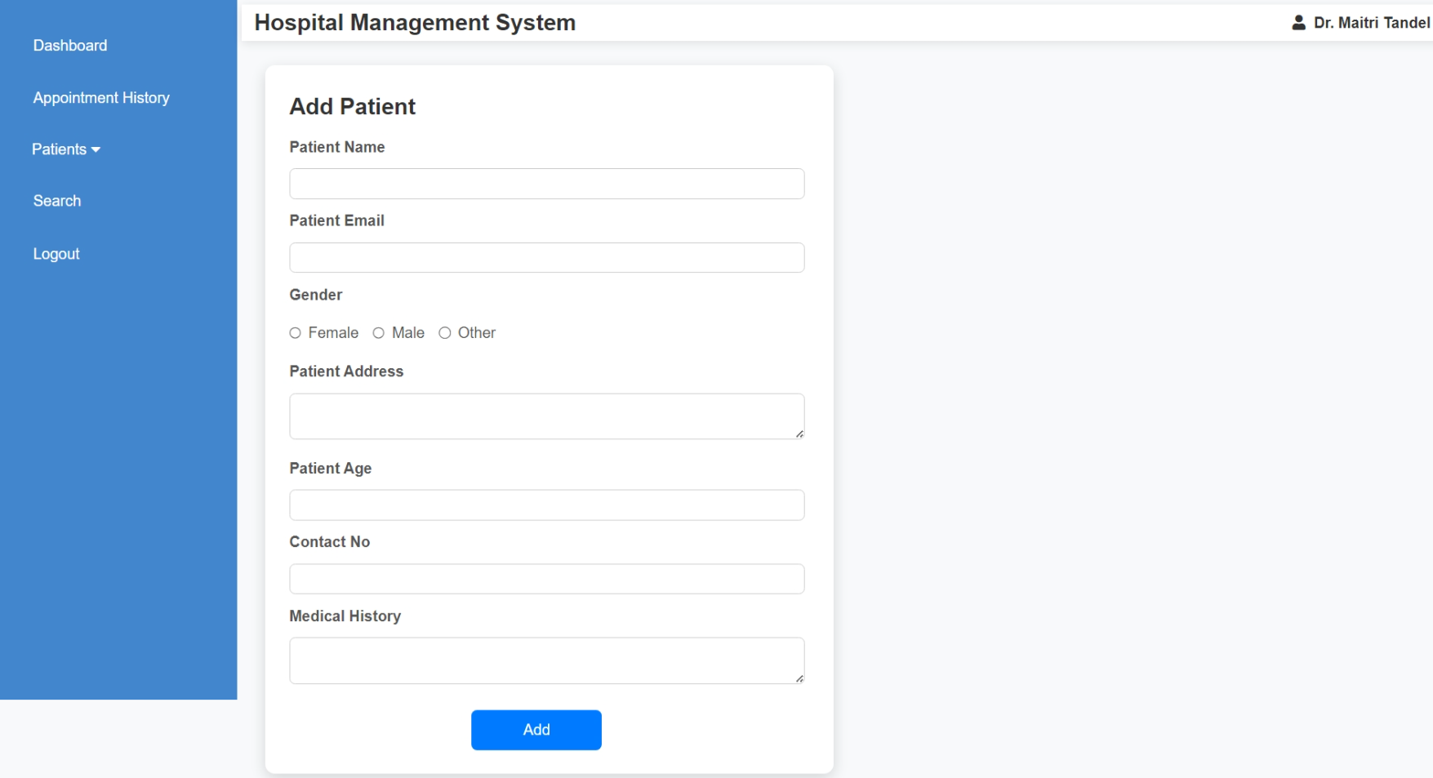<?php

include('doctor_header.php');

include('database.php');

if (!isset($_SESSION['doctor_id'])) {

    echo "<script>alert('Unauthorized access!'); window.location.href='login.php';</script>";

    exit;

}

$doctor_id = $_SESSION['doctor_id'];

if ($_SERVER["REQUEST_METHOD"] == "POST") {

    $fullname = mysqli_real_escape_string($conn, $_POST['fullname']);

    $email = mysqli_real_escape_string($conn, $_POST['email']);

    $gender = mysqli_real_escape_string($conn, $_POST['gender']);

    $address = mysqli_real_escape_string($conn, $_POST['address']);

    $age = mysqli_real_escape_string($conn, $_POST['age']);

    $contact_no = mysqli_real_escape_string($conn, $_POST['contact_no']);

    $medhis = mysqli_real_escape_string($conn, $_POST['medhis']);

    $sql = "INSERT INTO patient_detail (d_id, p_name, p_email, p_gender, p_add, p_age, p_contact, p_medhis)

            VALUES ('$doctor_id', '$fullname', '$email', '$gender', '$address', '$age', '$contact_no', '$medhis')";

    if ($conn->query($sql) === TRUE) {

        echo "<script>alert('Patient added successfully!'); window.location.href='manage_patient.php';</script>";

    } else {

        echo "Error: " . $sql . "<br>" . $conn->error;

    }

    $conn->close();

}

?>

<!DOCTYPE html>

<html lang="en">

<head>

    <meta charset="UTF-8">

    <meta name="viewport" content="width=device-width, initial-scale=1.0">

    <title>Add Patient</title>

    <style>

        body {

            font-family: Arial, sans-serif;

            background-color: #f8f9fa;

            margin: 0;

            padding: 0;

        }

        .container {

            width: 100%;

            max-width: 600px;

            background: white;

            padding: 25px;

            border-radius: 10px;

            box-shadow: 0px 5px 15px rgba(0, 0, 0, 0.15);

            margin-top: 2%;

            margin-left: 2%;

        }

        label {

            font-weight: bold;

            display: block;

            margin: 10px 0 5px;

            color: #555;

        }

        input, textarea {

            width: 99%;

            padding: 7px;

            margin-top: 5px;

            border: 1px solid #ccc;

            border-radius: 6px;

            font-size: 14px;

            transition: 0.3s;

        }

        input:focus, textarea:focus {

            border-color: #007bff;

            outline: none;

        }

        .radio-group {

            display: flex;

            align-items: center;

            gap: 15px;

        }

        .radio-group label {

            display: flex;

            align-items: center;

            gap: 7px;

            cursor: pointer;

            font-weight: lighter;

        }

        .radio-group input {

            margin: 0;

        }

        .btn-submit {

            background-color: #007bff;

            color: white;

            border: none;

            padding: 12px;

            margin-top: 20px;

            border-radius: 6px;

            cursor: pointer;

            font-size: 16px;

            width:25%;

            transition: background 0.3s;

            margin-left: 35%;

        }

        .btn-submit:hover {

            background-color: #0056b3;

        }

        @media (max-width: 600px) {

            .container {

                width: 95%;

                padding: 20px;

            }

        }

    </style>

</head>

<body>

    <div class="container">

        <h2>Add Patient</h2>

        <form method="post">

            <label>Patient Name</label>

            <input type="text" name="fullname" required>

            <label>Patient Email</label>

            <input type="email" name="email" required>

            <label>Gender</label>

            <div class="radio-group">

                <label><input type="radio" name="gender" value="Female" required> Female</label>

                <label><input type="radio" name="gender" value="Male" required> Male</label>

                <label><input type="radio" name="gender" value="Other" required> Other</label>

            </div>

            <label>Patient Address</label>

            <textarea name="address" required></textarea>

            <label>Patient Age</label>

            <input type="number" name="age" required>

            <label>Contact No</label>

            <input type="text" name="contact_no" required>

            <label>Medical History</label>

            <textarea name="medhis"></textarea>

            <button type="submit" class="btn-submit">Add</button>

        </form>

    </div>

</body>

</html>

* **Manage Patient (View & Edit Patient Details)**

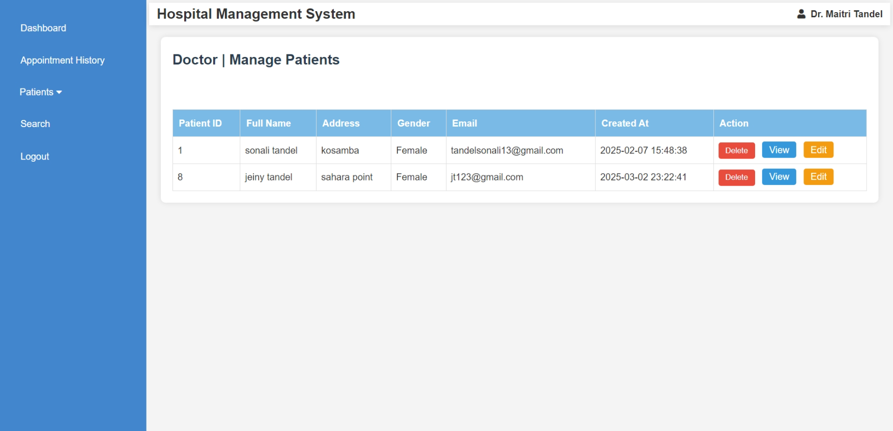

<?php

include("doctor_header.php");

include('database.php');

if (!isset($_SESSION['doctor_id'])) {

header('Location: doctor_login.php');

exit;

}

doctor_id = intval($_SESSION['doctor_id']);

if (isset($_POST['delete']) && isset($_POST['p_detail_id'])) {

$p_detail_id = intval($_POST['p_detail_id']);

$query = "DELETE FROM patient_detail WHERE p_detail_id = '$p_detail_id' AND d_id = '$doctor_id'";

$result = mysqli_query($conn, $query);

if ($result) {

echo "<script>alert('Patient deleted successfully.'); window.location.href='manage_patient.php';</script>";

} else {

echo "<script>alert('Error deleting patient: " . mysqli_error($conn) . "'); window.location.href='manage_patient.php';</script>";

}

}

$query = "SELECT DISTINCT p_detail_id, p_name, p_add, p_email, p_gender, created_at FROM patient_detail WHERE d_id = '$doctor_id'";

$result = mysqli_query($conn, $query);

?>

<!DOCTYPE html>

<html lang="en">

<head>

<meta charset="UTF-8">

<meta name="viewport" content="width=device-width, initial-scale=1.0">

<title>Manage Patients</title>

<style>

body {

font-family: Arial, sans-serif;

background-color: #f4f4f4;

margin: 0;

padding: 0;

}

section.dashboard {

margin: 20px;

padding: 20px;

background-color: #fff;

border-radius: 8px;

box-shadow: 0 0 10px rgba(0, 0, 0, 0.1);

}

h3 {

color: #2c3e50;

font-size: 24px;

margin-bottom: 20px;

}

table {

width: 100%;

border-collapse: collapse;

margin-top: 20px;

}

table, th, td {

border: 1px solid #ddd;

}

th {

background-color: rgb(121, 187, 230);

color: white;

padding: 10px;

text-align: left;

}

td {

padding: 8px;

text-align: left;

}

td input[type="submit"] {

background-color: #e74c3c;

color: white;

border: none;

padding: 6px 12px;

cursor: pointer;

border-radius: 4px;

transition: background-color 0.3s ease;

}

td input[type="submit"]:hover {

background-color: #c0392b;

}

.view-btn, .edit-btn {

background-color: #3498db;

color: white;

padding: 1px 12px;

text-decoration: none;

border-radius: 4px;

margin-left: 8px;

display: inline-block;

}

.edit-btn {

background-color: #f39c12;

}

@media screen and (max-width: 768px) {

table, th, td {

font-size: 14px;

}

td input[type="submit"] {

padding: 4px 8px;

}

}

</style>

</head>

<body>

<section class="dashboard">

<h3>Doctor | Manage Patients</h3><br>

<table border="1">

<thead>

<tr>

<th>Patient ID</th>

<th>Full Name</th>

<th>Address</th>

<th>Gender</th>

<th>Email</th>

<th>Created At</th>

<th>Action</th>

</tr>

</thead>

<tbody>

<?php

if ($result && mysqli_num_rows($result) > 0) {

while ($row = mysqli_fetch_assoc($result)) {

echo "<tr>

<td>{$row['p_detail_id']}</td>

<td>{$row['p_name']}</td>

<td>{$row['p_add']}</td>

<td>{$row['p_gender']}</td>

<td>{$row['p_email']}</td>

<td>{$row['created_at']}</td>

<td>

<form method='POST' action='' onsubmit='return confirmDelete()' style='display:inline;'>

<input type='hidden' name='p_detail_id' value='{$row['p_detail_id']}'>

<input type='submit' name='delete' value='Delete'>

</form>

<a href='view_patient.php?p_detail_id={$row['p_detail_id']}' class='view-btn'>View</a>

<a href='edit_patient.php?p_detail_id={$row['p_detail_id']}' class='edit-btn'>Edit</a>

</td>

</tr>";

}

} else {

echo "<tr><td colspan='7'>No patients found.</td></tr>";

}

?>

</tbody>

</table>

</section>

<script>

function confirmDelete() {

return confirm('Are you sure you want to delete this patient?');

}

</script>

</body>

</html>

* + **View Patient Details**

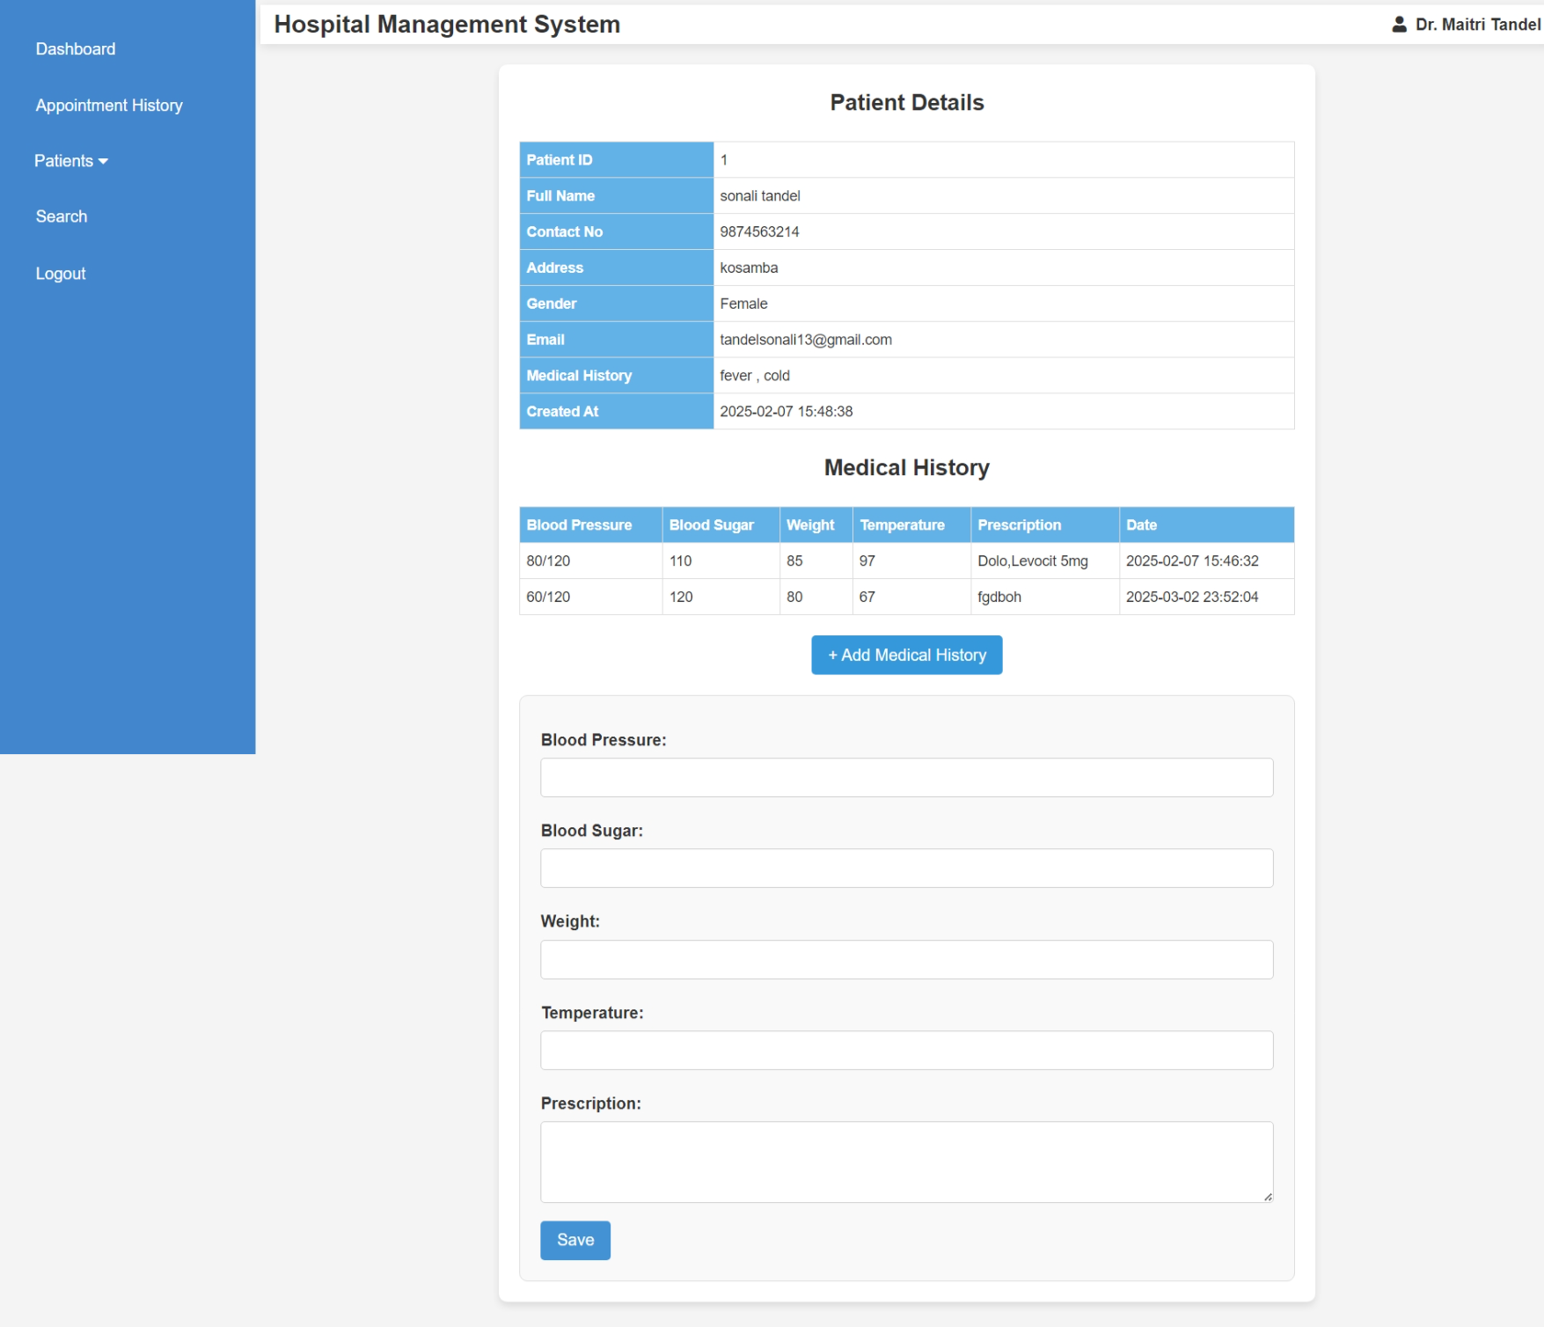

<?php

ob_start();

include("doctor_header.php");

include('database.php');

if (!isset($_SESSION['doctor_id'])) {

    header('Location: doctor_login.php');

    exit;

}

$doctor_id = intval($_SESSION['doctor_id']);

if (isset($_GET['p_detail_id'])) {

    $p_detail_id = intval($_GET['p_detail_id']);

    $query = "SELECT * FROM patient_detail WHERE p_detail_id = '$p_detail_id' AND d_id = '$doctor_id'";

    $result = mysqli_query($conn, $query);

    if ($result && mysqli_num_rows($result) > 0) {

        $row = mysqli_fetch_assoc($result);

    } else {

        echo "<p>Patient not found or access denied.</p>";

        exit;

    }

} else {

    echo "<p>Invalid request.</p>";

    exit;

}

if ($_SERVER['REQUEST_METHOD'] == 'POST') {

    if (isset($_POST['update_medical'])) {

        $bp = mysqli_real_escape_string($conn, $_POST['bp']);

        $bs = mysqli_real_escape_string($conn, $_POST['bs']);

        $weight = mysqli_real_escape_string($conn, $_POST['weight']);

        $temperature = mysqli_real_escape_string($conn, $_POST['temperature']);

        $m_prescription = mysqli_real_escape_string($conn, $_POST['m_prescription']);

        $med_update_query = "INSERT INTO medical_history (p_detail_id, bp, bs, weight, temperature, m_prescription, created_at)

                             VALUES ('$p_detail_id', '$bp', '$bs', '$weight', '$temperature', '$m_prescription', NOW())";

        mysqli_query($conn, $med_update_query);

        header("Location: view_patient.php?p_detail_id=$p_detail_id");

        exit;

    }

}

ob_end_flush();

?>

<!DOCTYPE html>

<html lang="en">

<head>

    <meta charset="UTF-8">

    <meta name="viewport" content="width=device-width, initial-scale=1.0">

    <title>Patient Details</title>

    <style>

        body {

            font-family: Arial, sans-serif;

            background-color: #f4f4f4;

            margin: 0;

            padding: 0;

        }

        .container {

            background: #fff;

            padding: 20px;

            border-radius: 8px;

            box-shadow: 0 4px 8px rgba(0, 0, 0, 0.1);

            max-width: 800px;

            width: 100%;

            margin: 20px auto;

        }

        h3 {

            text-align: center;

            color: #333;

            font-size: 22px;

            margin-bottom: 20px;

        }

        table {

            width: 100%;

            border-collapse: collapse;

            margin-bottom: 20px;

        }

        th, td {

            border: 1px solid #ddd;

            padding: 6px;

            font-size: 14px;

            text-align: left;

        }

        th {

            background-color: rgb(99, 178, 231);

            color: white;

            font-weight: bold;

        }

        .toggle-btn {

            display: block;

            margin: 20px auto;

            padding: 10px 16px;

            background-color: #3498db;

            color: white;

            border: none;

            border-radius: 4px;

            cursor: pointer;

            font-size: 16px;

            transition: 0.3s;

        }

        .toggle-btn:hover {

            background-color: #2980b9;

        }

        .form-container {

            display: none;

            background-color: #f9f9f9;

            padding: 20px;

            border-radius: 8px;

            border: 1px solid #ddd;

            margin-top: 20px;

        }

        .form-container label {

            display: block;

            font-weight: bold;

            margin: 10px 0 5px;

            color: #333;

        }

        .form-container input,

        .form-container textarea {

            width: 100%;

            padding: 10px;

            margin-bottom: 10px;

            border: 1px solid #ccc;

            border-radius: 4px;

            font-size: 14px;

        }

        .form-container textarea {

            resize: vertical;

            height: 80px;

        }

        button[type="submit"] {

            background-color: rgb(67, 146, 211);

            color: white;

            padding: 10px 16px;

            border: none;

            border-radius: 4px;

            cursor: pointer;

            font-size: 16px;

            transition: 0.3s;

        }

        button[type="submit"]:hover {

            background-color: rgb(73, 130, 190);

        }

        @media (max-width: 600px) {

            .container {

                padding: 15px;

            }

            th, td {

                padding: 8px;

            }

            .toggle-btn, button[type="submit"] {

                width: 100%;

            }

        }

    </style>

</head>

<body>

<div class="container">

    <h3>Patient Details</h3>

    <table>

        <tr><th style="width: 25%;">Patient ID</th><td><?php echo $row['p_detail_id']; ?></td></tr>

        <tr><th>Full Name</th><td><?php echo $row['p_name']; ?></td></tr>

        <tr><th>Contact No</th><td><?php echo $row['contact_no']; ?></td></tr>

        <tr><th>Address</th><td><?php echo $row['p_add']; ?></td></tr>

        <tr><th>Gender</th><td><?php echo $row['p_gender']; ?></td></tr>

        <tr><th>Email</th><td><?php echo $row['p_email']; ?></td></tr>

        <tr><th>Medical History</th><td><?php echo $row['p_medhis']; ?></td></tr>

        <tr><th>Created At</th><td><?php echo $row['created_at']; ?></td></tr>

    </table>

    <h3>Medical History</h3>

    <?php

    $medical_query = "SELECT * FROM medical_history WHERE p_detail_id = '$p_detail_id'";

    $medical_result = mysqli_query($conn, $medical_query);

    if (mysqli_num_rows($medical_result) > 0) { ?>

        <table>

            <tr>

                <th>Blood Pressure</th>

                <th>Blood Sugar</th>

                <th>Weight</th>

                <th>Temperature</th>

                <th>Prescription</th>

                <th>Date</th>

            </tr>

            <?php while ($med_row = mysqli_fetch_assoc($medical_result)) { ?>

                <tr>

                    <td><?php echo $med_row['bp']; ?></td>

                    <td><?php echo $med_row['bs']; ?></td>

                    <td><?php echo $med_row['weight']; ?></td>

                    <td><?php echo $med_row['temperature']; ?></td>

                    <td><?php echo $med_row['m_prescription']; ?></td>

                    <td><?php echo $med_row['created_at']; ?></td>

                </tr>

            <?php } ?>

        </table>

    <?php } else { echo "<p>No medical history available.</p>"; } ?>

    <button class="toggle-btn" onclick="toggleForm('medicalForm')">+ Add Medical History</button>

    <div id="medicalForm" class="form-container">

        <form method="POST" action="">

            <label>Blood Pressure:</label><input type="text" name="bp" required>

            <label>Blood Sugar:</label><input type="text" name="bs" required>

            <label>Weight:</label><input type="text" name="weight" required>

            <label>Temperature:</label><input type="text" name="temperature" required>

            <label>Prescription:</label><textarea name="m_prescription" required></textarea>

            <button type="submit" name="update_medical">Save</button>

        </form>

    </div>

</div>

<script>

function toggleForm(id) {

    var form = document.getElementById(id);

    form.style.display = (form.style.display === "none" || form.style.display === "") ? "block" : "none";

}

</script>

</body>

</html>

* + **Edit Patients Details**

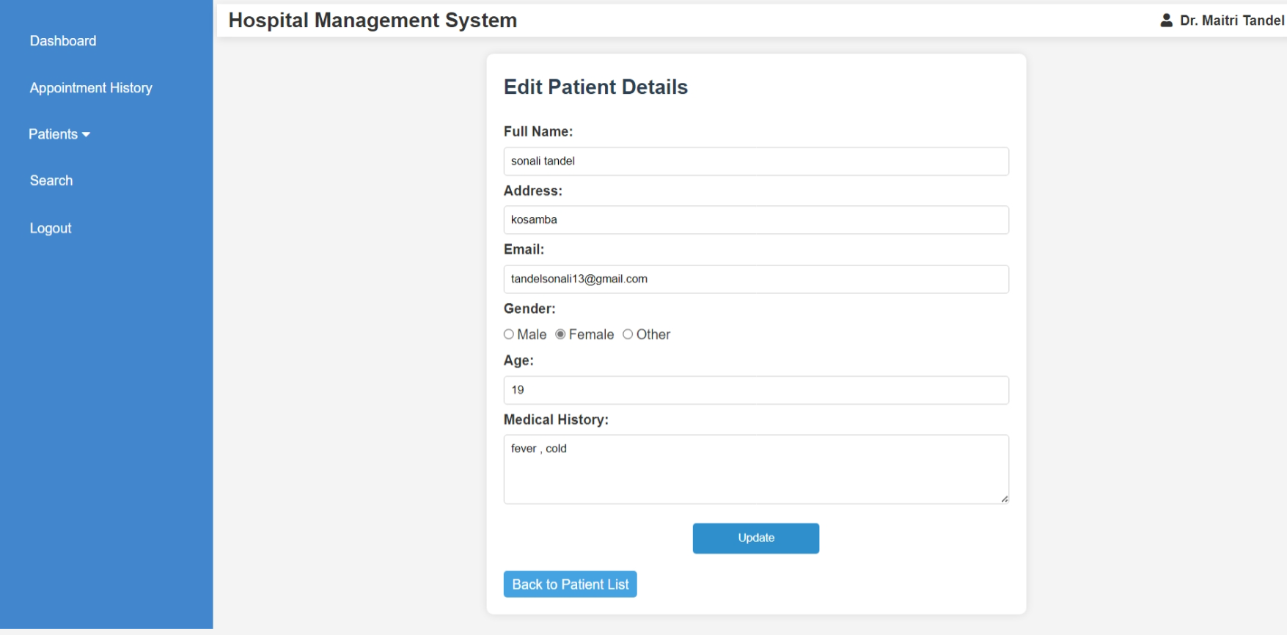

<?php

include("doctor_header.php");

include('database.php');

if (!isset($_SESSION['doctor_id'])) {

    header('Location: doctor_login.php');

    exit;

}

$doctor_id = intval($_SESSION['doctor_id']);

if (!isset($_GET['p_detail_id']) || empty($_GET['p_detail_id'])) {

    echo "<script>alert('Invalid patient ID.'); window.location.href='doctor_dashboard.php';</script>";

    exit;

}

$p_detail_id = intval($_GET['p_detail_id']);

$query = "SELECT * FROM patient_detail WHERE p_detail_id = '$p_detail_id' AND d_id = '$doctor_id'";

$result = mysqli_query($conn, $query);

if (!$result || mysqli_num_rows($result) == 0) {

    echo "<script>alert('Patient not found.'); window.location.href='doctor_dashboard.php';</script>";

    exit;

}

$patient = mysqli_fetch_assoc($result);

if ($_SERVER['REQUEST_METHOD'] == 'POST') {

    $p_name = mysqli_real_escape_string($conn, $_POST['p_name']);

    $p_add = mysqli_real_escape_string($conn, $_POST['p_add']);

    $p_email = mysqli_real_escape_string($conn, $_POST['p_email']);

    $p_gender = mysqli_real_escape_string($conn, $_POST['p_gender']);

    $p_age = intval($_POST['p_age']);

    $p_medhis = mysqli_real_escape_string($conn, $_POST['p_medhis']);

    $update_query = "UPDATE patient_detail SET

                        p_name='$p_name',

                        p_add='$p_add',

                        p_email='$p_email',

                        p_gender='$p_gender',

                        p_age='$p_age',

                        p_medhis='$p_medhis'

                    WHERE p_detail_id='$p_detail_id' AND d_id='$doctor_id'";

    if (mysqli_query($conn, $update_query)) {

        echo "<script>alert('Patient details updated successfully.'); window.location.href='view_patient.php?p_detail_id=$p_detail_id';</script>";

        exit;

    } else {

        echo "<script>alert('Error updating details: " . mysqli_error($conn) . "');</script>";

    }

}

?>

<!DOCTYPE html>

<html lang="en">

<head>

    <meta charset="UTF-8">

    <meta name="viewport" content="width=device-width, initial-scale=1.0">

    <title>Edit Patient</title>

    <style>

        body {

            font-family: Arial, sans-serif;

            background-color: #f4f4f4;

            margin: 0;

            padding: 0;

        }

        section.edit-form {

            width: 50%;

            margin: 20px auto;

            padding: 20px;

            background-color: #fff;

            border-radius: 8px;

            box-shadow: 0 0 10px rgba(0, 0, 0, 0.1);

        }

        h3 {

            color: #2c3e50;

            font-size: 24px;

            margin-bottom: 20px;

        }

        label {

            font-weight: bold;

        }

        input, select, textarea {

            width: 100%;

            padding: 8px;

            margin: 5px 0;

            border: 1px solid #ccc;

            border-radius: 4px;

        }

        input[type="submit"] {

            background-color: rgb(46, 143, 204);

            color: white;

            border: none;

            padding: 10px;

            cursor: pointer;

            border-radius: 4px;

            width: 25%;

            display: block;

            margin: 10px auto; /* Centers the button horizontally */

            text-align: center;

        }

        input[type="submit"]:hover {

            background-color:rgb(39, 118, 174);

        }

        .back-btn {

            display: inline-block;

            background-color:rgb(69, 163, 226);

            color: white;

            padding: 3px 10px;

            text-decoration: none;

            border-radius: 4px;

            margin-top: 10px;

        }

        .gender-options {

            display: flex;

            gap: 10px;

            margin: 5px 0;

            align-items: center;

        }

        .gender-options label {

            display: flex;

            align-items: center;

            font-weight: normal;

        }

        .gender-options input {

            margin-right: 3px;

        }

    </style>

</head>

<body>

<section class="edit-form">

    <h3>Edit Patient Details</h3>

    <form method="POST" action="">

        <label>Full Name:</label>

        <input type="text" name="p_name" value="<?php echo htmlspecialchars($patient['p_name']); ?>" required>

        <label>Address:</label>

        <input type="text" name="p_add" value="<?php echo htmlspecialchars($patient['p_add']); ?>" required>

        <label>Email:</label>

        <input type="email" name="p_email" value="<?php echo htmlspecialchars($patient['p_email']); ?>" required>

        <label>Gender:</label>

        <div class="gender-options">

            <label><input type="radio" name="p_gender" value="Male" <?php if ($patient['p_gender'] == 'Male') echo 'checked'; ?>> Male</label>

            <label><input type="radio" name="p_gender" value="Female" <?php if ($patient['p_gender'] == 'Female') echo 'checked'; ?>> Female</label>

            <label><input type="radio" name="p_gender" value="Other" <?php if ($patient['p_gender'] == 'Other') echo 'checked'; ?>> Other</label>

        </div>

        <label>Age:</label>

        <input type="number" name="p_age" value="<?php echo htmlspecialchars($patient['p_age']); ?>" required>

        <label>Medical History:</label>

        <textarea name="p_medhis" rows="4" required><?php echo htmlspecialchars($patient['p_medhis']); ?></textarea>

        <input type="submit" value="Update">

    </form>

    <a href="manage_patient.php" class="back-btn">Back to Patient List</a>

</section>

</body>

</html>

**Doctor Search Patient**

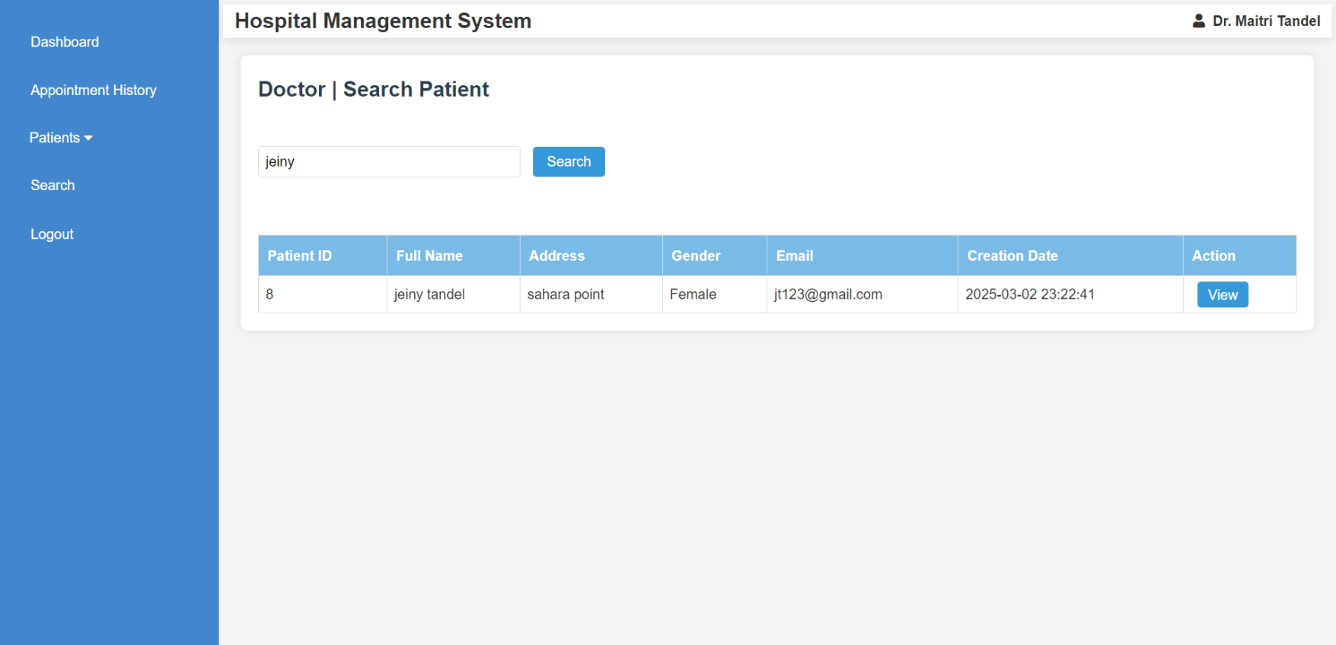<?php

    include("doctor_header.php");

    include('database.php');

    $searchQuery = '';

    if (isset($_POST['search'])) {

        $searchQuery = mysqli_real_escape_string($conn, $_POST['search_query']);

    }

    $query = "SELECT * FROM patient_detail WHERE p_name LIKE '%$searchQuery%' OR p_email LIKE '%$searchQuery%'";

    $result = mysqli_query($conn, $query);

?>

<style>

    body {

        font-family: Arial, sans-serif;

        background-color: #f4f4f4;

        margin: 0;

        padding: 0;

    }

    section.dashboard {

        margin: 20px;

        padding: 20px;

        background-color: #fff;

        border-radius: 8px;

        box-shadow: 0 0 10px rgba(0, 0, 0, 0.1);

    }

    h3 {

        color: #2c3e50;

        font-size: 24px;

        margin-bottom: 20px;

    }

    form {

        margin-bottom: 20px;

    }

    form input[type="text"] {

        padding: 8px;

        font-size: 16px;

        width: 300px;

        margin-right: 10px;

        border: 1px solid #ddd;

        border-radius: 4px;

    }

    form input[type="submit"] {

        padding: 8px 16px;

        background-color: #3498db;

        color: white;

        border: none;

        border-radius: 4px;

        cursor: pointer;

        font-size: 16px;

    }

    form input[type="submit"]:hover {

        background-color: #2980b9;

    }

    table {

        width: 100%;

        border-collapse: collapse;

        margin-top: 20px;

    }

    table, th, td {

        border: 1px solid #ddd;

    }

    th {

        background-color:rgb(121, 187, 230);

        color: white;

        padding: 10px;

        text-align: left;

    }

    td {

        padding: 8px;

        text-align: left;

    }

    td input[type="submit"] {

        background-color: #e74c3c;

        color: white;

        border: none;

        padding: 6px 12px;

        cursor: pointer;

        border-radius: 4px;

        transition: background-color 0.3s ease;

    }

    td input[type="submit"]:hover {

        background-color: #c0392b;

    }

    @media screen and (max-width: 768px) {

        table, th, td {

            font-size: 14px;

        }

        td input[type="submit"] {

            padding: 4px 8px;

        }

    }

</style>

<section class="dashboard">

<h3>Doctor | Search Patient</h3><br>

<form method="POST" action="">

    <input type="text" name="search_query" placeholder="Search by name or email" value="<?php echo $searchQuery; ?>" required>

    <input type="submit" name="search" value="Search">

</form>

<br>

<?php if (isset($_POST['search'])): ?>

    <table border="1">

        <thead>

            <tr>

                <th>Patient ID</th>

                <th>Full Name</th>

                <th>Address</th>

                <th>Gender</th>

                <th>Email</th>

                <th>Creation Date</th>

                <th>Action</th>

            </tr>

        </thead>

        <tbody>

            <?php

            if (mysqli_num_rows($result) > 0) {

                while ($row = mysqli_fetch_assoc($result)) {

                    echo "<tr>

                            <td>{$row['p_detail_id']}</td>

                            <td>{$row['p_name']}</td>

                            <td>{$row['p_add']}</td>

                            <td>{$row['p_gender']}</td>

                            <td>{$row['p_email']}</td>

                            <td>{$row['created_at']}</td>

                            <td>

                                <a href='view_patient.php?p_detail_id={$row['p_detail_id']}' style='background-color: #3498db; color: white; padding: 6px 12px; text-decoration: none; border-radius: 4px; margin-left: 8px;'>View</a>

                            </td>

                        </tr>";

                }

            } else {

                echo "<tr><td colspan='8'>No patients found.</td></tr>";

            }

            ?>

        </tbody>

    </table>

<?php endif; ?>

</section>

</body>

</html>

**Patient Register**

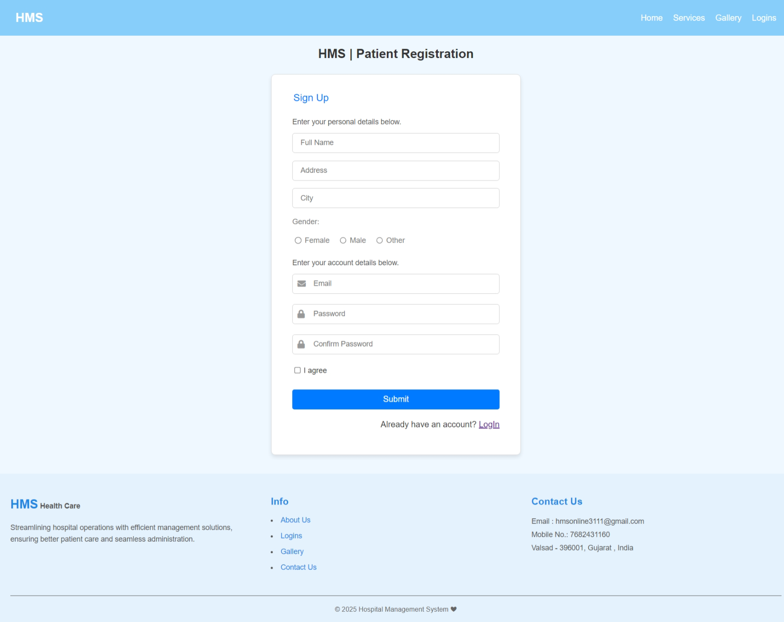

<?php

    session_start();

    include("header.php");

?>

<!DOCTYPE html>

<html lang="en">

<head>

    <meta charset="UTF-8">

    <meta name="viewport" content="width=device-width, initial-scale=1.0">

    <title>HMS | Patient Registration</title>

    <link href="https://cdnjs.cloudflare.com/ajax/libs/font-awesome/5.15.4/css/all.min.css" rel="stylesheet">

    <link rel="stylesheet" href="css/rl_style.css">

</head>

<body>

    <div class="container">

    <h1>HMS | Patient Registration</h1>

        <div class="form-container" style="margin-bottom: 3%;">

            <form action="<?php echo htmlspecialchars($_SERVER["PHP_SELF"])?>" method="POST">

                <fieldset>

                    <legend>Sign Up</legend>

                    <p class="p1">Enter your personal details below.</p>

                    <input type="text" id="fullname" name="fullname" class="input-field" placeholder="Full Name" required>

                    <input type="text" id="address" name="address" class="input-field" placeholder="Address" required>

                    <input type="text" id="city" name="city" class="input-field" placeholder="City" required>

                    <label style="color: grey;">Gender:</label>

                    <div class="radio-group" >

                        <input type="radio" id="female" name="gender" value="Female" required>

                        <label for="female" style="color: grey;">Female</label>

                        <input type="radio" id="male" name="gender" value="Male" required>

                        <label for="male" style="color: grey;">Male</label>

                        <input type="radio" id="other" name="gender" value="Other" required>

                        <label for="other" style="color: grey;">Other</label>

                    </div>

                    <p class="p1">Enter your account details below.</p>

                    <div class="input-group">

                    <label for="email">

                        <i class="fa fa-envelope"></i>

                    </label>

                    <input type="email" id="email" name="email" placeholder="Email" required>

                    </div>

                    <div class="input-group">

                    <label for="password">

                        <i class="fa fa-lock"></i>

                    </label>

                    <input type="password" id="password" name="password" placeholder="Password" required>

                    </div>

                    <div class="input-group">

                        <label for="confirm_password">

                            <i class="fa fa-lock"></i>

                        </label>

                        <input type="password" id="confirm_password" name="confirm_password" placeholder="Confirm Password" required>

                    </div>

                    <div class="checkbox-group">

                        <input type="checkbox" id="agree" name="agree" required>

                        <label for="agree">I agree</label>

                    </div>

                    <button type="submit" class="submit-btn">Submit</button>

                </fieldset>

    <?php

        include("database.php");

        if($_SERVER["REQUEST_METHOD"]=="POST"){

            $fullname =filter_input(INPUT_POST,"fullname",FILTER_SANITIZE_SPECIAL_CHARS);

            $address =filter_input(INPUT_POST,"address",FILTER_SANITIZE_SPECIAL_CHARS);

            $city =filter_input(INPUT_POST,"city",FILTER_SANITIZE_SPECIAL_CHARS);

            $gender =filter_input(INPUT_POST,"gender",FILTER_SANITIZE_SPECIAL_CHARS);

            $email =filter_input(INPUT_POST,"email",FILTER_SANITIZE_SPECIAL_CHARS);

            $password =filter_input(INPUT_POST,"password",FILTER_SANITIZE_SPECIAL_CHARS);

            $password_hash=password_hash($password,PASSWORD_DEFAULT);

            if(empty($_POST["fullname"]) || empty($_POST["email"]) || empty($_POST["address"]) || empty($_POST["city"]) || empty($_POST["gender"]) || empty($_POST["password"])){ echo "";}

            else{

                $sql = "INSERT INTO patient_mast(fullname, address, city, gender, email, password) VALUES ('$fullname', '$address', '$city', '$gender', '$email', '$password_hash')";

                try {

                    mysqli_query($conn, $sql);

                    $patient_id = $conn->insert_id;

                    $_SESSION['patient_id'] = $patient_id;

                    $_SESSION['email'] = $email;

                    $_SESSION['patient_name'] = $fullname;

                    header("Location: index.php");

                } catch (mysqli_sql_exception) {

                    echo "<p style='color:red'>Sign up failed..</p>";

                }

            }

        }

        mysqli_close($conn);

    ?>

    </form>

            <p>Already have an account? <a href="patient_login.php">LogIn</a></p>

        </div>

    </div>

    <?php

        include("footer.php");

    ?>

</body>

</html>

**Patient Login**

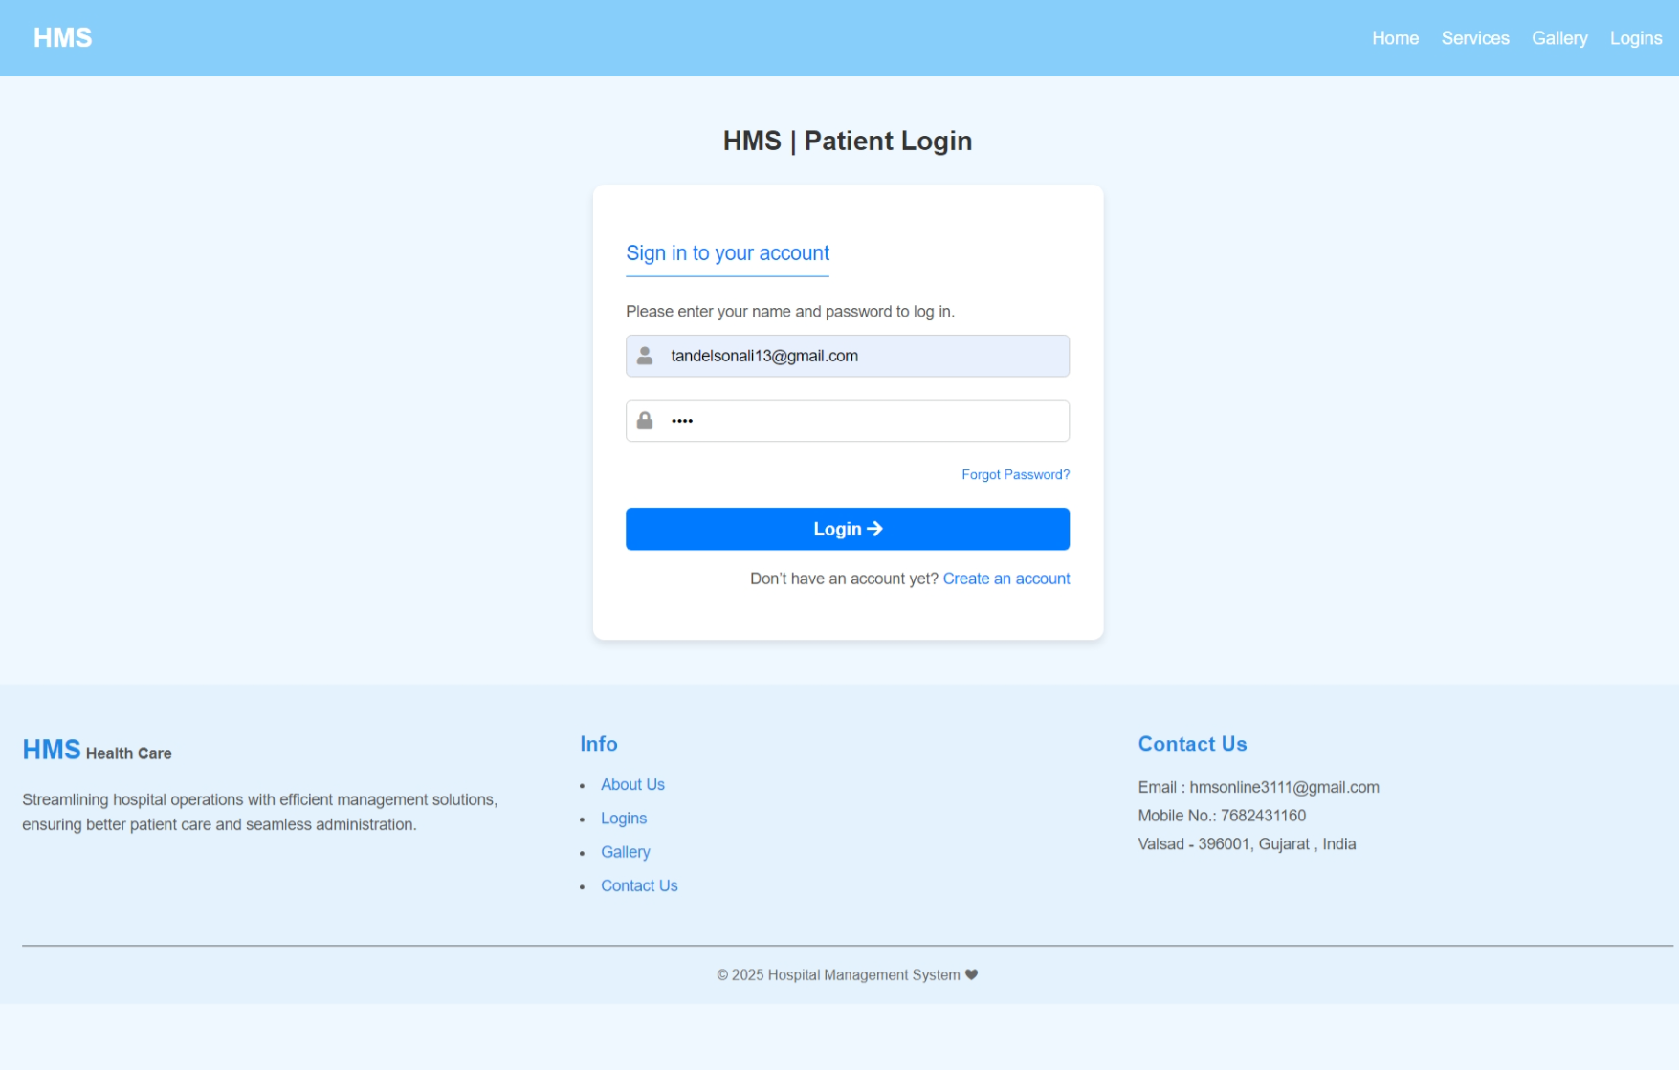<?php

    session_start();

    include("header.php");

?>

<!DOCTYPE html>

<html lang="en">

<head>

    <meta charset="UTF-8">

    <meta name="viewport" content="width=device-width, initial-scale=1.0">

    <title>HMS | Patient Login</title>

    <link href="https://cdnjs.cloudflare.com/ajax/libs/font-awesome/5.15.4/css/all.min.css" rel="stylesheet">

    <link rel="stylesheet" href="css/rl_style.css">

</head>

<body>

    <section class="login-container" style="margin-bottom: -23%;">

    <h1>HMS | Patient Login</h1>

        <div class="login-box" style="margin-bottom: 25%;">

            <form  method="POST" action="<?php echo htmlspecialchars($_SERVER["PHP_SELF"])?>">

                <p class="p2">Sign in to your account</p>

                <p class="p1">Please enter your name and password to log in.</p>

                <div class="input-group">

                    <label for="email">

                        <i class="fa fa-user"></i>

                    </label>

                    <input type="email" id="email" name="email" placeholder="Email" required>

                </div>

                <div class="input-group">

                    <label for="password">

                        <i class="fa fa-lock"></i>

                    </label>

                    <input type="password" id="password" name="password" placeholder="Password" required>

                </div>

                <a href="otp.php" class="forgot-password">Forgot Password?</a>

                <button type="submit" class="login-btn">Login <i class="fa fa-arrow-right"></i></button>

                <p class="register-link">

                    Don’t have an account yet? <a href="patient_register.php">Create an account</a>

                </p>

                <?php

                    include("database.php");

                    if($_SERVER["REQUEST_METHOD"]=="POST")

                    {

                        $email = filter_input(INPUT_POST,"email",FILTER_SANITIZE_SPECIAL_CHARS);

                        $password = filter_input(INPUT_POST,"password",FILTER_SANITIZE_SPECIAL_CHARS);

                        if(!empty($email) && !empty($password))

                        {

                            $sql = "SELECT * FROM patient_mast WHERE email = '$email'";

                            $result = mysqli_query($conn, $sql);

                            if (mysqli_num_rows($result) > 0) {

                                $user = mysqli_fetch_assoc($result);

                                if (password_verify($password, $user["password"])) {

                                    $_SESSION['patient_id']=$user['p_id'];

                                    $_SESSION['email']=$email;

                                    $_SESSION['patient_name']=$user['fullname'];

                                    header("Location:patient_index.php");

                                    exit;

                                } else {

                                    echo "<p style='color:red'>Incorrect password..!</p>";

                                }

                            } else {

                                echo "<p style='color:red'>Invalid email..!</p>";

                            }

                        }

                    }

                    mysqli_close($conn);

                ?>

            </form>

        </div>

    </section>

    <?php

        include("footer.php");

    ?>

</body>

</html>

**Patient Forget Password (OTP on email & Change Password)**

* **Otp**

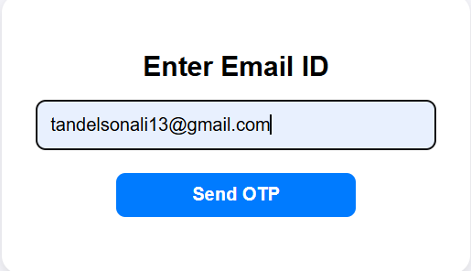 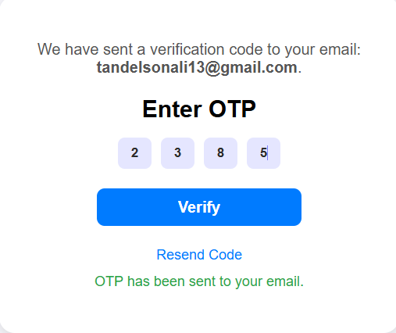 

<?php

include("database.php");

session_start();

use PHPMailer\PHPMailer\PHPMailer;

use PHPMailer\PHPMailer\Exception;

require('./PHPMailer-master/src/Exception.php');

require('./PHPMailer-master/src/PHPMailer.php');

require('./PHPMailer-master/src/SMTP.php');

function sendOtp($email,$otp){

    $mail=new PHPMailer(true);

    try{

        $mail->isSMTP();

        $mail->Host = 'smtp.gmail.com';

        $mail->SMTPAuth = true;

        $mail->Username = 'hmsonline3111@gmail.com';

        $mail->Password = 'qjcqkyuggdcmksbk';

        $mail->SMTPSecure = PHPMailer::ENCRYPTION_STARTTLS;

        $mail->Port = 587;

        $mail->setFrom('hmsonline3111@gmail.com', 'HMS');

        $mail->addAddress($email);

        $mail->isHTML(true);

        $mail->Subject='Recovery Password';

        $mail->Body="OTP: <b>$otp</b>";

        $mail->send();

        return true;

    }catch(Exception $e){

        return false;

    }

}

if ($_SERVER['REQUEST_METHOD'] === 'POST' && isset($_POST['send_otp'])) {

    $email = $_POST['email'];

    if (filter_var($email, FILTER_VALIDATE_EMAIL)) {

        $stmt = $conn->prepare("SELECT email FROM patient_mast WHERE email = ?");

        $stmt->bind_param("s", $email);

        $stmt->execute();

        $result = $stmt->get_result();

        if ($result->num_rows > 0) {

            $_SESSION['email'] = $email;

            $_SESSION['otp'] = rand(1000, 9999);

            if (sendOtp($email, $_SESSION['otp'])) {

                $otp_sent = "OTP has been sent to your email.";

            } else {

                $error = "Failed to send OTP.";

            }

        } else {

            echo "<script>

                    alert('Email not found in our records. Please try again.');

                    window.location.href = 'otp.php';

                  </script>";

            exit;

        }

        $stmt->close();

    } else {

        $error = "Invalid email address. Please try again.";

    }

}

if ($_SERVER['REQUEST_METHOD'] === 'POST' && isset($_POST['verify_otp'])) {

    $enteredOtp = $_POST['otp'];

    if ($enteredOtp == $_SESSION['otp']) {

        unset($_SESSION['otp']);

        header('Location: change_password.php');

        exit;

    } else {

        $error = "Invalid OTP. Please try again.";

    }

}

?>

<!DOCTYPE html>

<html lang="en">

<head>

    <meta charset="UTF-8">

    <meta name="viewport" content="width=device-width, initial-scale=1.0">

    <title>OTP Verification</title>

    <style>

        body {

            font-family: Arial, sans-serif;

            background-color: #f4f4f9;

            margin: 0;

            display: flex;

            justify-content: center;

            align-items: center;

            height: 100vh;

        }

        .otp-modal {

            background-color: #fff;

            border-radius: 16px;

            padding: 30px;

            box-shadow: 0 4px 10px rgba(0, 0, 0, 0.1);

            text-align: center;

            width: 100%;

            max-width: 350px;

            position: relative;

        }

        .otp-close {

            position: absolute;

            top: 15px;

            right: 15px;

            font-size: 18px;

            background: none;

            border: none;

            cursor: pointer;

        }

        .otp-heading {

            font-size: 1.5rem;

            margin-bottom: 15px;

            font-weight: bold;

        }

        .otp-subheading {

            font-size: 1rem;

            color: #555;

            margin-bottom: 20px;

        }

        .otp-input-container {

            width: 100%;

            display: flex;

            flex-direction: row;

            gap: 10px;

            align-items: center;

            justify-content: center;

            margin-bottom: 20px;

            }

        .otp-input {

            background-color: rgb(228, 228, 228);

            width: 30px;

            height: 30px;

            text-align: center;

            border: none;

            border-radius: 7px;

            caret-color: rgb(127, 129, 255);

            color: rgb(44, 44, 44);

            outline: none;

            font-weight: 600;

            }

        .otp-input:focus,

        .otp-input:valid {

            background-color: rgba(127, 129, 255, 0.199);

            transition-duration: .3s;

        }

        .otp-email {

                width: 100%;

                padding: 12px;

                font-size: 1rem;

                border: 1px solid #ccc;

                border-radius: 8px;

        }

        .otp-button {

                width: 60%;

                padding: 10px;

                background-color:#007bff;

                color: #fff;

                border: none;

                border-radius: 8px;

                font-size: 1rem;

                font-weight: bold;

                cursor: pointer;

                transition: background-color 0.3s ease;

                margin-bottom: 20px;

        }

        .otp-button:hover {

                background-color:#0056b3;

        }

        .otp-resend {

                margin-top: 15px;

                font-size: 0.9rem;

                color: #007bff;

                text-decoration: none;

                cursor: pointer;

        }

        .otp-resend:hover {

                text-decoration: underline;

        }

        .otp-error {

                color: #dc3545;

                font-size: 0.9rem;

                margin-top: 10px;

        }

    </style>

</head>

<body>

    <div class="otp-modal">

        <?php if (!isset($_POST['send_otp'])): ?>

            <form method="POST">

                <h2 class="otp-heading">Enter Email ID</h2>

                <div class="otp-input-container">

                    <input type="email" name="email" class="otp-email" placeholder="example@mail.xyz" required>

                </div>

                <button type="submit" name="send_otp" class="otp-button">Send OTP</button>

            </form>

        <?php else: ?>

            <p class="otp-subheading">We have sent a verification code to your email: <strong><?php echo htmlspecialchars($_SESSION['email']); ?></strong>.</p>

            <form method="POST">

                <h2 class="otp-heading">Enter OTP</h2>

                <div class="otp-input-container">

                    <input type="text" maxlength="1" name="otp_digit[]" class="otp-input" required>

                    <input type="text" maxlength="1" name="otp_digit[]" class="otp-input" required>

                    <input type="text" maxlength="1" name="otp_digit[]" class="otp-input" required>

                    <input type="text" maxlength="1" name="otp_digit[]" class="otp-input" required>

                </div>

                <input type="hidden" name="otp" id="otp" value="">

                <button type="submit" name="verify_otp" class="otp-button" onclick="combineOtp()">Verify</button>

            </form>

            <a href="#" class="otp-resend">Resend Code</a>

        <?php endif; ?>

        <?php if (isset($error)): ?>

            <p class="otp-error"><?php echo $error; ?></p>

        <?php elseif (isset($otp_sent)): ?>

            <p class="otp-error" style="color: #28a745;"><?php echo $otp_sent; ?></p>

        <?php endif; ?>

    </div>

    <script>

        function combineOtp() {

            const inputs = document.querySelectorAll('.otp-input');

            const otpField = document.getElementById('otp');

            otpField.value = Array.from(inputs).map(input => input.value).join('');

        }

    </script>

</body>

</html>

* **Change Password**

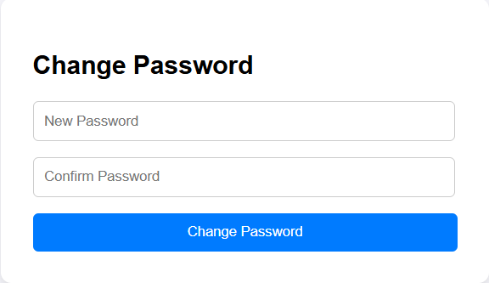

<?php

session_start();

if (!isset($_SESSION['email'])) {

    header('Location: otp.php');

    exit;

}

if ($_SERVER['REQUEST_METHOD'] === 'POST' && isset($_POST['change_password'])) {

    $new_password = $_POST['new_password'];

    $confirm_password = $_POST['confirm_password'];

    if ($new_password === $confirm_password) {

        $hashed_password = password_hash($new_password, PASSWORD_BCRYPT);

        $email = $_SESSION['email'];

        include("database.php");

        $stmt = $conn->prepare("UPDATE patient_mast SET password = ? WHERE email = ?");

        $stmt->bind_param('ss', $hashed_password, $email);

        if ($stmt->execute()) {

            unset($_SESSION['email']);

            $success = "Password changed successfully. You can now <a href='logins.php'>log in</a>";

        } else {

            $error = "Failed to update password.";

        }

        $stmt->close();

        $conn->close();

    } else {

        $error = "Passwords do not match.";

    }

}

?>

<!DOCTYPE html>

<html lang="en">

<head>

    <meta charset="UTF-8">

    <meta name="viewport" content="width=device-width, initial-scale=1.0">

    <title>Change Password</title>

    <style>

        body {

            font-family: Arial, sans-serif;

            display: flex;

            justify-content: center;

            align-items: center;

            height: 100vh;

            background-color: #f4f4f9;

        }

        .form-container {

            background: white;

            padding: 30px;

            border-radius: 10px;

            box-shadow: 0 4px 8px rgba(0, 0, 0, 0.1);

            width: 100%;

            max-width: 400px;

        }

        .form-container h2 {

            margin-bottom: 20px;

        }

        .form-container input {

            width: 94%;

            padding: 10px;

            margin-bottom: 15px;

            border: 1px solid #ccc;

            border-radius: 5px;

        }

        .form-container button {

            width: 100%;

            padding: 10px;

            background-color: #007bff;;

            color: white;

            border: none;

            border-radius: 5px;

            cursor: pointer;

        }

        .form-container button:hover {

            background-color:rgb(67, 72, 177);

        }

        .error, .success {

            color: red;

            font-size: 0.9rem;

        }

        .success {

            color: green;

        }

    </style>

</head>

<body>

    <div class="form-container">

        <h2>Change Password</h2>

        <form method="POST">

            <input type="password" name="new_password" placeholder="New Password" required>

            <input type="password" name="confirm_password" placeholder="Confirm Password" required>

            <button type="submit" name="change_password">Change Password</button>

        </form>

        <?php if (isset($error)): ?>

            <p class="error"><?php echo $error; ?></p>

        <?php elseif (isset($success)): ?>

            <p class="success"><?php echo $success; ?></p>

        <?php endif; ?>

    </div>

</body>

</html>

**Patient Account**

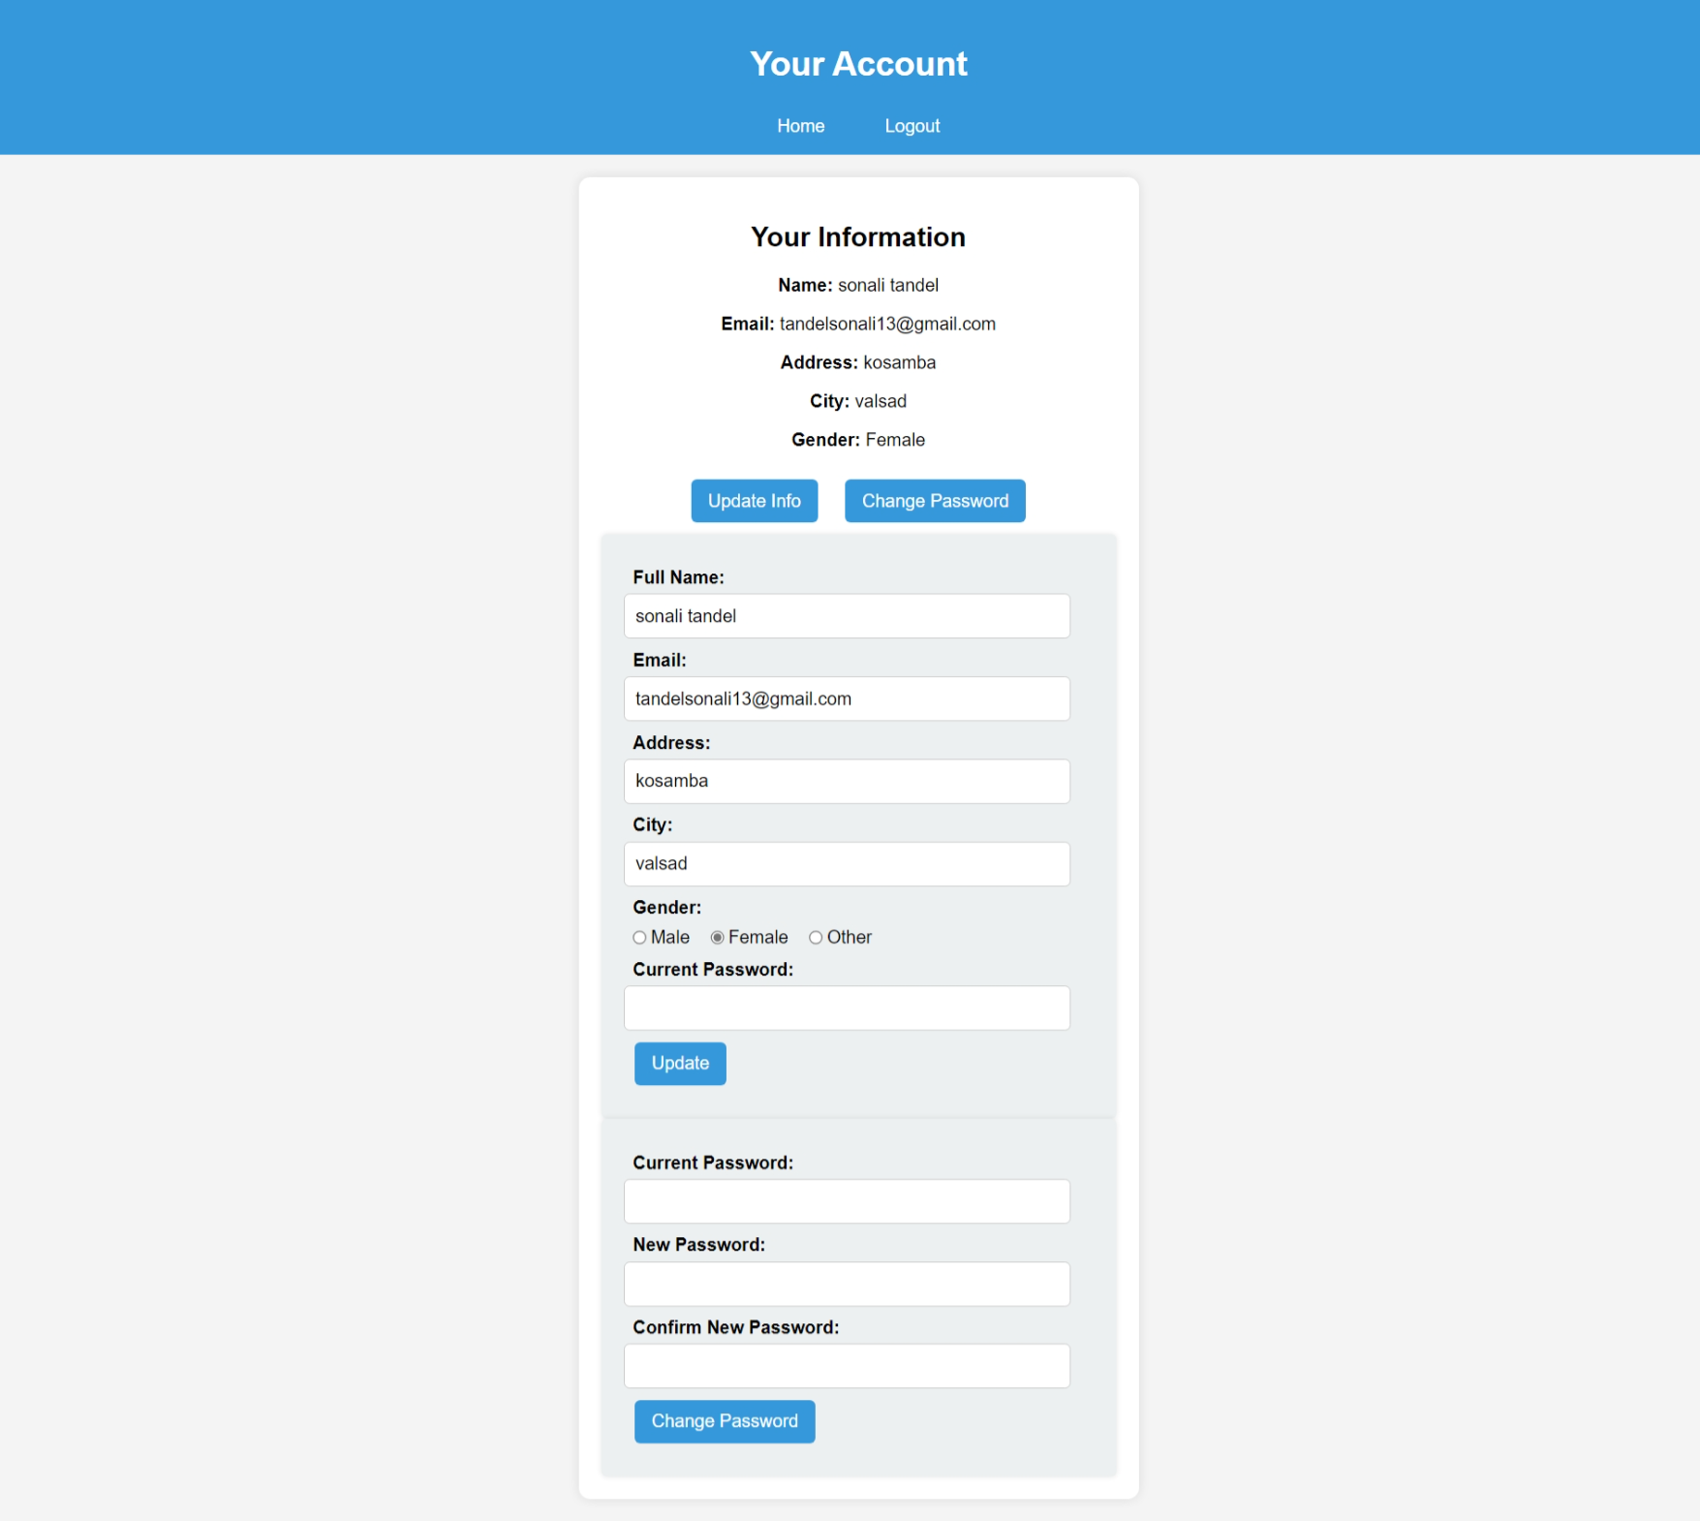

<?php

session_start();

include("database.php");

if (!isset($_SESSION['patient_id'])) {

    header("Location: patient_login.php");

    exit();

}

$patient_id = $_SESSION['patient_id'];

$query = "SELECT * FROM patient_mast WHERE p_id = '$patient_id'";

$result = mysqli_query($conn, $query);

if ($result && mysqli_num_rows($result) > 0) {

    $patient = mysqli_fetch_assoc($result);

} else {

    die("Patient not found.");

}

$message = "";

if ($_SERVER["REQUEST_METHOD"] == "POST" && isset($_POST['update'])) {

    $name = trim($_POST['fullname']);

    $new_email = trim($_POST['email']);

    $password = trim($_POST['password']);

    $address = trim($_POST['address']);

    $city = trim($_POST['city']);

    $gender = trim($_POST['gender']);

    $name = mysqli_real_escape_string($conn, $name);

    $new_email = mysqli_real_escape_string($conn, $new_email);

    $password = mysqli_real_escape_string($conn, $password);

    $address = mysqli_real_escape_string($conn, $address);

    $city = mysqli_real_escape_string($conn, $city);

    $gender = mysqli_real_escape_string($conn, $gender);

    if (password_verify($password, $patient['password'])) {

        $update_query = "UPDATE patient_mast SET fullname='$name', email='$new_email', address='$address', city='$city', gender='$gender' WHERE p_id='$patient_id'";

        if (mysqli_query($conn, $update_query)) {

            echo "<script>alert('Account details updated successfully!'); window.location.href='patient_account.php';</script>";

            exit();

        } else {

            echo "<script>alert('Error updating account details.');</script>";

        }

    } else {

        echo "<script>alert('Incorrect password. Please try again.');</script>";

    }

}

if ($_SERVER["REQUEST_METHOD"] == "POST" && isset($_POST['change_password'])) {

    $password = trim($_POST['password']);

    $new_password = trim($_POST['new_password']);

    $confirm_password = trim($_POST['confirm_password']);

    if (password_verify($password, $patient['password'])) {

        if ($new_password === $confirm_password) {

            $hashed_new_password = password_hash($new_password, PASSWORD_DEFAULT);

            $update_query = "UPDATE patient_mast SET password='$hashed_new_password' WHERE p_id='$patient_id'";

            if (mysqli_query($conn, $update_query)) {

                echo "<script>alert('Password updated successfully!'); window.location.href='patient_account.php';</script>";

                exit();

            } else {

                echo "<script>alert('Error updating password.');</script>";

            }

        } else {

            echo "<script>alert('New passwords do not match!');</script>";

        }

    } else {

        echo "<script>alert('Incorrect current password!');</script>";

    }

}

?>

<!DOCTYPE html>

<html lang="en">

<head>

    <meta charset="UTF-8">

    <meta name="viewport" content="width=device-width, initial-scale=1.0">

    <title>Patient Account</title>

    <style>

        body {

            font-family: Arial, sans-serif;

            background-color: #f4f4f4;

            margin: 0;

            padding: 0;

        }

        header {

            background-color: #3498db;

            color: white;

            padding: 15px;

            text-align: center;

            font-size: 20px;

        }

        nav {

            margin-top: 10px;

        }

        nav a {

            color: white;

            text-decoration: none;

            margin: 0 10px;

            font-size: 16px;

        }

        .container {

            width: 30%;

            background-color: white;

            margin: 20px auto;

            padding: 20px;

            border-radius: 10px;

            box-shadow: 0 0 10px rgba(0, 0, 0, 0.1);

        }

        .sec {

            text-align: center;

        }

        .btn {

            background-color: #3498db;

            color: white;

            border: none;

            padding: 10px 15px;

            border-radius: 5px;

            cursor: pointer;

            font-size: 16px;

            margin: 10px;

        }

        .btn:hover {

            background-color: #2980b9;

        }

        .form-section {

            display: none;

            padding: 20px;

            background-color: #ecf0f1;

            border-radius: 5px;

            box-shadow: 0 0 5px rgba(0, 0, 0, 0.1);

            text-align: left;

        }

        .form-section label {

            display: block;

            text-align: left;

            font-weight: bold;

            margin-top: 10px;

            margin-left: 2%;

        }

        .radio-group {

            display: flex;

            align-items: center;

            gap:10px; /* Space between Male and Female */

        }

        .radio-group label {

            display: flex;

            align-items: center;

            gap: 3px;

            margin: 0;

            margin-left: 2%;

            margin-top: 2%;

            font-weight: lighter;

        }

        .radio-group input[type="radio"] {

            margin: 0;

            padding: 0;

        }

        input, select {

            width: 90%;

            padding: 10px;

            margin-top: 5px;

            border: 1px solid #ccc;

            border-radius: 5px;

            font-size: 16px;

        }

    </style>

</head>

<body>

    <header>

        <h2>Your Account</h2>

        <nav>

            <a href="patient_index.php">Home</a>&nbsp;&nbsp;&nbsp;&nbsp;&nbsp;

            <a href="logout.php">Logout</a>

        </nav>

    </header>

    <div class="container">

        <section class="sec">

            <h2>Your Information</h2>

            <p><strong>Name:</strong> <?php echo htmlspecialchars($patient['fullname']); ?></p>

            <p><strong>Email:</strong> <?php echo htmlspecialchars($patient['email']); ?></p>

            <p><strong>Address:</strong> <?php echo htmlspecialchars($patient['address']); ?></p>

            <p><strong>City:</strong> <?php echo htmlspecialchars($patient['city']); ?></p>

            <p><strong>Gender:</strong> <?php echo htmlspecialchars($patient['gender']); ?></p>

            <?php if ($message): ?>

                <p style="color: red;"><?php echo $message; ?></p>

            <?php endif; ?>

            <button class="btn" onclick="toggleForm('update-info-form')">Update Info</button>

            <button class="btn" onclick="toggleForm('change-password-form')">Change Password</button>

            <form method="POST" id="update-info-form" class="form-section">

                <label>Full Name:</label>

                <input type="text" name="fullname" value="<?php echo htmlspecialchars($patient['fullname']); ?>" required>

                <label>Email:</label>

                <input type="email" name="email" value="<?php echo htmlspecialchars($patient['email']); ?>" required>

                <label>Address:</label>

                <input type="text" name="address" value="<?php echo htmlspecialchars($patient['address']); ?>" required>

                <label>City:</label>

                <input type="text" name="city" value="<?php echo htmlspecialchars($patient['city']); ?>" required>

                <label>Gender:</label>

                <div class="radio-group">

                    <label><input type="radio" name="gender" value="Male" <?php if ($patient['gender'] == 'Male') echo 'checked'; ?>>Male</label>

                    <label><input type="radio" name="gender" value="Female" <?php if ($patient['gender'] == 'Female') echo 'checked'; ?>>Female</label>

                    <label><input type="radio" name="gender" value="Other" <?php if ($patient['gender'] == 'Other') echo 'checked'; ?>>Other</label>

                </div>

                <label>Current Password:</label>

                <input type="password" name="password" required>

                <button type="submit" class="btn" name="update">Update</button>

            </form>

            <form method="POST" id="change-password-form" class="form-section">

                <label>Current Password:</label>

                <input type="password" name="password" required>

                <label>New Password:</label>

                <input type="password" name="new_password" required>

                <label>Confirm New Password:</label>

                <input type="password" name="confirm_password" required>

                <button type="submit" class="btn" name="change_password">Change Password</button>

            </form>

        </section>

    </div>

    <script>

        function toggleForm(formId) {

            var form = document.getElementById(formId);

            form.style.display = form.style.display === "block" ? "none" : "block";

        }

    </script>

</body>

</html>

**Patient Header**

<?php

    include('database.php');

    if (!isset($_SESSION['patient_id'])) {

        header('Location: patient_login.php');

        exit;

    }

    $patient_name = $_SESSION['patient_name'];

?>

<!DOCTYPE html>

<html lang="en">

<head>

    <meta charset="UTF-8">

    <meta name="viewport" content="width=device-width, initial-scale=1.0">

    <title>Hospital Management System</title>

    <link rel="website icon" href="img/logo1.jpg" type="jpg">

    <link href="https://cdnjs.cloudflare.com/ajax/libs/font-awesome/5.15.4/css/all.min.css" rel="stylesheet">

    <link rel="stylesheet" href="css/style.css">

    <style>

        * {

        margin: 0;

        padding: 0;

        box-sizing: border-box;

        font-family: Arial, sans-serif;

        }

        body {

            display: flex;

            background-color: #f0f8ff;

        }

        .sidebar {

            width: 250px;

            height: 100vh;

            background:rgb(66, 134, 206);

            color: white;

            padding: 20px;

        }

        .sidebar h2 {

            text-align: center;

            margin-bottom: 20px;

        }

        .sidebar ul {

            list-style: none;

            padding: 0;

        }

        .sidebar ul li {

            padding: 15px;

        }

        .sidebar ul li a {

            color: white;

            text-decoration: none;

            display: block;

        }

        .sidebar ul li a:hover {

            background:rgb(94, 142, 193);

            border-radius: 5px;

        }

        .main-content {

            flex: 1;

            padding:5px;

        }

        header {

            display: flex;

            justify-content: space-between;

            align-items: center;

            background: white;

            box-shadow: 0px 2px 10px rgba(0, 0, 0, 0.1);

        }

        .dashboard {

            margin-top: 20px;

        }

        .cards {

            display: flex;

            justify-content: space-evenly;

            gap: 15px;

        }

        .card {

            background: white;

            padding: 20px;

            text-align: center;

            width: 30%;

            border-radius: 10px;

            box-shadow: 0px 4px 10px rgba(0, 0, 0, 0.1);

        }

        .card img {

            width: 50px;

            margin-bottom: 10px;

        }

        .card a {

            display: block;

            margin-top: 10px;

            color:rgb(50, 128, 210);

            text-decoration: none;

        }

        .card a:hover {

            text-decoration: underline;

        }

    </style>

</head>

<body>

    <div class="sidebar">

        <ul>

            <li><a href="patient_index.php">Dashboard</a></li>

            <li><a href="book_appointment.php">Book Appointment</a></li>

            <li><a href="appointment_history.php">Appointment History</a></li>

            <li><a href="medical_history.php">Medical History</a></li>

            <li><a href="logout.php" onclick="confirmLogout()">Logout</a></li>

            <script>

                function confirmLogout() {

                    if (confirm("Are you sure you want to log out?")) {

                        window.location.href = "logout.php";

                    }

                }

            </script>

        </ul>

    </div>

    <div class="main-content">

        <header>

            <h2>&nbsp;&nbsp;Hospital Management System</h2>

            <div class="user-info" style="font-weight: bold; margin-right:1%;">

            <i class="fas fa-user"></i>&nbsp;&nbsp;<?php echo $patient_name; ?>

            </div>

        </header>

**Patient Dashboard**

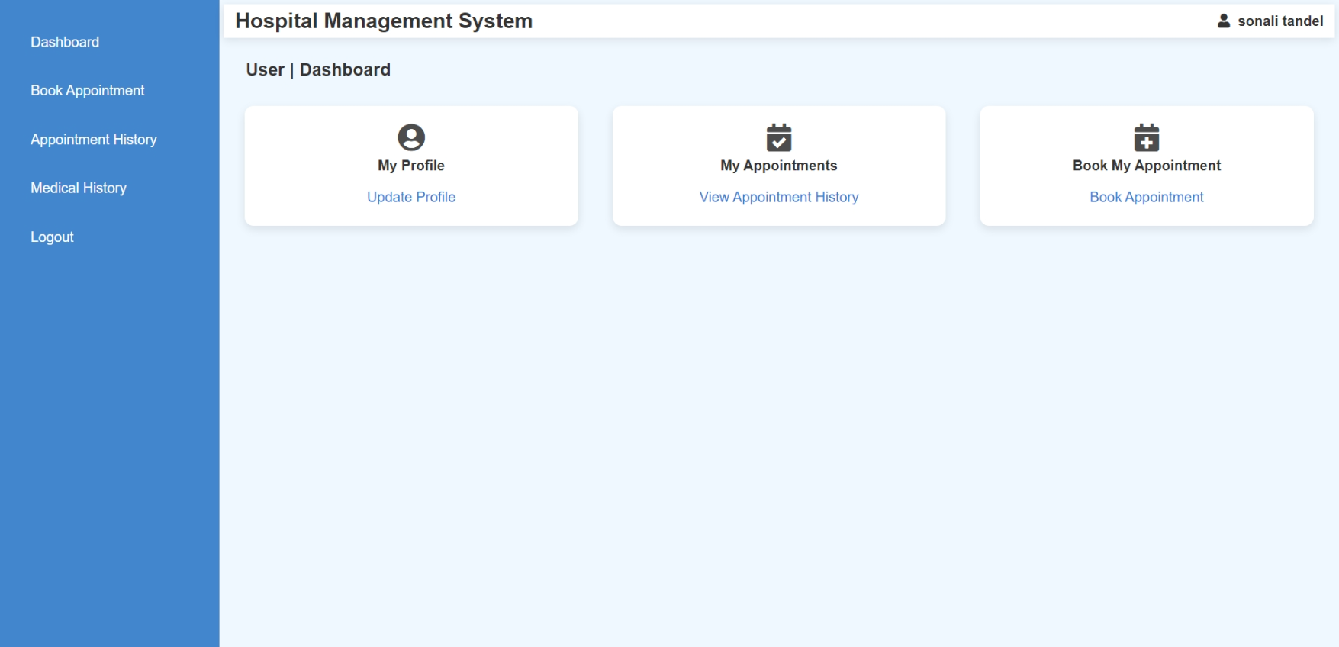

<?php

    session_start();

    include('database.php');

    if(isset($_SESSION['patient_name'])){

        $patient_name = $_SESSION['patient_name'];

    }

    else{

        header('location:patient_login.php');

    }

?>

<?php

    include("patient_header.php");

?>

            <section class="dashboard">

            <h3 style="margin-left: 2%; font-size:20px;">User | Dashboard</h3><br>

            <div class="cards">

                <div class="card">

                    <i class="fas fa-user-circle fa-2x" style="opacity: 0.9;"></i><br>

                    <h4>My Profile</h4>

                    <a href="patient_account.php">Update Profile</a>

                </div>

                <div class="card">

                    <i class="fas fa-calendar-check fa-2x" style="opacity: 0.9;"></i>

                    <h4>My Appointments</h4>

                    <a href="appointment_history.php">View Appointment History</a>

                </div>

                <div class="card">

                    <i class="fas fa-calendar-plus fa-2x" style="opacity: 0.9;"></i>

                    <h4>Book My Appointment</h4>

                    <a href="book_appointment.php">Book Appointment</a>

                </div>

            </div>

        </section>

    </div>

</body>

</html>

**Patient Book Appointment**

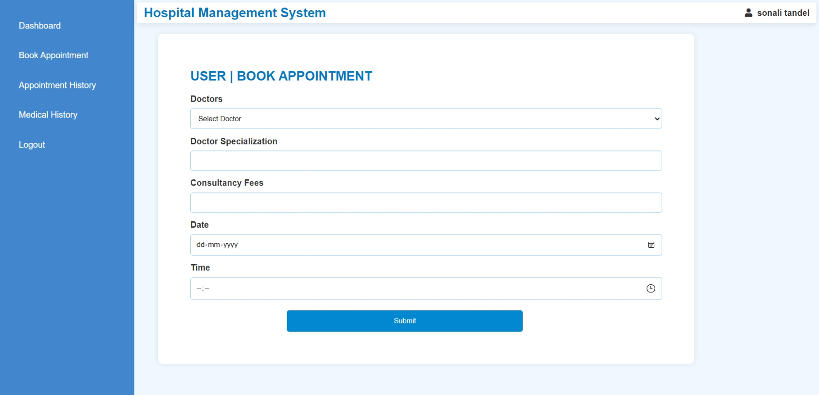

<?php

session_start();

include('database.php');

if (!isset($_SESSION['patient_id'])) {

    header('location:patient_login.php');

    exit;

}

$patient_id = $_SESSION['patient_id'];

$message = "";

if ($_SERVER['REQUEST_METHOD'] === 'POST') {

    $doctor_id = mysqli_real_escape_string($conn, $_POST['doctor']);

    $specialization = mysqli_real_escape_string($conn, $_POST['specialization']);

    $docfees = mysqli_real_escape_string($conn, $_POST['docfees']);

    $date = mysqli_real_escape_string($conn, $_POST['date']);

    $time = mysqli_real_escape_string($conn, $_POST['time']);

    if (!empty($doctor_id) && !empty($specialization) && !empty($docfees) && !empty($date) && !empty($time)) {

        $min_time = "10:00";

        $max_time = "17:00";

        if ($time < $min_time || $time > $max_time) {

            $message = "<p style='color: red; text-align: center;'>Appointments can only be booked between 10:00 AM and 5:00 PM.</p>";

        } else {

            $checkQuery = "SELECT * FROM appointment

                           WHERE d_id='$doctor_id'

                           AND a_date='$date'

                           AND ABS(TIMESTAMPDIFF(MINUTE, STR_TO_DATE(a_time, '%H:%i'), STR_TO_DATE('$time', '%H:%i'))) < 15";

            $result = mysqli_query($conn, $checkQuery);

            if (mysqli_num_rows($result) > 0) {

                $message = "<p style='color: red; text-align: center;'>This doctor is already booked within 15 minutes of the selected time. Please choose another time.</p>";

            } else {

                $insertQuery = "INSERT INTO appointment (specilization, d_id, p_id, fees, a_date, a_time, userstatus, d_status)

                                VALUES ('$specialization', '$doctor_id', '$patient_id', '$docfees', '$date', '$time', 1, 0)";

                if (mysqli_query($conn, $insertQuery)) {

                    $message = "<p style='color: green; text-align: center;'>Appointment successfully booked.</p>";

                } else {

                    $message = "<p style='color: red; text-align: center;'>Error booking appointment: " . mysqli_error($conn) . "</p>";

                }

            }

        }

    } else {

        $message = "<p style='color: red; text-align: center;'>All fields are required.</p>";

    }

}

?>

<!DOCTYPE html>

<html lang="en">

<head>

    <meta charset="UTF-8">

    <meta name="viewport" content="width=device-width, initial-scale=1.0">

    <title>Book Appointment</title>

    <link rel="stylesheet" href="styles.css">

    <style>

        .form-container {

            margin-left: 40px;

            margin-top: 20px;

            background: white;

            padding: 60px;

            border-radius: 8px;

            box-shadow: 0px 0px 10px rgba(0, 0, 0, 0.1);

            width: 1000px;

        }

        h2 {

            color: #0277bd;

        }

        label {

            display: block;

            margin-top: 10px;

            font-weight: bold;

            text-align: left;

        }

        select, input {

            width: 100%;

            padding: 10px;

            margin-top: 5px;

            border: 1px solid #90caf9;

            border-radius: 4px;

        }

        button {

            width: 50%;

            padding: 12px;

            background: #0288d1;

            color: white;

            border: none;

            border-radius: 4px;

            margin-left: 20.50%;

            margin-top: 20px;

            cursor: pointer;

        }

        button:hover {

            background: #01579b;

        }

        .message {

            text-align: center;

            font-size: 16px;

            margin-top: 10px;

        }

    </style>

</head>

<body>

<?php include("patient_header.php"); ?>

<div class="form-container">

    <h2>USER | BOOK APPOINTMENT</h2>

    <?php echo $message; ?>

    <form method="POST" action="" onsubmit="return validateTime()">

        <label>Doctors</label>

        <select name="doctor" id="doctor" required>

            <option value="">Select Doctor</option>

            <?php

            $doctorQuery = "SELECT d_id, name, specilization, docfees FROM doctor_mast";

            $doctorResult = mysqli_query($conn, $doctorQuery);

            if ($doctorResult && mysqli_num_rows($doctorResult) > 0) {

                while ($row = mysqli_fetch_assoc($doctorResult)) {

                    echo "<option value='{$row['d_id']}' data-specialization='{$row['specilization']}' data-fees='{$row['docfees']}'>{$row['name']}</option>";

                }

            } else {

                echo "<option disabled>No doctors available</option>";

            }

            ?>

        </select>

        <label>Doctor Specialization</label>

        <input type="text" id="specialization" name="specialization" readonly>

        <label>Consultancy Fees</label>

        <input type="text" id="docfees" name="docfees" readonly>

        <label>Date</label>

        <input type="date" name="date" required min="<?php echo date('Y-m-d'); ?>">

        <label>Time</label>

        <input type="time" name="time" id="time" required min="10:00" max="17:00">

        <button type="submit">Submit</button>

    </form>

</div>

<script>

    document.getElementById("doctor").addEventListener("change", function() {

        let selectedDoctor = this.options[this.selectedIndex];

        document.getElementById("specialization").value = selectedDoctor.getAttribute("data-specialization") || "";

        document.getElementById("docfees").value = selectedDoctor.getAttribute("data-fees") || "";

    });

    function validateTime() {

        let timeInput = document.getElementById("time").value;

        let minTime = "10:00";

        let maxTime = "17:00";

        if (timeInput < minTime || timeInput > maxTime) {

            alert("Appointments can only be booked between 10:00 AM and 5:00 PM.");

            return false;

        }

        return true;

    }

</script>

</body>

</html>

**Patient Appointment History**

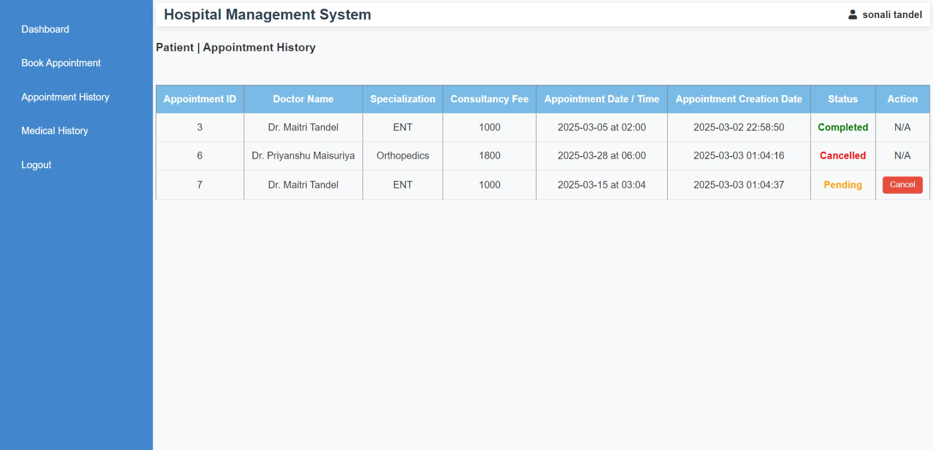

<?php

session_start();

include('database.php');

if (!isset($_SESSION['patient_id'])) {

    echo "<p>Error: Patient ID not found in session.</p>";

    exit;

}

$p_id = $_SESSION['patient_id'];

if (isset($_POST['cancel']) && isset($_POST['a_id'])) {

    $a_id = mysqli_real_escape_string($conn, $_POST['a_id']);

    $query = "UPDATE appointment SET d_status = 2 WHERE a_id = '$a_id' AND p_id = '$p_id'";

    $result = mysqli_query($conn, $query);

    if ($result) {

        echo "<script>alert('Appointment cancelled successfully.'); window.location.href='appointment_history.php';</script>";

    } else {

        echo "<p>Error cancelling appointment: " . mysqli_error($conn) . "</p>";

    }

}

$query = "SELECT a.a_id, d.name AS doctor_name, d.specilization AS specialization, d.docfees AS fees,

                 a.a_date, a.a_time, a.postingdate AS created_at, a.d_status

          FROM appointment a

          JOIN doctor_mast d ON a.d_id = d.d_id

          WHERE a.p_id = '$p_id'";

$result = mysqli_query($conn, $query);

?>

<?php include("patient_header.php"); ?>

<!DOCTYPE html>

<html lang="en">

<head>

    <meta charset="UTF-8">

    <meta name="viewport" content="width=device-width, initial-scale=1.0">

    <title>Appointment History</title>

    <link rel="stylesheet" href="styles.css">

    <style>

        body {

            font-family: Arial, sans-serif;

            background-color: #f8f9fa;

            margin: 0;

            padding: 0;

        }

        .container {

            width: 80%;

            margin: 20px auto;

            background: white;

            padding: 20px;

            border-radius: 8px;

            box-shadow: 0 0 10px rgba(0, 0, 0, 0.1);

        }

        h2 {

            color: #2c3e50;

            text-align: center;

        }

        table {

            width: 100%;

            border-collapse: collapse;

            margin-top: 20px;

        }

        th, td {

            padding: 10px;

            text-align: center;

            border-bottom: 1px solid #ddd;

        }

        th {

            background-color: rgb(121, 187, 230);

            color: white;

        }

        .cancel-btn {

            background-color: #e74c3c;

            color: white;

            border: none;

            padding: 6px 12px;

            cursor: pointer;

            border-radius: 4px;

            transition: background-color 0.3s ease;

            text-decoration: none;

        }

        .cancel-btn:hover {

            background-color: #c0392b;

        }

        .status-pending {

            color: orange;

            font-weight: bold;

        }

        .status-completed {

            color: green;

            font-weight: bold;

        }

        .status-cancelled {

            color: red;

            font-weight: bold;

        }

    </style>

</head>

<body>

<section class="dashboard">

<h3>Patient | Appointment History</h3><br>

<table border="1">

    <thead>

        <tr>

            <th>Appointment ID</th>

            <th>Doctor Name</th>

            <th>Specialization</th>

            <th>Consultancy Fee</th>

            <th>Appointment Date / Time</th>

            <th>Appointment Creation Date</th>

            <th>Status</th>

            <th>Action</th>

        </tr>

    </thead>

    <tbody>

        <?php

        if (mysqli_num_rows($result) > 0) {

            while ($row = mysqli_fetch_assoc($result)) {

                $status = "";

                $status_class = "";

                if ($row['d_status'] == 0) {

                    $status = "Pending";

                    $status_class = "status-pending";

                } elseif ($row['d_status'] == 1) {

                    $status = "Completed";

                    $status_class = "status-completed";

                } elseif ($row['d_status'] == 2) {

                    $status = "Cancelled";

                    $status_class = "status-cancelled";

                }

                echo "<tr>

                        <td>{$row['a_id']}</td>

                        <td>{$row['doctor_name']}</td>

                        <td>{$row['specialization']}</td>

                        <td>{$row['fees']}</td>

                        <td>{$row['a_date']} at {$row['a_time']}</td>

                        <td>{$row['created_at']}</td>

                        <td class='{$status_class}'>{$status}</td>

                        <td>";

                if ($row['d_status'] == 0) {

                    echo "<form method='POST' action='' onsubmit='return confirmDelete()'>

                              <input type='hidden' name='a_id' value='{$row['a_id']}'>

                              <input type='submit' class='cancel-btn' name='cancel' value='Cancel'>

                          </form>";

                } else {

                    echo "N/A";

                }

                echo "</td></tr>";

            }

        } else {

            echo "<tr><td colspan='8'>No Appointment Found.</td></tr>";

        }

        ?>

    </tbody>

</table>

</section>

<script>

    function confirmDelete() {

        return confirm('Are you sure you want to cancel this appointment?');

    }

</script>

</body>

</html>

**Patient Medical History**

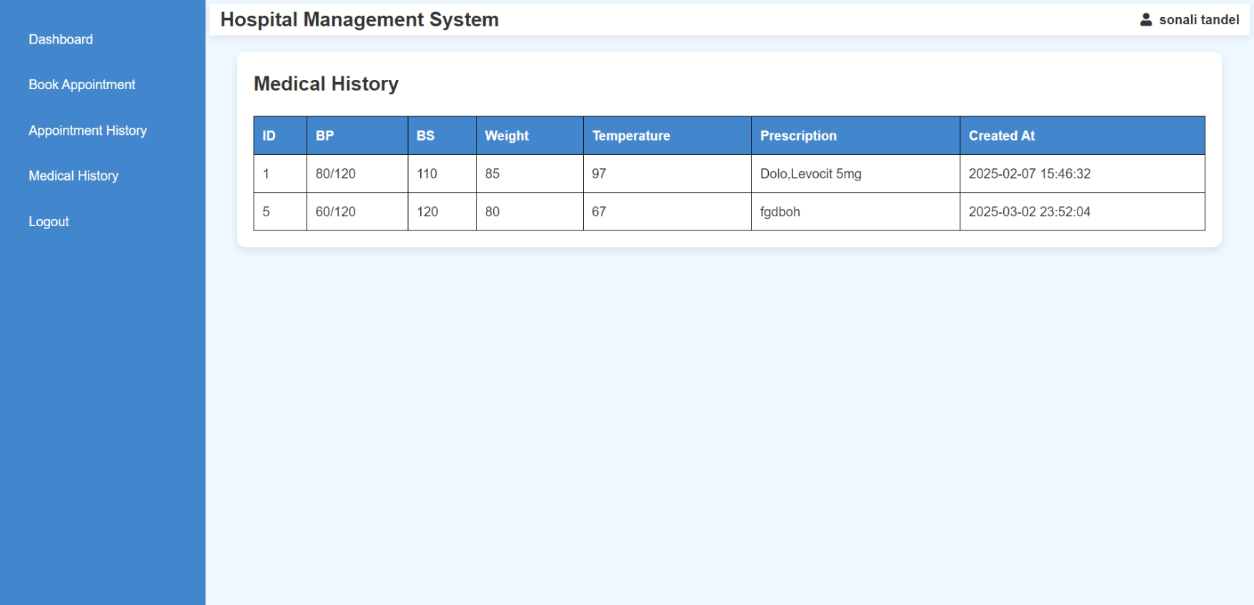

<?php

session_start();

include("database.php");

$p_id = (int)$_SESSION['patient_id'];

$sql_history = "SELECT * FROM medical_history WHERE p_detail_id = $p_id";

$result_history = $conn->query($sql_history);

?>

<?php

include("patient_header.php");

?>

<!DOCTYPE html>

<html lang="en">

<head>

    <meta charset="UTF-8">

    <meta name="viewport" content="width=device-width, initial-scale=1.0">

    <title>Medical History</title>

    <style>

        body {

            font-family: Arial, sans-serif;

            background-color: #f0f8ff;

            margin: 0;

            padding: 0;

        }

        .container {

            width: 98%;

            margin: 20px auto;

            background: white;

            padding: 20px;

            border-radius: 10px;

            box-shadow: 0px 4px 10px rgba(0, 0, 0, 0.1);

        }

        table {

            width: 100%;

            border-collapse: collapse;

            margin-top: 20px;

        }

        table, th, td {

            border: 1px solid black;

        }

        th, td {

            padding: 10px;

            text-align: left;

        }

        th {

            background-color: rgb(66, 134, 206);

            color: white;

        }

        .status {

            font-weight: bold;

        }

        .completed { color: green; }

        .pending { color: orange; }

        .cancelled { color: red; }

        .status-form select {

            padding: 5px;

        }

        .status-form button {

            padding: 5px 10px;

            background-color: #4CAF50;

            color: white;

            border: none;

            cursor: pointer;

        }

        .status-form button:hover {

            background-color: #45a049;

        }

    </style>

</head>

<body>

<div class="container">

    <h2>Medical History</h2>

    <table>

        <tr>

            <th>ID</th>

            <th>BP</th>

            <th>BS</th>

            <th>Weight</th>

            <th>Temperature</th>

            <th>Prescription</th>

            <th>Created At</th>

        </tr>

        <?php

        if ($result_history->num_rows > 0) {

            while ($row = $result_history->fetch_assoc()) {

                echo "<tr>

                    <td>{$row['m_id']}</td>

                    <td>{$row['bp']}</td>

                    <td>{$row['bs']}</td>

                    <td>{$row['weight']}</td>

                    <td>{$row['temperature']}</td>

                    <td>{$row['m_prescription']}</td>

                    <td>{$row['created_at']}</td>

                </tr>";

            }

        } else {

            echo "<tr><td colspan='7'>No medical history found.</td></tr>";

        }

        ?>

    </table>

</div>

</body>

</html>

<?php

$conn->close();

?>

**Logout**



<?php

    session_start();

    session_unset();

    session_destroy();

    header("Location: index.php?message=logged_out");

    exit();

?>

**CSS:**

* **style.css**

body {

    font-family: "Arial", sans-serif;

    margin: 0;

    padding: 0;

    color: #333;

    background-color: #f0f8ff;

    line-height: 1.6;

}

.container {

    width: 90%;

    max-width: 1200px;

    margin: 0 auto;

}

.header {

    display: flex;

    justify-content: space-between;

    align-items: center;

    padding: 15px 30px;

    background: #87cefa;

    color: white;

    position: sticky;

    top: 0;

    z-index: 1000;

}

.header .logo {

    font-size: 24px;

    font-weight: bold;

    text-transform: uppercase;

}

.header nav ul {

    list-style: none;

    display: flex;

    gap: 20px;

    margin: 0;

    padding: 0;

}

.header nav ul li a {

    text-decoration: none;

    color: white;

    font-size: 16px;

    transition: color 0.3s;

}

.header nav ul li a:hover {

    color: #4682b4;

}

.header .btn {

    background: #4682b4;

    color: white;

    padding: 10px 20px;

    text-decoration: none;

    font-weight: bold;

    border-radius: 5px;

    transition: background 0.3s, color 0.3s;

}

.header .btn:hover {

    background: white;

    color: #4682b4;

}

.hero-section {

    position: relative;

    text-align: center;

}

.hero-image {

    width: 100%;

    height:auto;

    margin: 0 auto;

    display: block;

}

.hero-overlay {

    position: absolute;

    top: 50%;

    left: 50%;

    transform: translate(-50%, -50%);

    color: white;

    font-size: 35px;

    font-weight: bold;

    text-shadow: 2px 2px 4px rgba(0, 0, 0, 0.7);

    z-index: 1;

}

.log {

    font-family: 'Arial', 'Helvetica', sans-serif;

    font-size: 1.5em;

    color: #4682b4;

    font-weight: bold;

    margin-top: 3px;

    text-align: center;

    margin-bottom: 4%;

}

.logins-section {

    padding: 60px 30px;

    background: linear-gradient(135deg, #d8e9f5, #f0f8ff);

    text-align: center;

}

.logins-section h2 {

    font-size: 2.8em;

    color: #4682b4;

    margin-bottom: 25px;

    font-family: 'Arial', sans-serif;

    text-transform: uppercase;

}

.login-cards {

    display: flex;

    justify-content: center;

    gap: 30px;

    flex-wrap: wrap;

    align-items: stretch;

}

.login-card {

    background: #ffffff;

    box-shadow: 0 4px 10px rgba(0, 0, 0, 0.15);

    padding: 20px;

    border-radius: 15px;

    width: 240px;

    text-align: center;

    transition: all 0.4s ease;

    font-size: 1em;

    font-weight: 600;

    color: #333;

    cursor: pointer;

    border: 2px solid transparent;

}

.login-card img {

    width: 230px;

    height: 150px;

    margin-bottom: 10px;

    border-radius: 10px;

    transition: transform 0.3s, box-shadow 0.3s;

    object-fit: cover;

}

.login-card:hover img {

    transform: scale(1.1);

    box-shadow: 0 8px 15px rgba(30, 144, 255, 0.4);

}

.login-card:hover {

    transform: translateY(-6px);

    background:#87cefa;

    color: #fff;

    border: 2px solid #87cefa;

    box-shadow: 0 8px 15px rgba(30, 144, 255, 0.4);

}

.logBtn {

    background-color: #1e90ff;

    color: #ffffff;

    border: none;

    padding: 9px 5px;

    font-size: 14px;

    font-weight: bold;

    border-radius: 4px;

    cursor: pointer;

    transition: all 0.3s ease;

    box-shadow: 0 4px 6px rgba(0, 0, 0, 0.1);

    margin-top: -5%;

}

.logBtn:hover {

    background-color: #4682b4;

    box-shadow: 0 6px 10px rgba(0, 0, 0, 0.15);

    transform: translateY(-2px);

}

.logBtn:active {

    background-color: #1c75d8;

    box-shadow: 0 2px 4px rgba(0, 0, 0, 0.2);

    transform: translateY(0);

}

.features-section {

    padding: 40px 20px;

    background: white;

    text-align: center;

}

.features-section h2 {

    font-size: 2.5em;

    color: #4682b4;

    margin-bottom: 20px;

}

.features-section i {

    font-size: 2.1em;

    margin-bottom: 18px;

}

.features-section p {

    font-size: 20px;

    margin-bottom: 2px;

}

.feature-list {

    display: flex;

    justify-content: center;

    flex-wrap: wrap;

    gap: 30px;

    max-width: 900px;

    margin: 0 auto;

}

.feature-item {

    background: #e6f7ff;

    box-shadow: 0 2px 5px rgba(0, 0, 0, 0.1);

    padding: 20px 20px;

    border-radius: 10px;

    font-size: 18px;

    font-weight: bold;

    color: #333;

    text-align: center;

    width: calc(33.333% - 20px);

    flex: 1 1 calc(33.333% - 20px);

    max-width: 180px;

    transition: transform 0.3s, background 0.3s, color 0.3s;

}

@media (max-width: 768px) {

    .feature-item {

        width: calc(50% - 15px);

        flex: 1 1 calc(50% - 15px);

    }

}

@media (max-width: 480px) {

    .feature-item {

        width: 100%;

        flex: 1 1 100%;

    }

}

.about-section {

    padding: 50px 20px;

    background: #f0f8ff;

    text-align: center;

}

.about-section h2 {

    font-size: 2.5em;

    color: #4682b4;

    margin-bottom: 20px;

}

.about-section p {

    font-size: 16px;

    line-height: 1.8;

    color: #555;

    max-width: 800px;

    margin: auto;

}

.gallery-section {

    padding: 50px 20px;

    background: white;

    text-align: center;

}

.gallery-section h2 {

    font-size: 2.5em;

    color: #4682b4;

    margin-bottom: 20px;

}

.gallery-grid {

    display: grid;

    grid-template-columns: repeat(auto-fit, minmax(150px, 1fr));

    gap: 20px;

    max-width: 900px;

    margin: auto;

}

.gallery-image {

    width: 100%;

    border-radius: 10px;

    box-shadow: 0 2px 5px rgba(0, 0, 0, 0.1);

    transition: transform 0.3s, box-shadow 0.3s;

}

.gallery-image:hover {

    transform: scale(1.05);

    box-shadow: 0 4px 10px rgba(0, 0, 0, 0.2);

}

.contact-section {

    padding: 50px 20px;

    text-align: center;

}

.contact-section h2 {

    font-size: 2.5em;

    color: #4682b4;

    margin-bottom: 20px;

}

.contact-form {

    display: flex;

    flex-direction: column;

    gap: 15px;

    max-width: 400px;

    margin: auto;

}

.contact-form input, .contact-form textarea {

    width: 100%;

    padding: 10px;

    border: 1px solid #ccc;

    border-radius: 5px;

    font-size: 16px;

}

.contact-form button {

    background: #4682b4;

    color: white;

    padding: 10px 15px;

    border: none;

    border-radius: 5px;

    font-size: 18px;

    font-weight: bold;

    cursor: pointer;

    transition: background 0.3s, transform 0.3s;

}

.contact-form button:hover {

    background: #0056b3;

    transform: scale(1.05);

}

.feature-item img {

    width: 80px;

    height: 80px;

    margin-bottom: 10px;

}

.gallery-image {

    width: 100%;

    height: auto;

    border-radius: 8px;

    margin: 5px;

}

.about-image {

    width: 100%;

    height: auto;

    margin-top: 20px;

    border-radius: 8px;

}

.log{

    color: black;

}

.footer {

    background: #e3f2fd;

    color: #333;

    padding: 20px;

    display: flex;

    flex-wrap: wrap;

    justify-content: flex-start;

    gap: 20px;

}

.footer-box {

    flex: 1 1 250px;

}

.footer-box h2, .footer-box h3 {

    color: #1e88e5;

    margin-bottom: 10px;

}

.footer-box p, .footer-box span, .footer-box li {

    font-size: 14px;

    color: #555;

    margin-bottom: 8px;

}

.footer-box a {

    color: #1e88e5;

    text-decoration: none;

    transition: 0.3s;

}

.footer-box a:hover {

    color: #1565c0;

}

.social a {

    color: #2196f3;

    margin-right: 10px;

    font-size: 18px;

}

.copyright {

    text-align: center;

    font-size: 13px;

    margin-top: 15px;

    color: #666;

    width: 100%;

    border-top: 1px solid #555;

}

.hospital-gallery-container {

    max-width: 1200px;

    margin: 0 auto;

    padding: 20px;

    text-align: center;

}

.gallery-title {

    color: #2c3e50;

    margin-bottom: 20px;

}

.hospital-gallery {

    display: grid;

    grid-template-columns: repeat(auto-fill, minmax(300px, 1fr));

    gap: 20px;

}

.gallery-item-doctor,

.gallery-item-patient,

.gallery-item-medical-image {

    background-color: #fff;

    border-radius: 8px;

    box-shadow: 0 4px 8px rgba(0, 0, 0, 0.1);

    overflow: hidden;

    transition: transform 0.3s ease-in-out;

}

.gallery-item-doctor img,

.gallery-item-patient img,

.gallery-item-medical-image img {

    width: 100%;

    height: auto;

    display: block;

    object-fit: cover;

}

.gallery-item-doctor p,

.gallery-item-patient p,

.gallery-item-medical-image p {

    padding: 10px;

    background-color: #ecf0f1;

    font-size: 16px;

    color: #2c3e50;

}

.gallery-item-doctor:hover,

.gallery-item-patient:hover,

.gallery-item-medical-image:hover {

    transform: scale(1.05);

}

.about-section {

    padding: 10px;

    background-color: #f9f9f9;

}

.about-container {

    display: flex;

    align-items: center;

    gap: 10px;

}

.about-image {

    width: 40%;

    max-width: 400px;

    border-radius: 3px;

}

.about-content {

    flex: 1;

}

.about-title {

    font-size: 1.8rem;

    color: #333;

}

.about-description {

    font-size: 1rem;

    color: #555;

}

.gallery-section {

    padding: 2rem;

    background-color: #f9f9f9;

    text-align: center;

}

.gallery-section h2 {

    font-size: 2rem;

    color: #333;

    margin-bottom: 1.5rem;

}

.gallery-grid {

    display: grid;

    grid-template-columns: repeat(auto-fit, minmax(300px, 1fr));

    gap: 2.5rem;

    justify-items: center;

}

.gallery-grid img {

    width: 100%;

    max-width: 400px;

    height: auto;

    box-shadow: 0 4px 8px rgba(0, 0, 0, 0.1);

    transition: transform 0.3s ease, box-shadow 0.3s ease;

}

.gallery-grid img:hover {

    transform: scale(1.05);

    box-shadow: 0 8px 16px rgba(0, 0, 0, 0.2);

}

* **rl-style.php**

.container {

    display: flex;

    justify-content: center;

    align-items: center;

    min-height: 100vh;

    flex-direction: column;

}

.form-container {

    background: #fff;

    border: 1px solid #ddd;

    border-radius: 8px;

    padding: 30px 40px;

    box-shadow: 0 4px 8px rgba(0, 0, 0, 0.1);

    width: 100%;

    max-width: 400px;

    text-align: center;

}

.form-container h2 {

    margin-bottom: 20px;

    color: #007bff;

    font-size: 1.5rem;

}

form {

    width: 100%;

    text-align: left;

}

fieldset {

    border: none;

    margin: 0;

    padding: 0;

}

.form-container legend {

    font-size: 1.2em;

    color: #007bff;

    margin-bottom: 10px;

    display: inline-block;

}

.form-container label {

    display: block;

    font-size: 0.9em;

    color: #333;

    margin-bottom: 5px;

}

.input-field {

    width: 100%;

    margin-bottom: 15px;

    padding: 10px 10px 10px 15px;

    font-size: 14px;

    border: 1px solid #ccc;

    border-radius: 5px;

    box-sizing: border-box;

    outline: none;

}

.radio-group {

    margin-bottom: 15px;

    display: flex;

}

.radio-group input {

    margin-right: 6px;

}

.radio-group label {

    margin-right: 15px;

    margin-top: 8px;

}

.checkbox-group {

    margin-bottom: 20px;

    display: flex;

}

.checkbox-group input {

    margin-right: 5px;

    margin-top: -3px;

}

.submit-btn {

    background: #007bff;

    color: #fff;

    padding: 10px 20px;

    border: none;

    border-radius: 4px;

    cursor: pointer;

    font-size: 1em;

    width: 100%;

    transition: background 0.3s;

}

.submit-btn:hover {

    background: #0056b3;

}

p{

    text-align: right;

}

.login-container {

    display: flex;

    flex-direction: column;

    align-items: center;

    justify-content: center;

    min-height: 100vh;

    padding: 20px;

}

.login-box {

    background-color: #fff;

    border-radius: 10px;

    box-shadow: 0px 4px 8px rgba(0, 0, 0, 0.1);

    padding: 30px;

    width: 100%;

    max-width: 400px;

    text-align: center;

}

h1 {

    font-size: 24px;

    margin-bottom: 20px;

    color: #333;

}

.p2 {

    font-size: 18px;

    margin-bottom: 10px;

    color: #007bff;

    border-bottom: 1px solid #007bff;

    display: inline-block;

    padding-bottom: 5px;

}

.p1 {

    margin: 10px 0;

    font-size: 14px;

    color: #555;

    text-align: left;

}

.input-group {

    position: relative;

    margin-bottom: 20px;

}

.input-group label {

    position: absolute;

    top: 50%;

    left: 10px;

    transform: translateY(-50%);

    color: #999;

    font-size: 16px;

}

.input-group input {

    width: 100%;

    padding: 10px 10px 10px 40px;

    font-size: 14px;

    border: 1px solid #ccc;

    border-radius: 5px;

    box-sizing: border-box;

    outline: none;

    transition: all 0.3s;

}

.input-group input:focus {

    border-color: #007bff;

    box-shadow: 0 0 5px rgba(0, 123, 255, 0.5);

}

.forgot-password {

    display: block;

    text-align: right;

    font-size: 12px;

    color: #007bff;

    text-decoration: none;

    margin-bottom: 20px;

}

.forgot-password:hover {

    text-decoration: underline;

}

.login-btn {

    width: 100%;

    padding: 10px;

    font-size: 16px;

    font-weight: bold;

    color: #fff;

    background-color: #007bff;

    border: none;

    border-radius: 5px;

    cursor: pointer;

    transition: background-color 0.3s;

}

.login-btn:hover {

    background-color: #0056b3;

}

.register-link {

    font-size: 14px;

    color: #555;

}

.register-link a {

    color: #007bff;

    text-decoration: none;

}

.register-link a:hover {

    text-decoration: underline;

}

* **account_style.css**

  .container {

    max-width: 550px;

    margin: 50px auto;

    padding: 20px;

    background: #ffffff;

    border-radius: 15px;

    box-shadow: 0px 10px 20px rgba(0, 0, 0, 0.1);

    justify-items: center;

}

header {

    text-align: center;

    background-color: #007bff;

    color: white;

    padding: 20px;

    border-radius: 15px 15px 0 0;

}

header h2 {

    margin: 0;

    font-size: 2rem;

}

nav {

    margin-top: 10px;

}

nav a {

    color: #ffffff;

    text-decoration: none;

    font-size: 1rem;

    margin: 0 15px;

}

nav a:hover {

    text-decoration: underline;

}

.sec {

    padding: 20px 0;

}

.sec h2 {

    font-size: 1.8rem;

    color: #333;

    margin-bottom: 10px;

}

.sec p {

    color: #555;

    margin: 8px 0;

}

.btn1 {

    display: inline-block;

    background: #0056b3;

    color: white;

    padding: 10px 15px;

    border: none;

    border-radius: 5px;

    font-size: 1rem;

    margin-right: 10px;

    cursor: pointer;

    text-transform: uppercase;

}

.btn1:hover {

    background: #004494;

}

.form-section {

    width: 400px;

    display: none;

    padding: 20px;

    background: #f9f9f9;

    border: 1px solid #ddd;

    border-radius: 8px;

    margin-top: 10px;

}

.form-section label {

    display: block;

    font-size: 1rem;

    color: #333;

    margin: 6px 0 5px;

}

.ipt1,

.email-pass,

.ipt {

    width: 100%;

    padding: 12px;

    font-size: 1rem;

    border: 1px solid #ccc;

    border-radius: 5px;

    margin-bottom: 15px;

    box-sizing: border-box;

    outline: none;

}

.ipt1:focus,

.email-pass:focus,

.ipt:focus {

    border-color: #007bff;

    box-shadow: 0px 0px 5px rgba(0, 123, 255, 0.5);

}

.btn {

    background: #007bff;

    color: white;

    padding: 12px;

    border: none;

    border-radius: 5px;

    font-size: 1rem;

    cursor: pointer;

    width: 100%;

    text-transform: uppercase;

}

.btn:hover {

    background: #0056b3;

}

h3 {

    color: #0056b3;

}

**4.2 Testing Approach**

**4.2.1 Types of Testing**

To ensure the **Hospital Management System (HMS)** works properly, we used the following testing types:

**Unit Testing:** Tests individual functions or components to ensure they work correctly.

**Module Testing:** Checks if a group of related units function properly as a module.

**Sub-System Testing:** Combines multiple modules to test their interaction before full system testing.

**System Testing:** Tests the entire system to ensure all components work together as per requirements.

**4.2.2 Use Case**

A **use case** defines how users interact with the system. It helps to:

Identify and organize system requirements.

Show different possible interactions between users and the system.

Detect potential errors in system behavior.

**4.2.3 Test Case**

A **test case** is a set of conditions to verify if the system works correctly. It helps in:

Ensuring the software meets requirements.

Identifying problems in design or functionality.

Improving software quality before deployment.

**CHAPTER 5**

**Results and Discussion**

**5.1 Future Scope**

Hospitals and healthcare centers have improved significantly with the use of technology. Many healthcare administrators are now using **hospital management software** to better manage operations and provide improved patient care.

**Key Features of Hospital Management Software**

**User-Friendly Interface:** The software is designed with a **simple and easy-to-use interface**, making it convenient for hospital staff to access and operate different modules efficiently.

**Multiple Functional Modules:** The software consists of **several modules** that can be used for different hospital functions, allowing staff to manage processes without difficulty.

**Customizable Solutions:** Every hospital has unique needs, so IT companies offer **customized hospital management software** to meet specific requirements. This flexibility ensures that hospitals can **tailor the system** to fit their needs perfectly.

**CHAPTER 6**

**Conclusion**

The **Hospital Management System (HMS)** is an essential tool that helps hospitals and healthcare centers manage their daily operations efficiently. It simplifies tasks like **patient registration, record-keeping, appointment scheduling** ensuring smooth hospital workflow.

With HMS, **patient records are stored digitally**, making it easy to access medical histories and treatment details. The system improves **hospital efficiency, reduces paperwork, and minimizes errors**, leading to **better patient care**. Its **user-friendly interface** allows staff to operate it easily, while strict security measures ensure that only **authorized personnel** can modify data.

Additionally, HMS can be **customized** to meet the specific needs of different hospitals, making it suitable for **multi-specialty hospitals and small clinics**. By automating various processes, the system helps hospitals **save time, improve accuracy, and enhance the overall patient experience**.